**About Java Programming Fundamentals**

* Java Programming language has been designed to be used in the development of distributed applications because of platform independence. It was inspired by C++ and has many of its syntax.
* It is a simple and powerful programming language. One can build any type of application like enterprise application, web application, mobile application, cloud based application using Java.
* Originally developed by James Gosling, it is most popular programming language for enterprise applications.

**About Java**

* Java is a general-purpose, high-level programming language developed by a small team (called Green team), led by James Gosling and Patrick Naughton at Sun Microsystems in 1991. It is currently owned by Oracle Corporation.
* It was designed to be small, simple, and portable across platforms and operating systems.
* It was initially developed for consumer devices. Later it has become a popular platform to develop enterprise applications.
* Java 8 is the latest version of Java which was released in March, 2015.

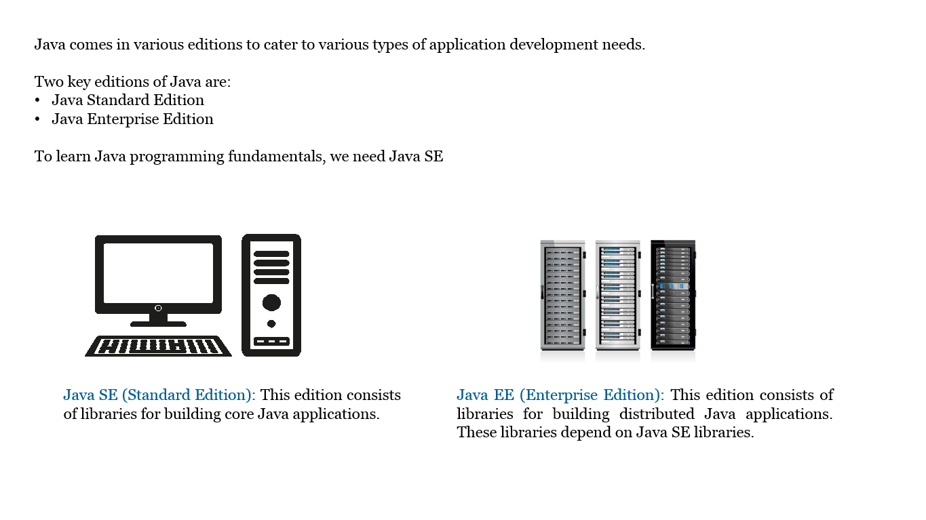

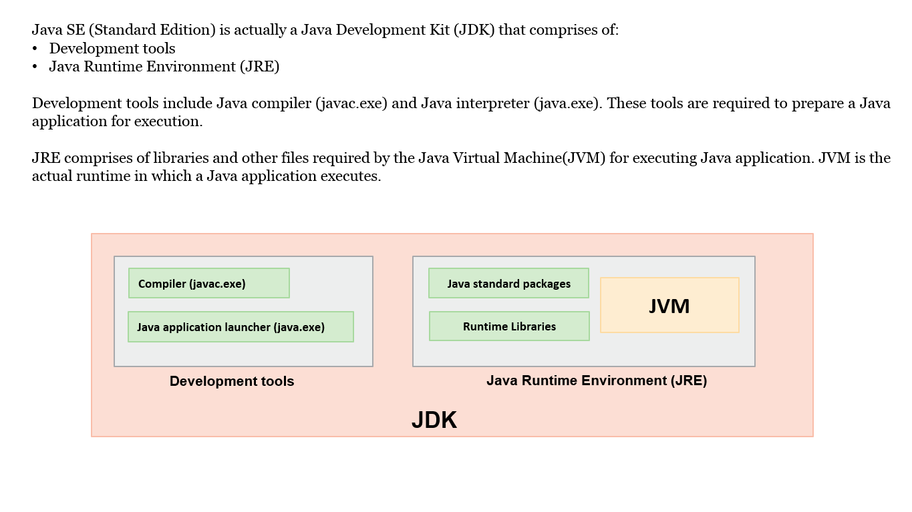

* The JRE will be installed as part of the JDK installation, as shown
* The JRE includes the Java tool which launches the JVM to execute the Java program
* Please note that JRE can also be installed without JDK, if the requirement is only to execute the Java applications, not the development
* JRE installers are available for different platforms like Windows and Linux . It is platform dependent

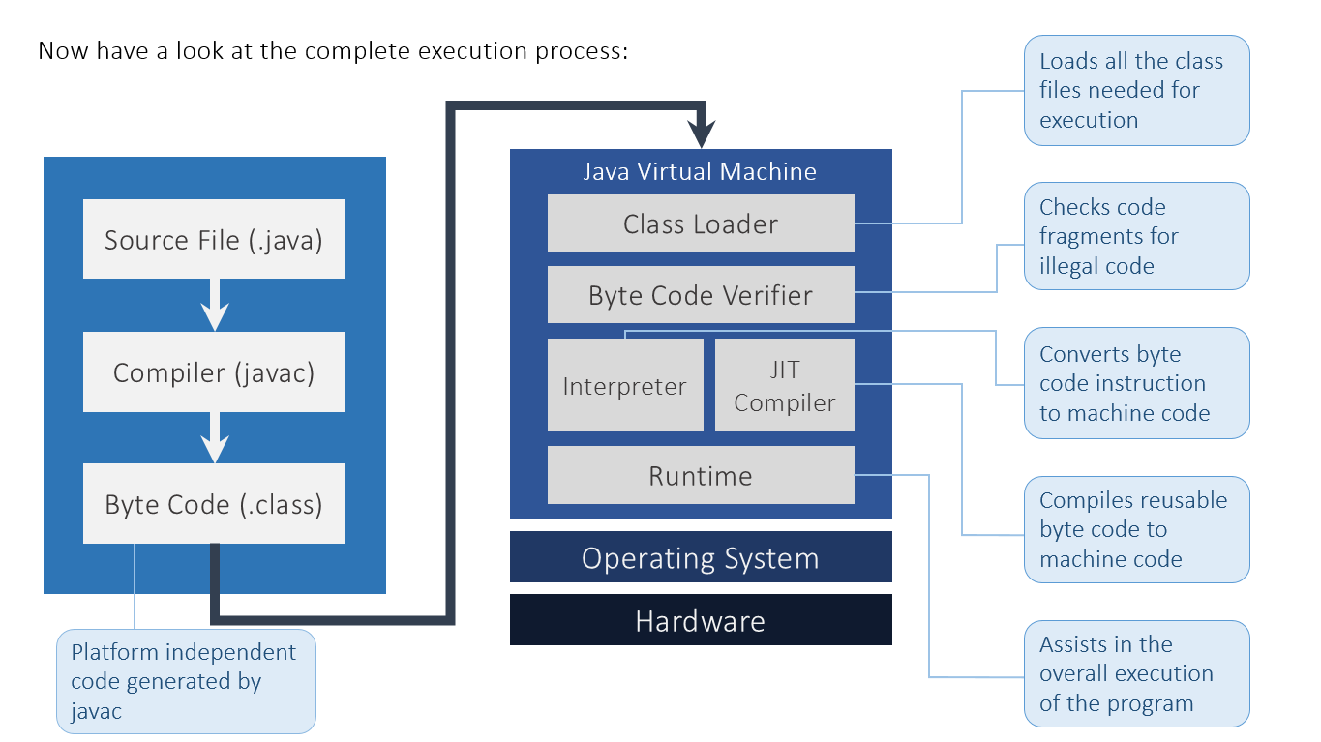

**Defining a Class in Java**

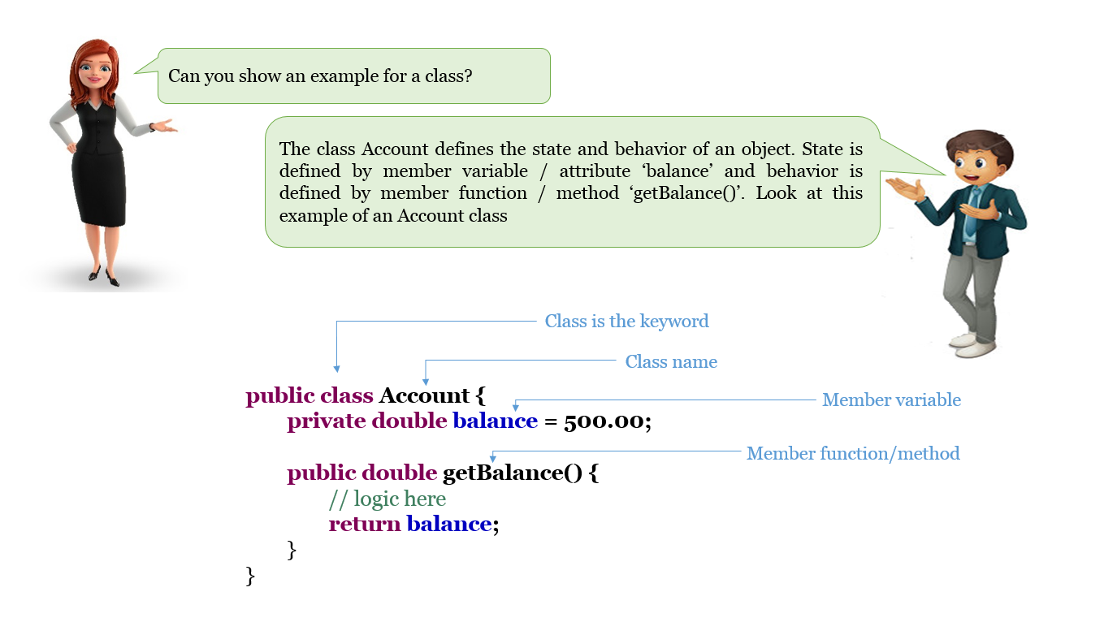

**Defining a method in Java**

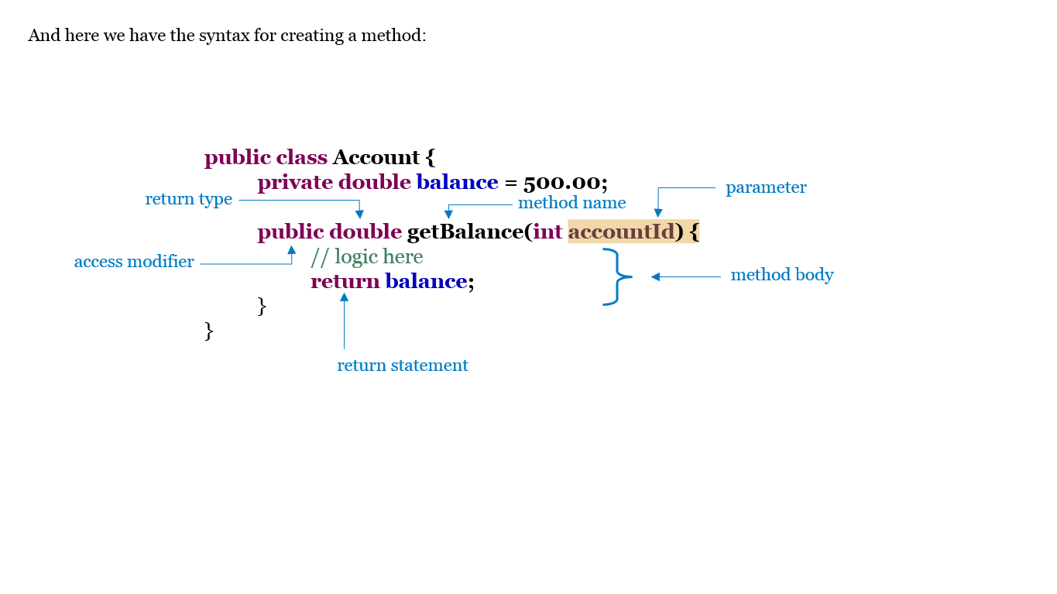

**The main method**

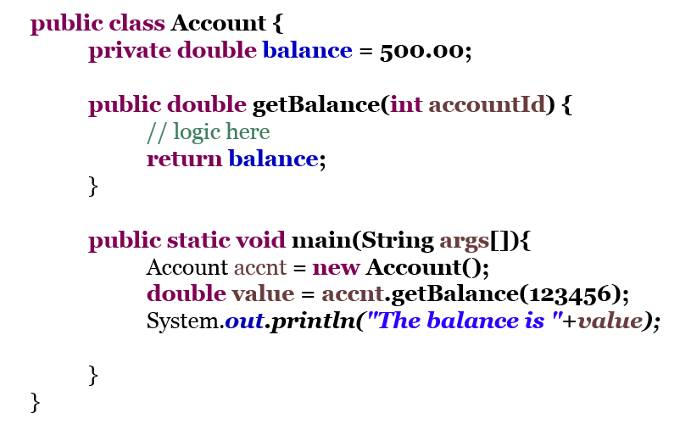

The main method is the starting point of program execution in Java.

* It has public modifier because the method needs to be invoked by the JVM using the java tool.
* The static modifier is used because the JVM does not have an instance of the class to invoke the main method. We will learn about static modifier later in this course.
* Method does not return any value so the return type is void.
* The parameter of the main method is a String array. When we run a Java program, we can pass any number of inputs to our program using command line arguments to the java tool (java). These inputs are stored in the String array and can be used in building programming logic. Further look at the points mentioned here.

**Complete Java Program**

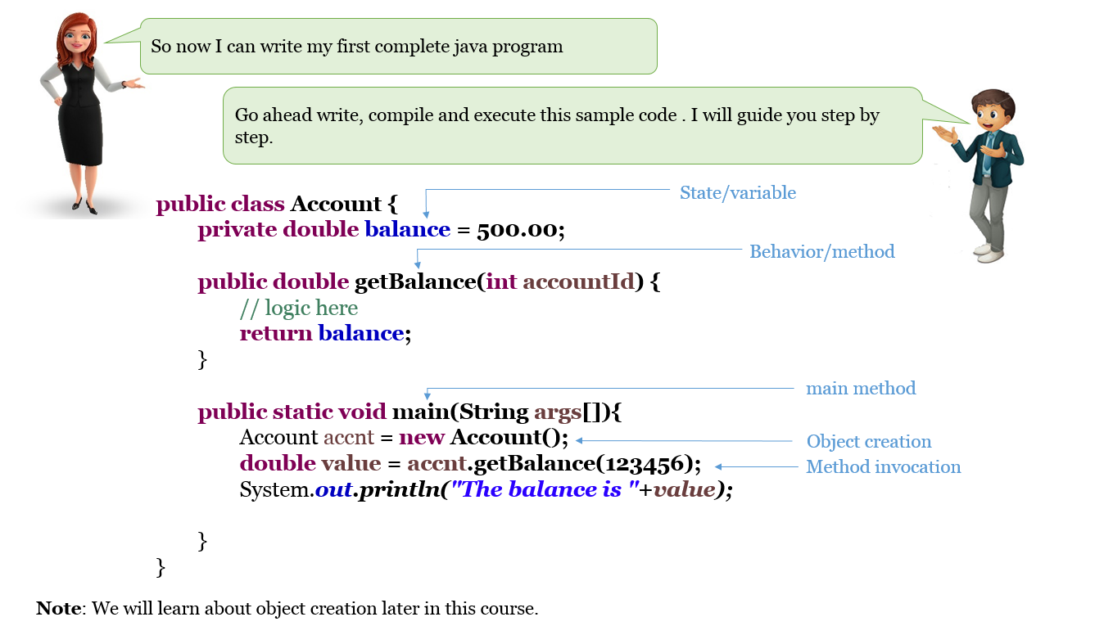

**Running the Program**

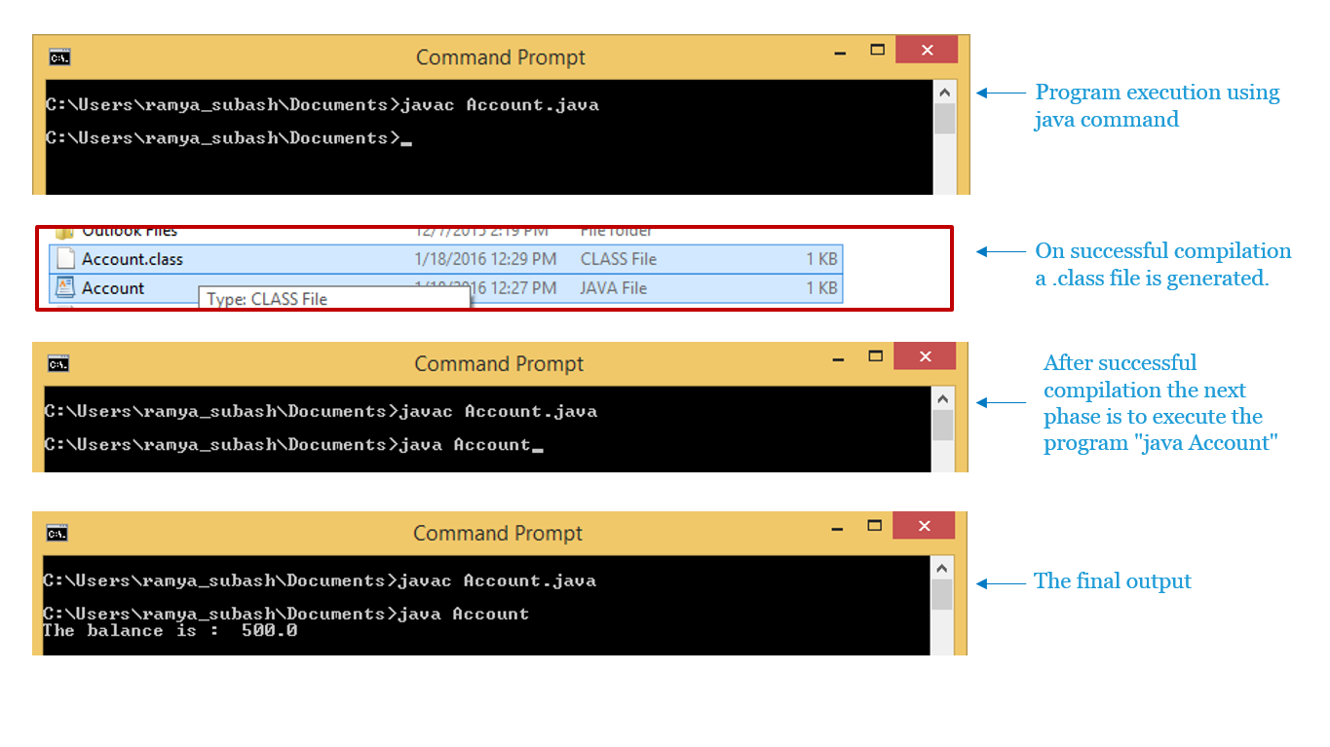

**Example to demonstrate Command Line Arguments**

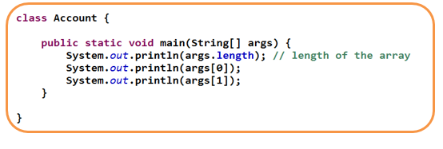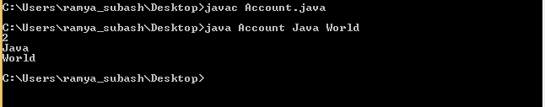

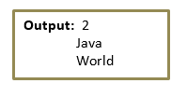

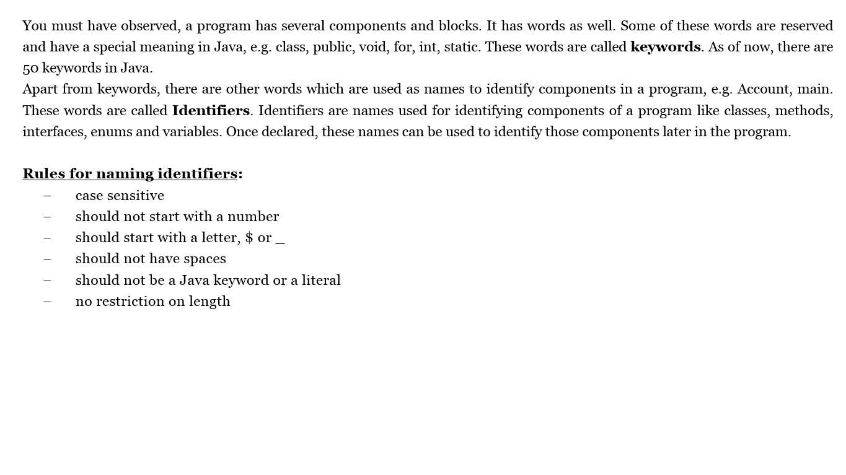

**Data Types and Variables**

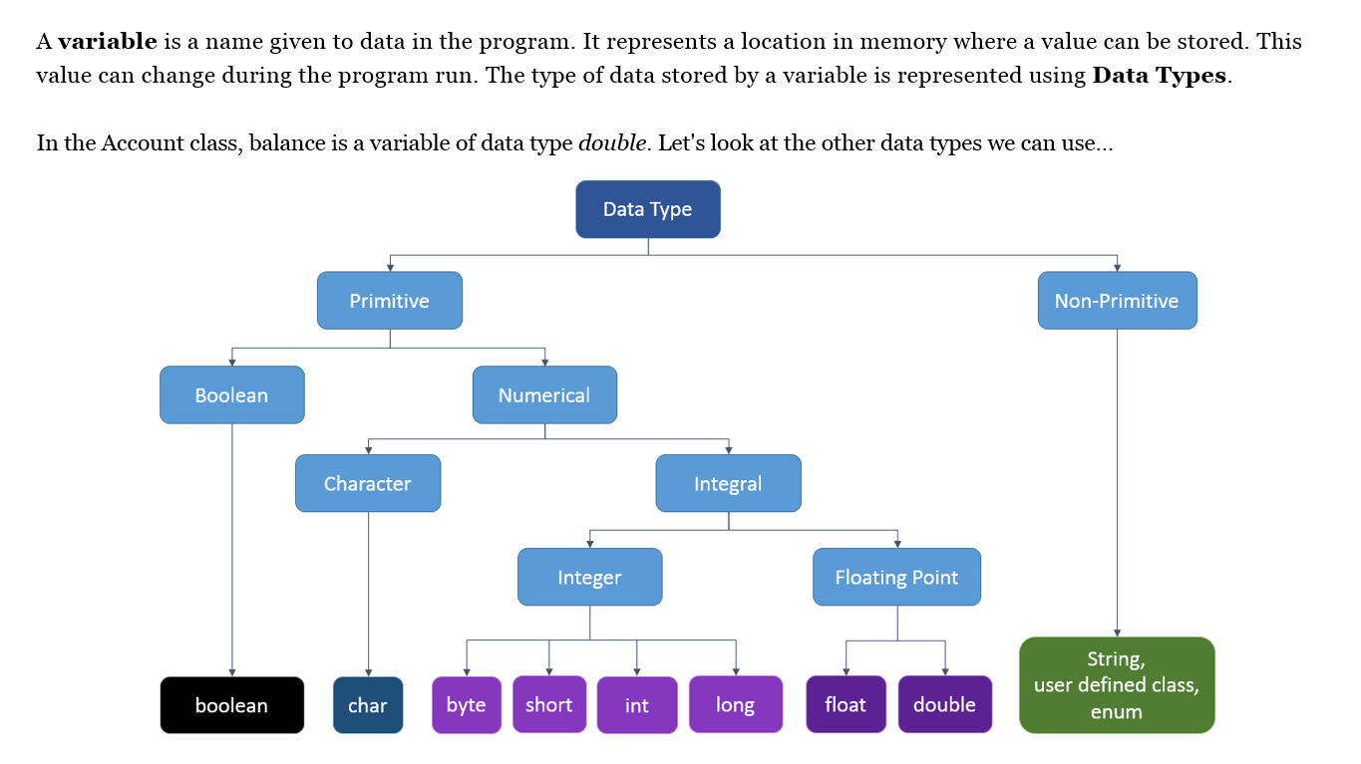

A data type defines a variable’s memory requirement and the operations that can be performed on it.

There are two different categories of datatypes in Java:

**Primitive Data Types**

* It holds the value of the data item
* Example: int, float

**Non-primitive Data Types**

* It holds the memory address where the data item (object) is stored.
* Examples : Classes, enum
* Also known as Reference datatypes

**Primitive Data Types**

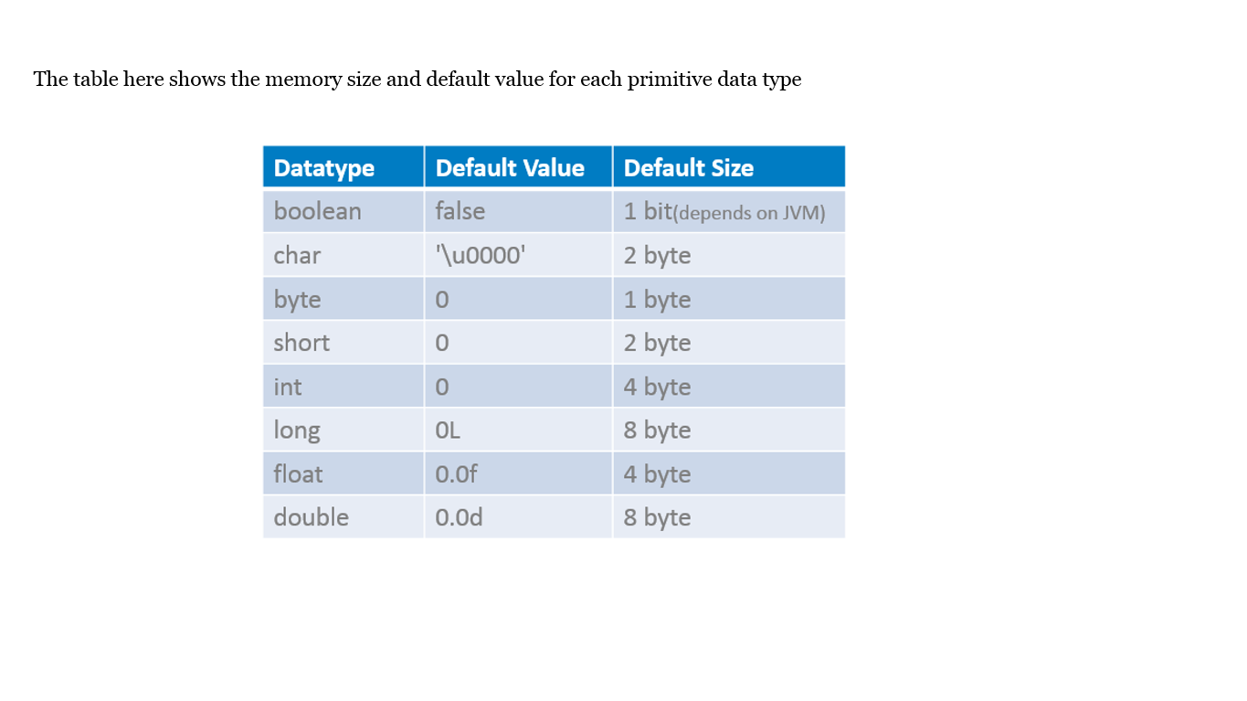

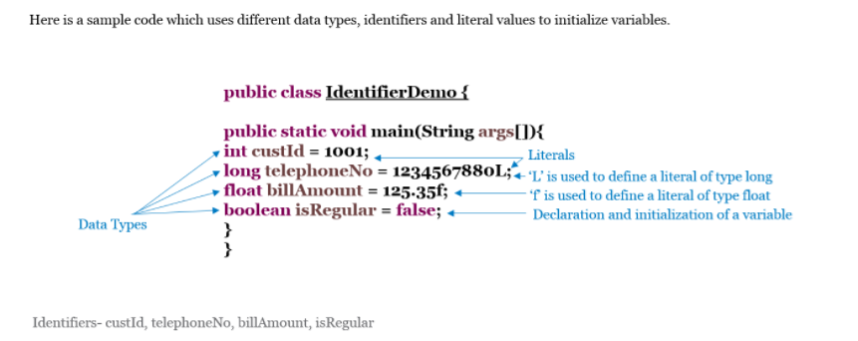

The name of variables should start with a lowercase letter using CamelCase notation, like for example isRegular

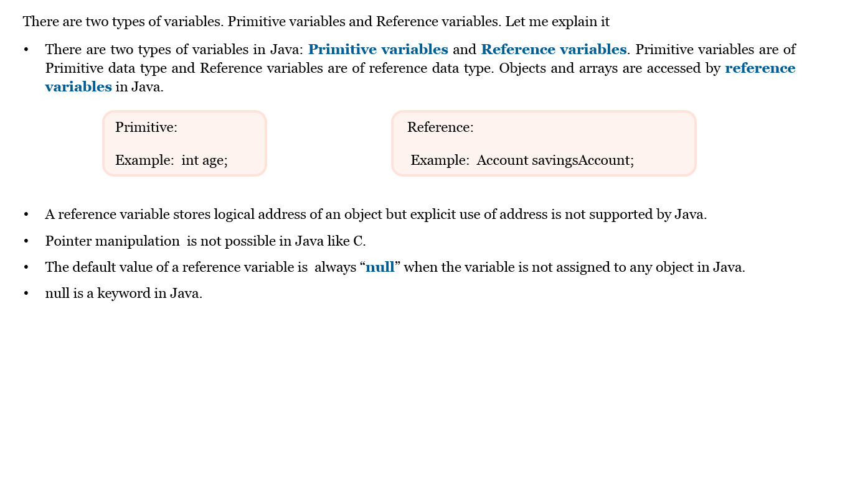

**int Data Type**

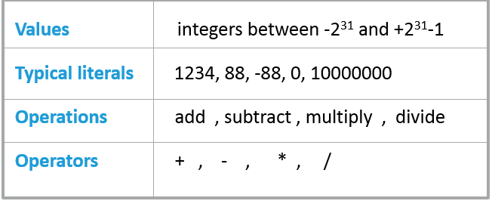

**float Data Type**

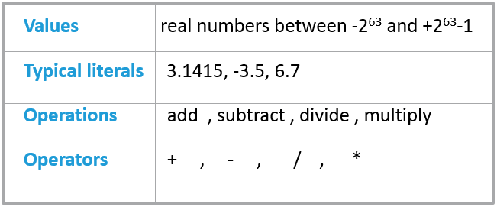

**boolean Data Type**

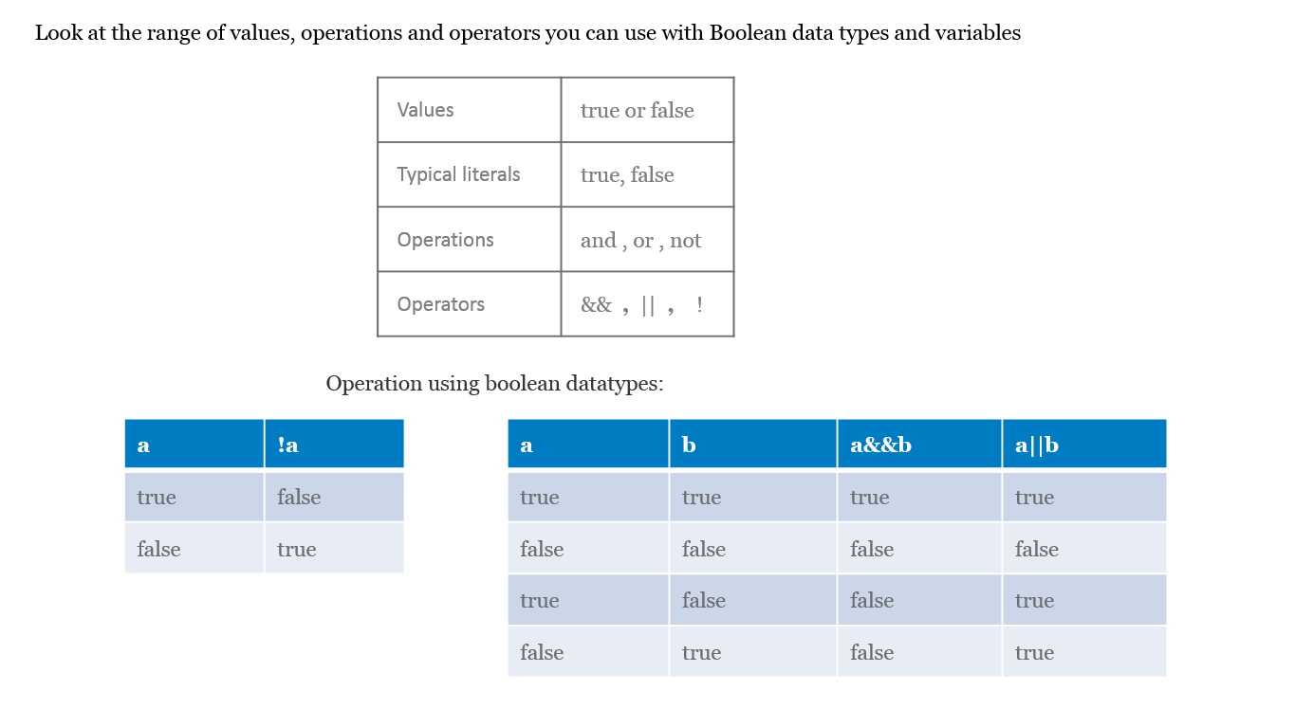

**Reference Type**

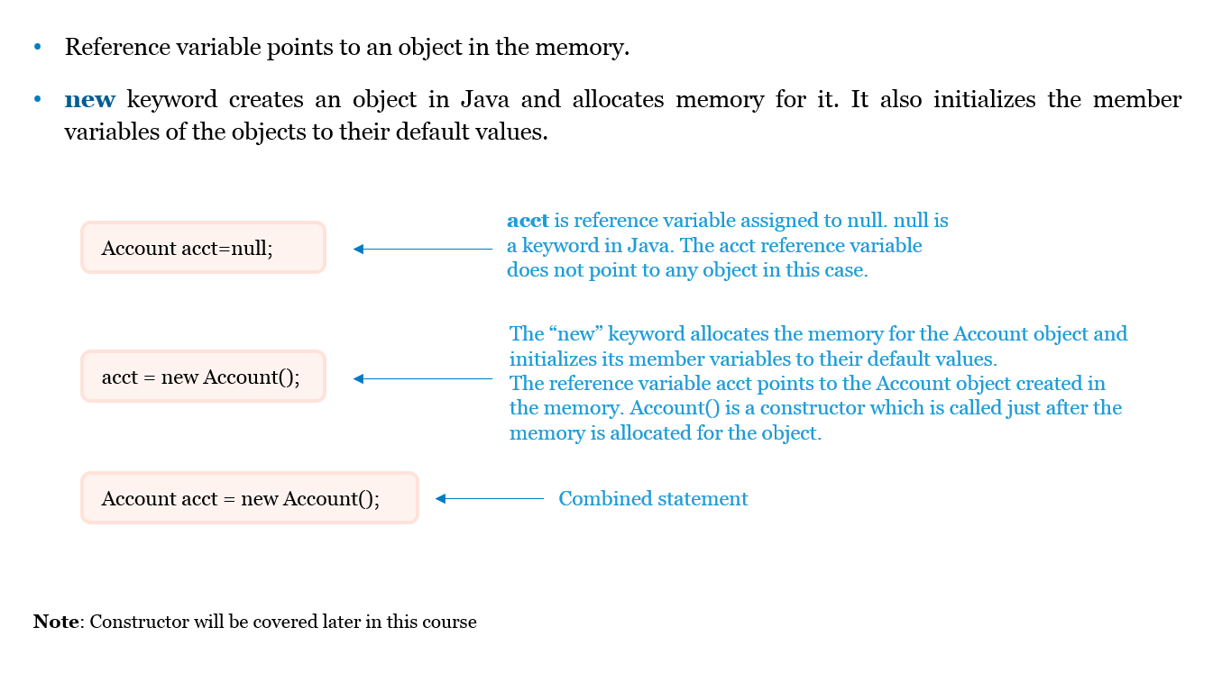

**Scope of Variables**

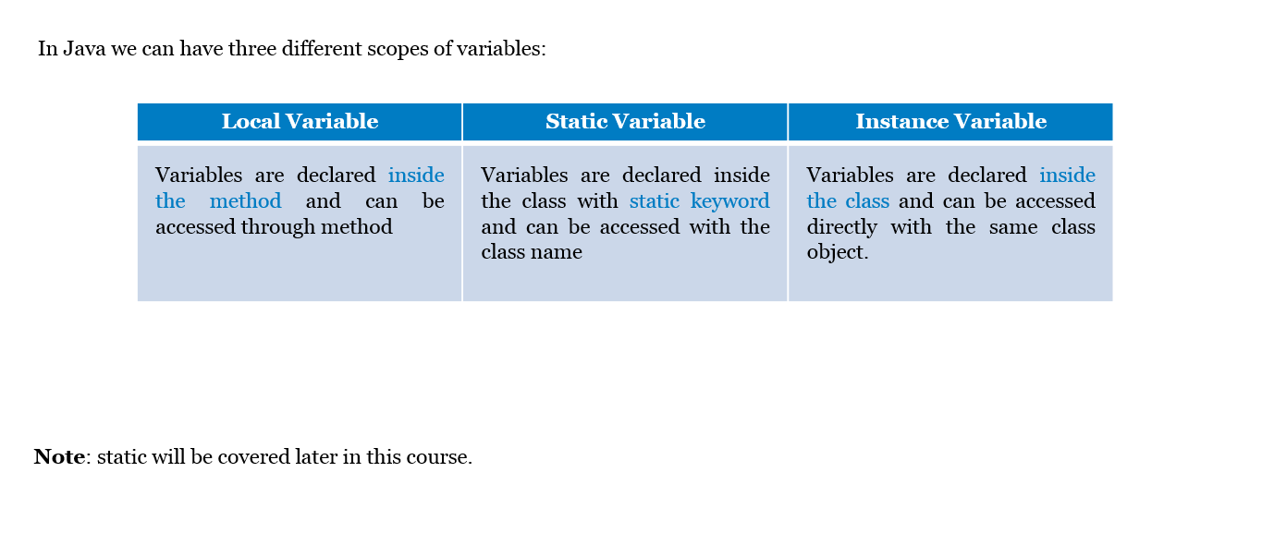

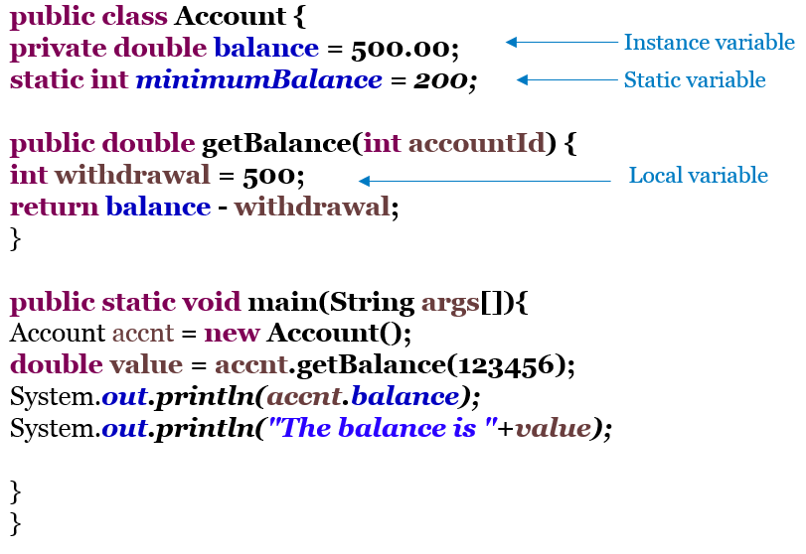

* Local variable withdrawal is declared inside the method getBalance and can be accessed only in the method.
* Static variable minimumBalance is declared inside the class with static keyword and can be accessed anywhere within the class and outside the class it is accessed with a class name ex: Account.minimumBalance.
* Instance variable balance is declared inside the class and can be accessed directly with the same class , outside the class and within static methods of the Account class it is accessed with the object reference ex: accnt.balance.

**Arithmetic Operators**

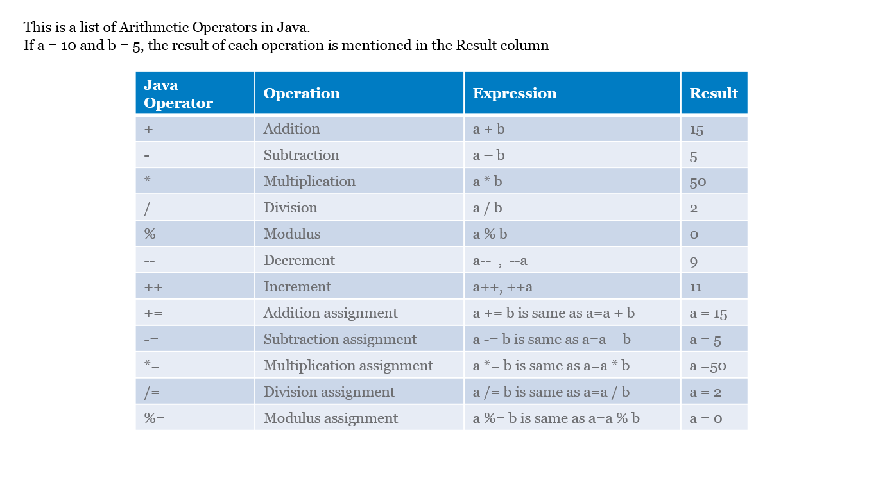

**Bitwise Operators**

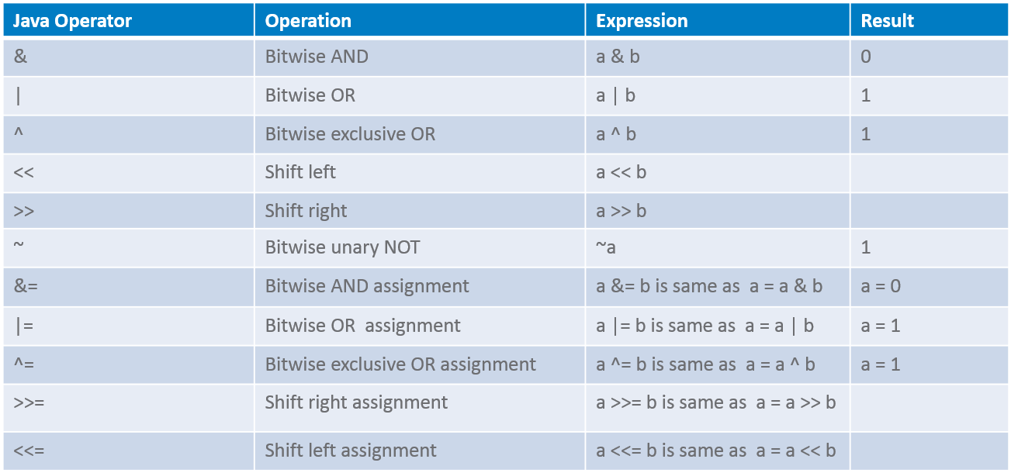

**Bitwise Operators - The Truth Table**

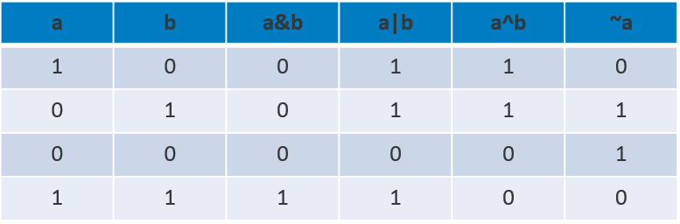

Right shift by 1 is equivalent to divide by 2. Example: 40>>1 is same as 40/2^1 =2

**Shift Operators**

* Right Shift: 20>>2 = 5

Binary value of 20 is: 00000000000000000000000000010100

shift bits 2 positions to right: 00000000000000000000000000000101

Result is: 1*22 + 0*21 + 1*20 = 5

* Left Shift: 13<<2=52

Binary value of 13 is: 00000000000000000000000000001101

shift bits 2 positions to left and fill right bits with 0’s: 00000000000000000000000000110100

Result is: 1*2^5+1*2^4+0*2^3+1*2^2+0*2^1+0*2^0 = 52

* Unsigned right shift: -1>>>2 = 1073741823

Binary value of -1 is: 11111111111111111111111111111111

shift bits 2 positions to right and add 0’s to the left: 001111111111111111111111111111

Result is: 1073741823

**Relational Operators**

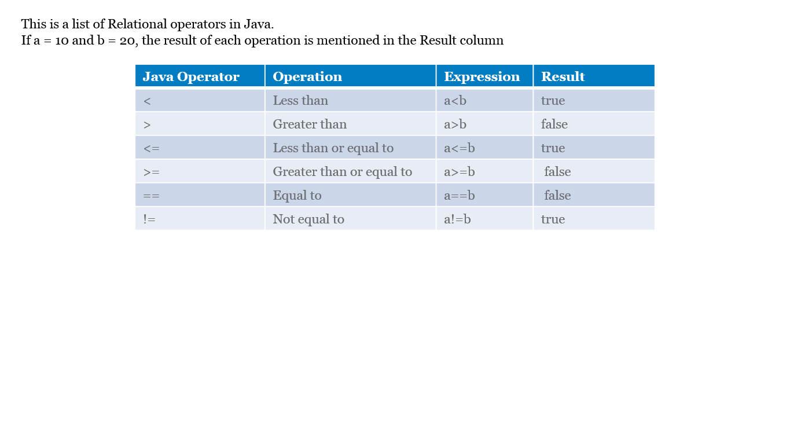

**Ternary Operator**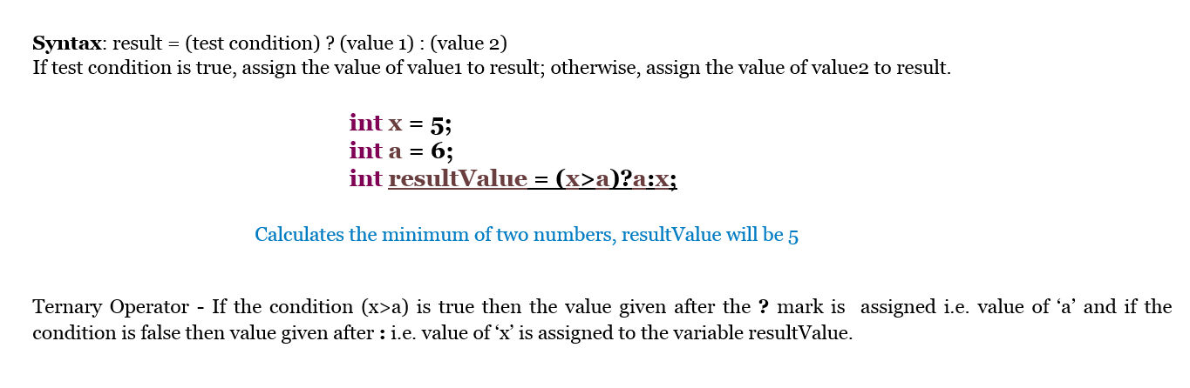

**Logical Operators**

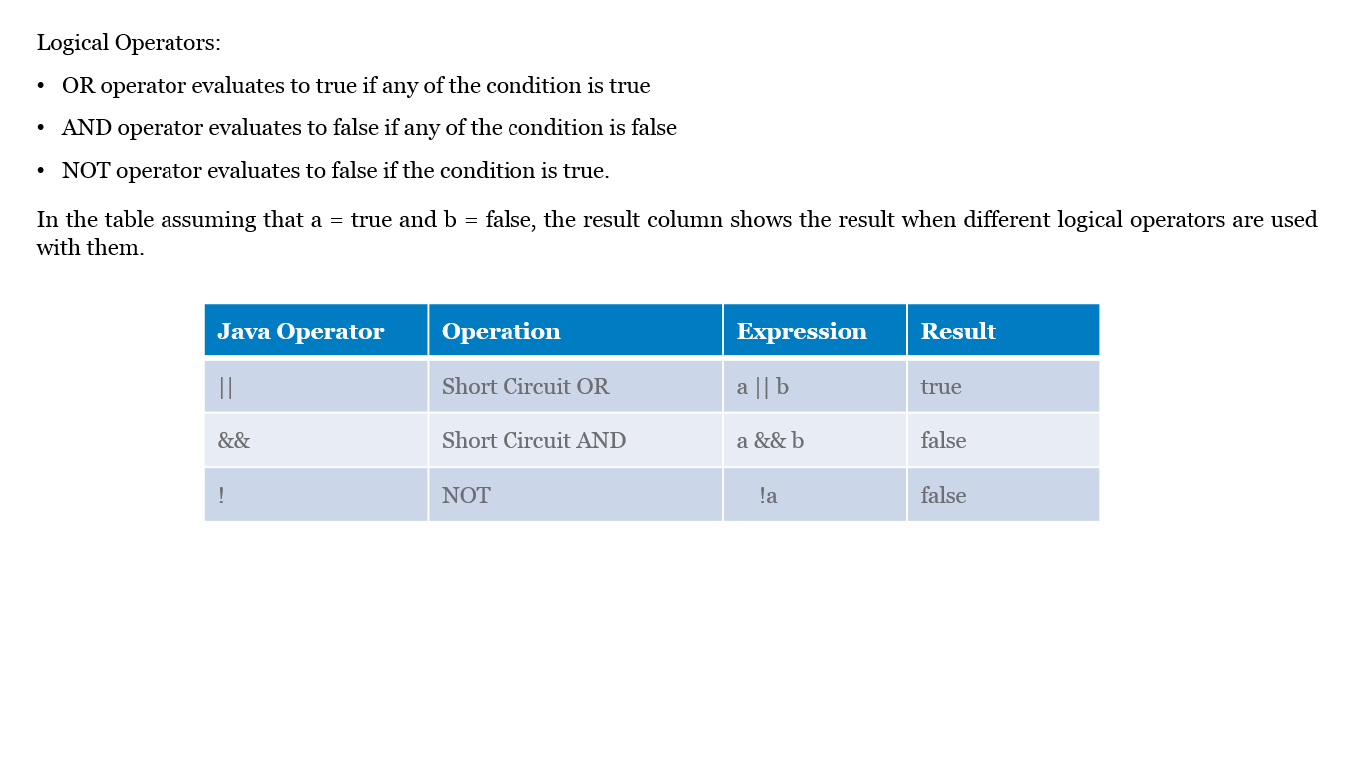

**Widening and Narrowing**

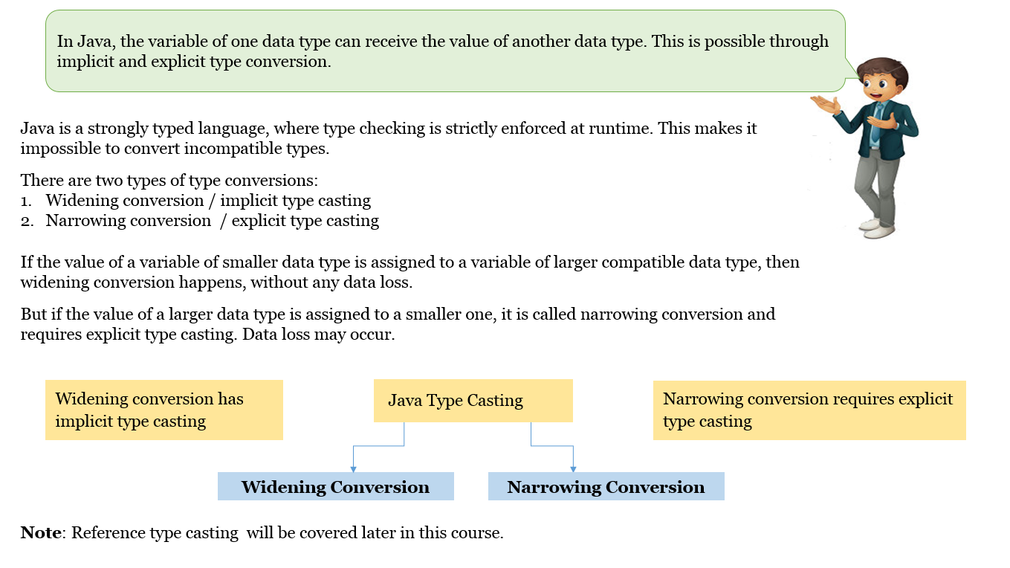

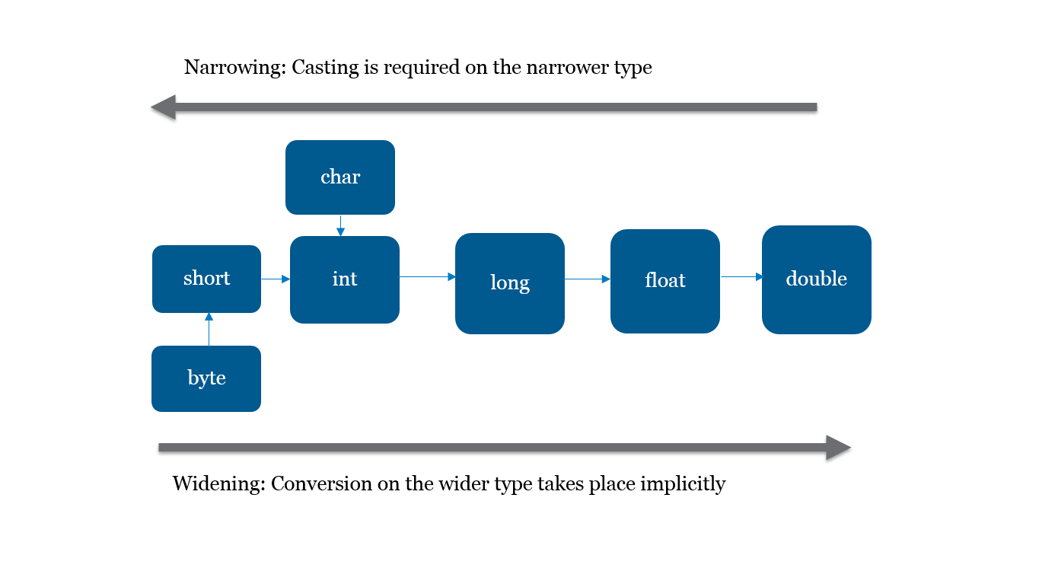

Best Practices:

* It is safe to use instanceof keyword before type casting to avoid runtime exceptions
* A boolean cannot be cast to any other data type and vice versa

**Control Flow and Looping**

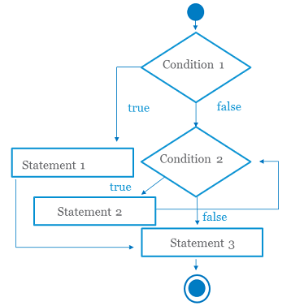

**if-else statement**

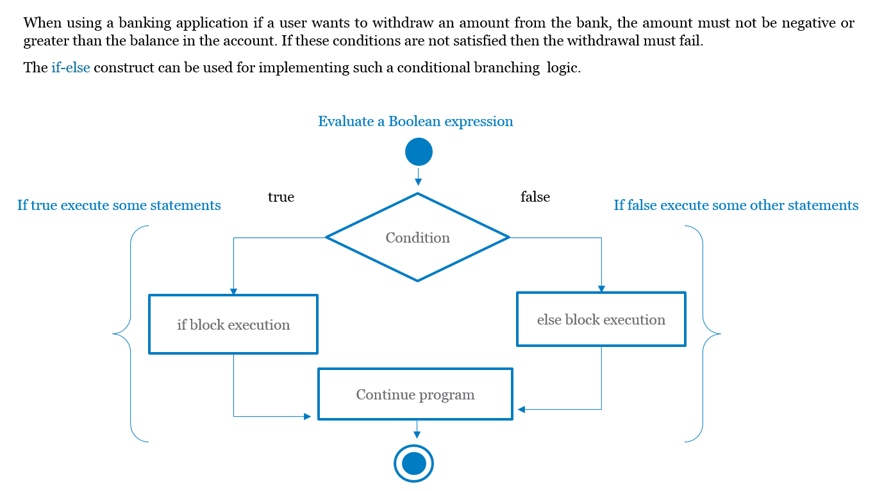

**if-elseif-else statement**

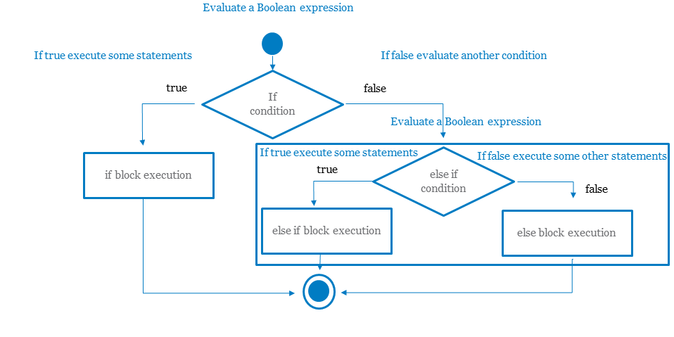

**switch–case statement**

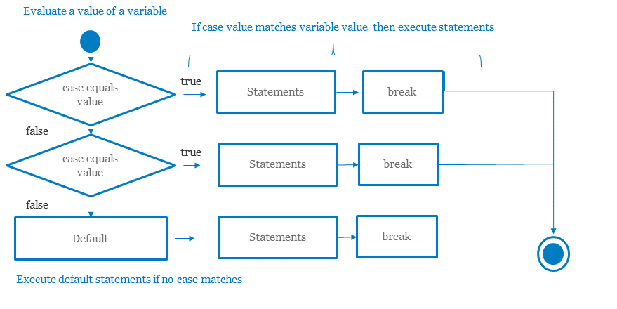

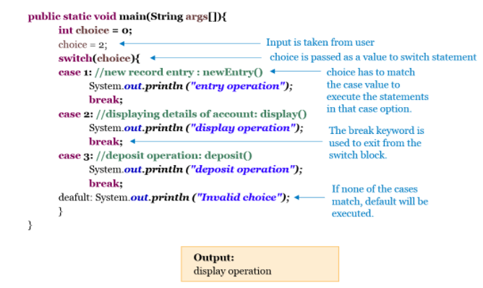

Best Practices:

* Switch case statements are faster than if-else statements as the switch case statement generates more efficient byte code

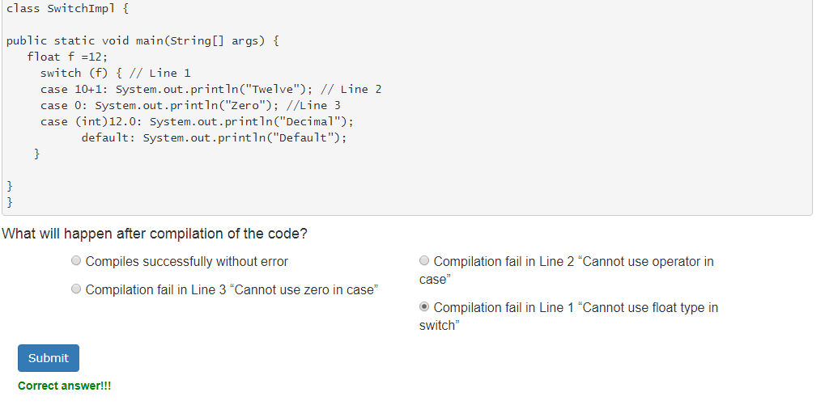

**Do-while Loop**

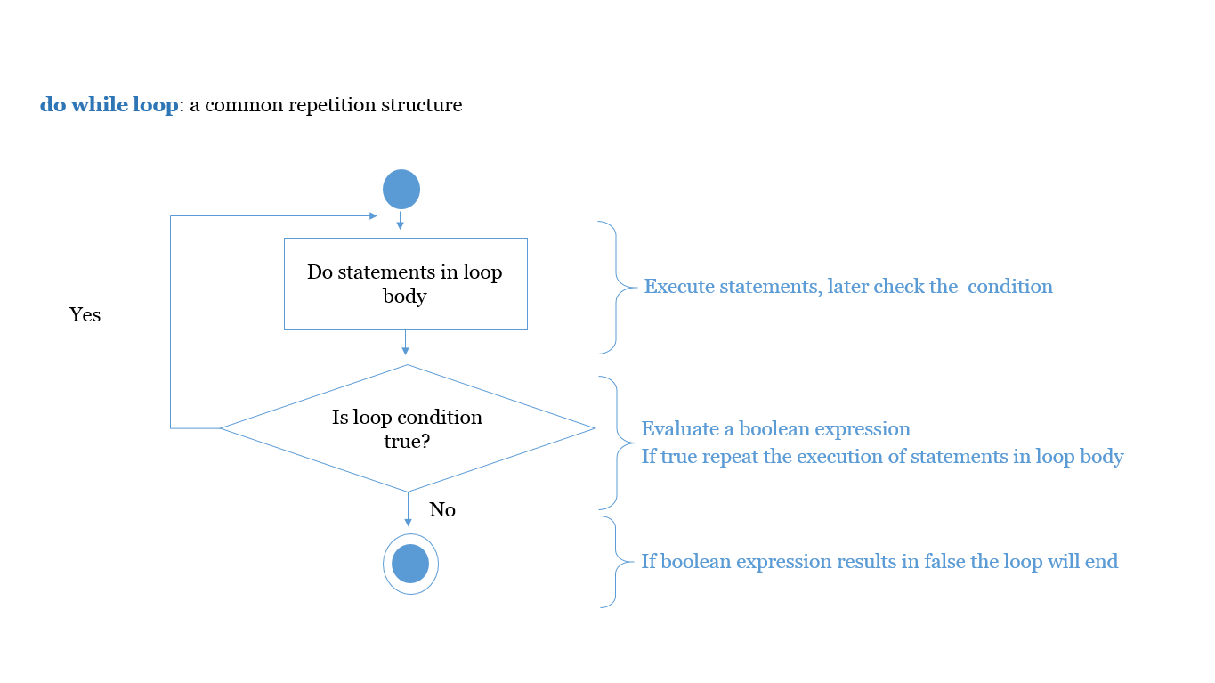

**while Loop**

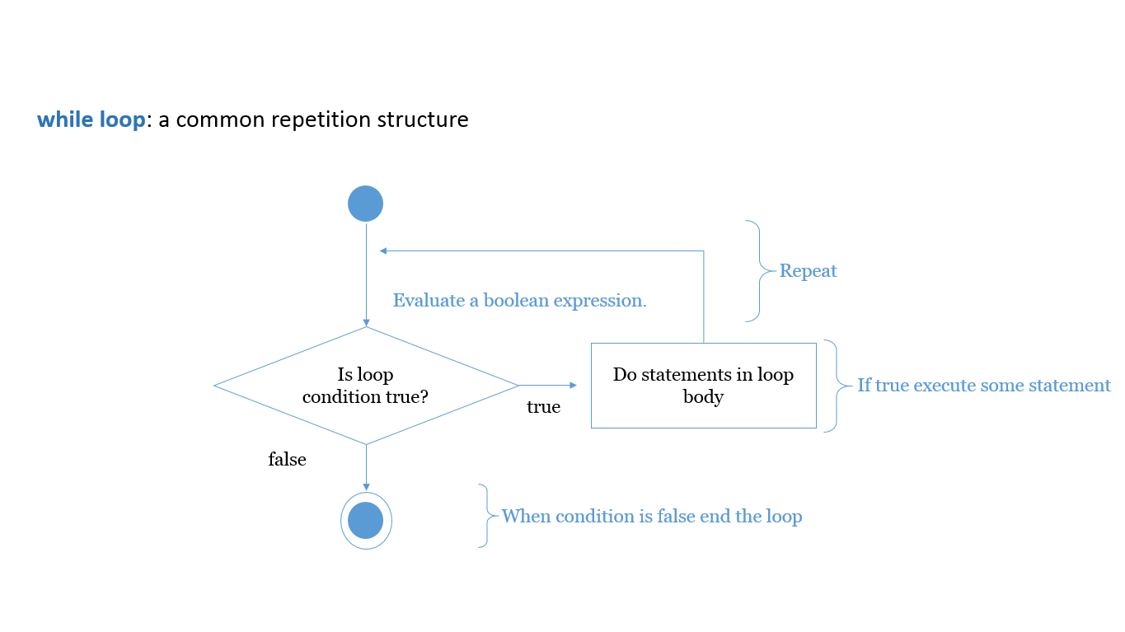

**For Loop**

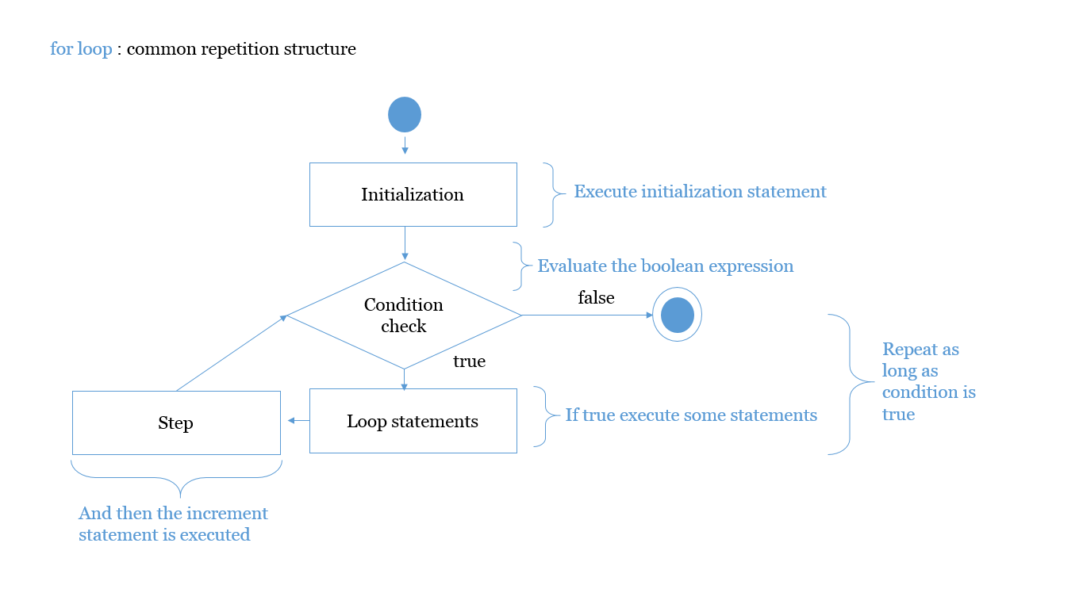

**Anatomy of for loop**

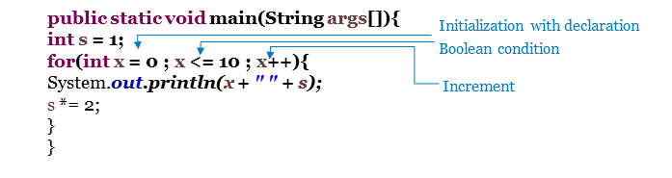

**Arrays**

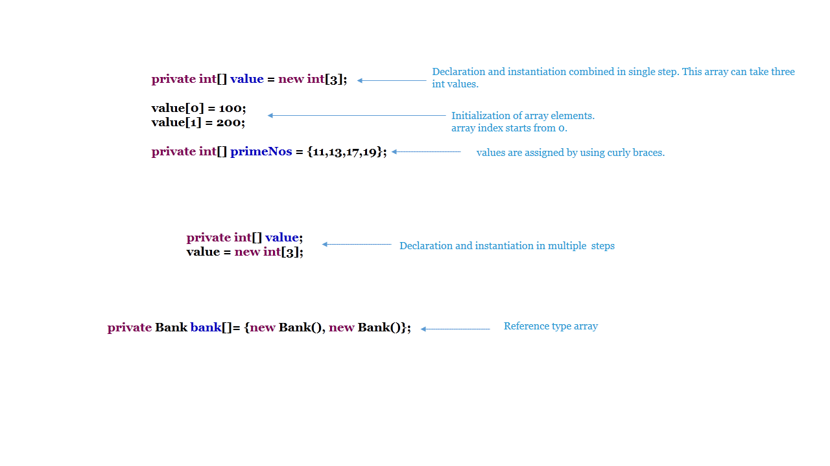

**Multi Dimensional Arrays**

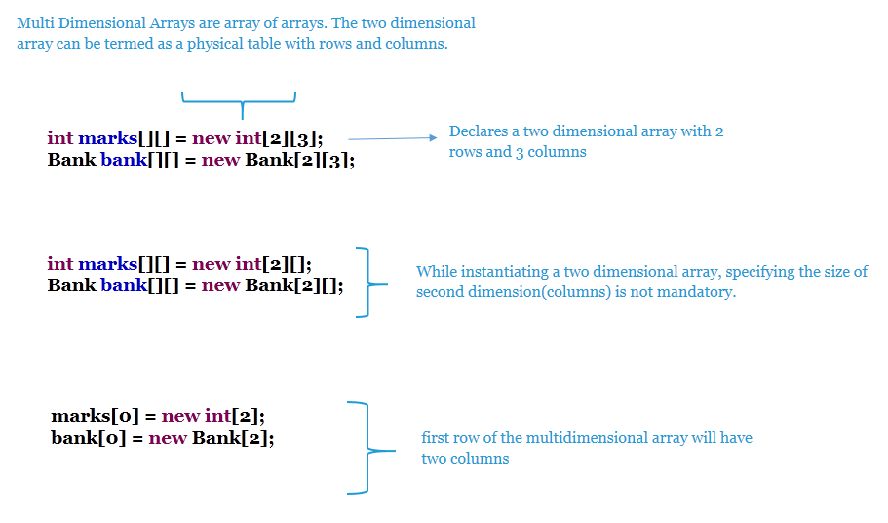

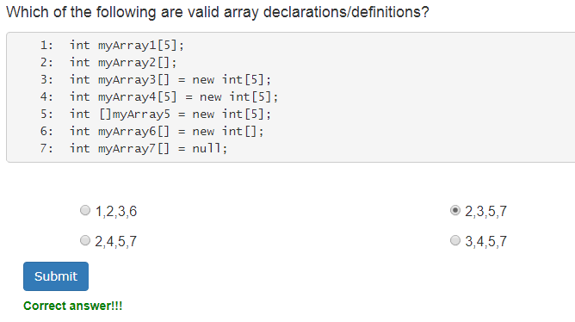

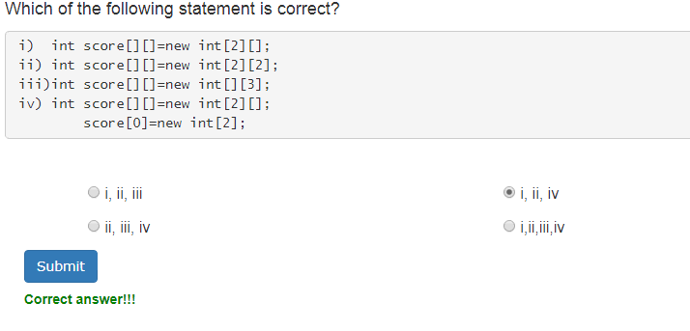

**Enhanced for loop (for-each loop)**

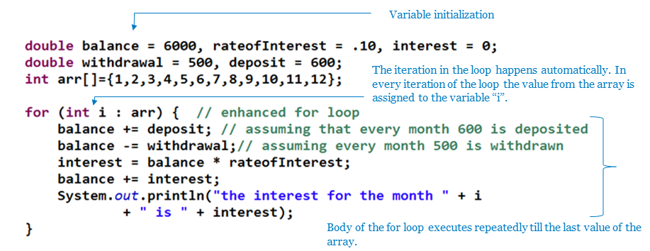

Best Practices:

* Prefer using a for-each loop for better readability
* A normal for loop using index is faster than a for-each loop, as for-each creates an iterator internally to iterate through the elements
* You can't use for-each when
* You have to modify or delete the collection or array selectively
* You need to iterate through more than one collection in parallel

**Class and Object**

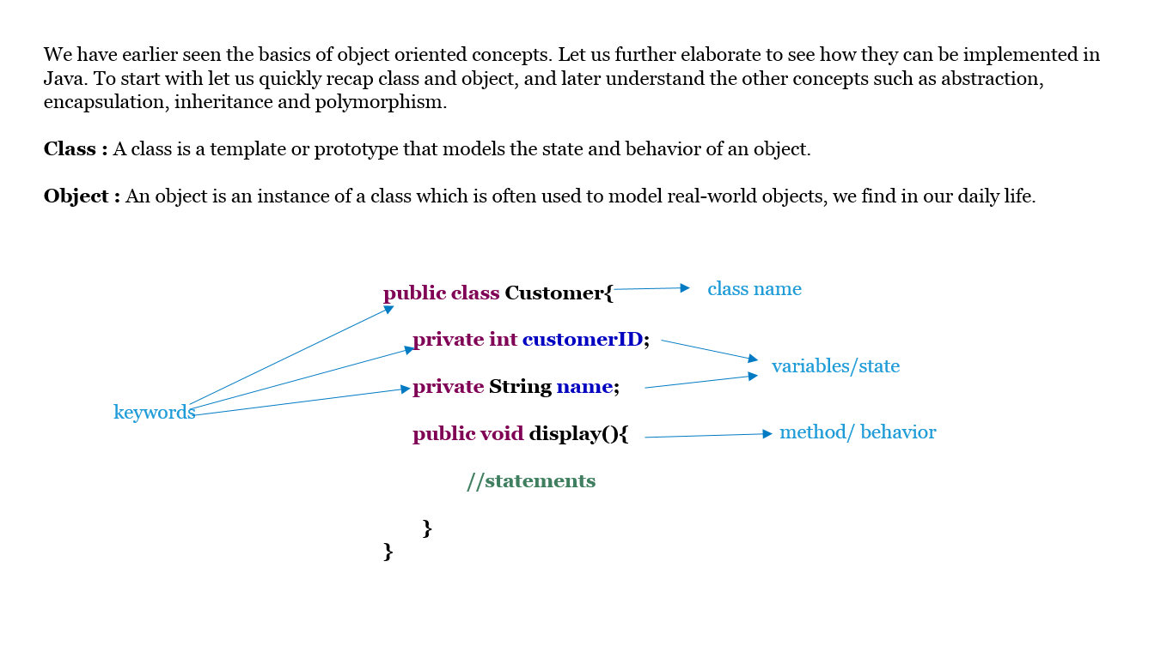

**Abstraction**

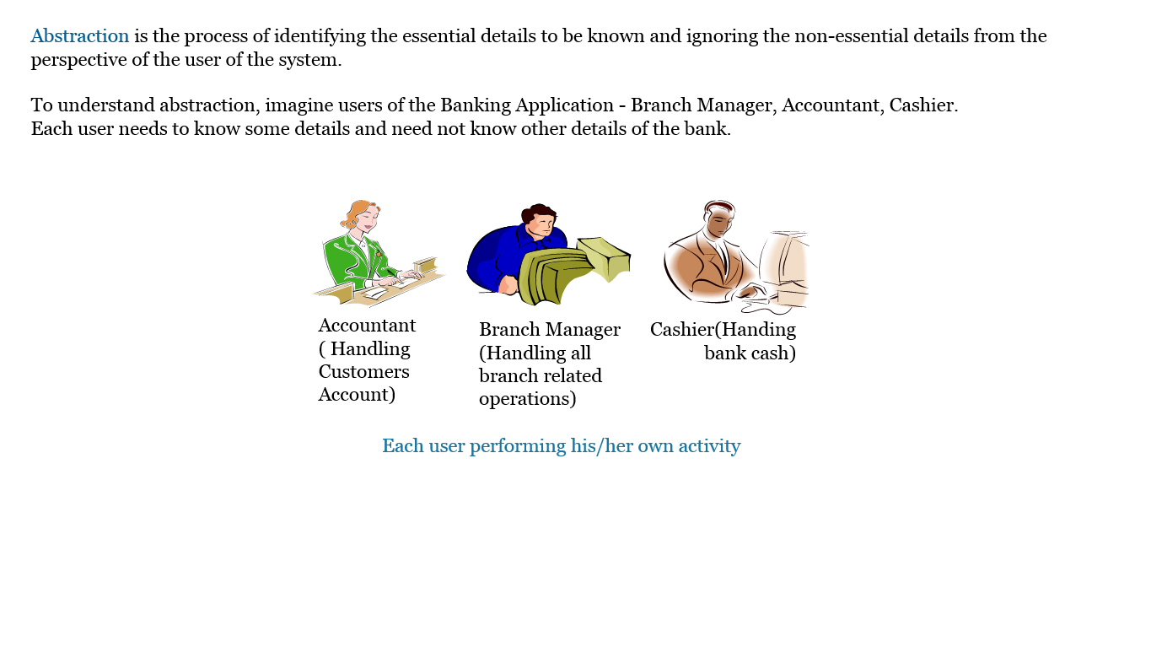

**Encapsulation**

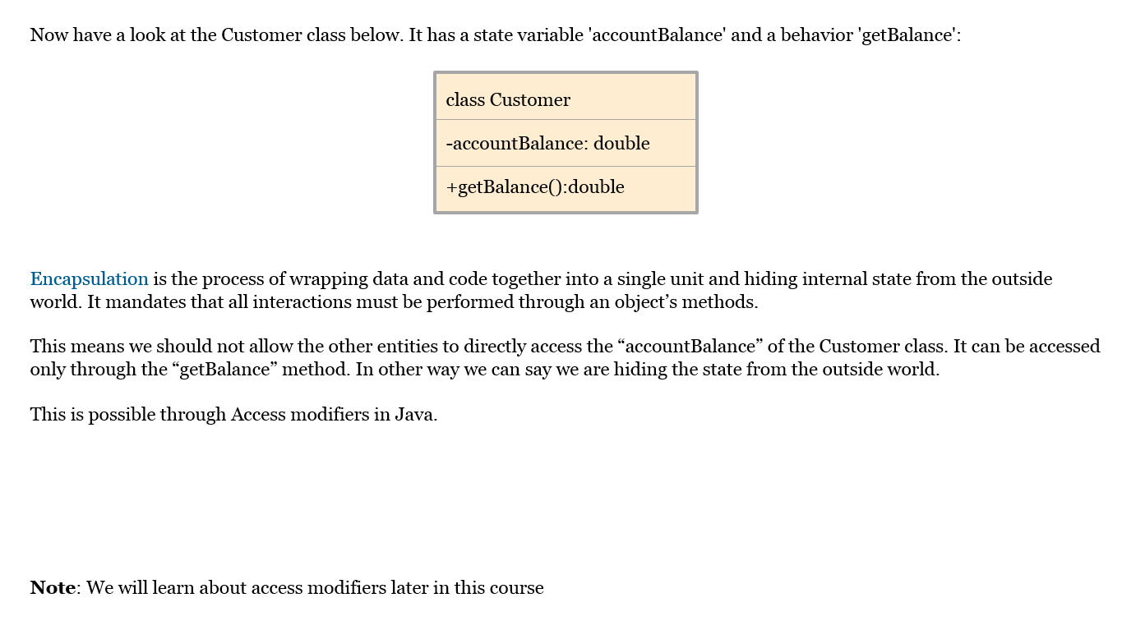

**Inheritance**

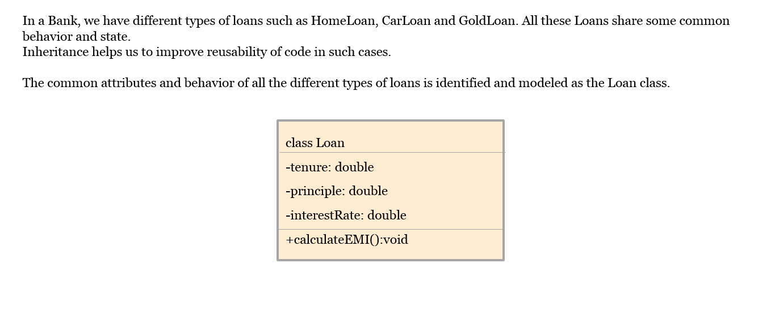

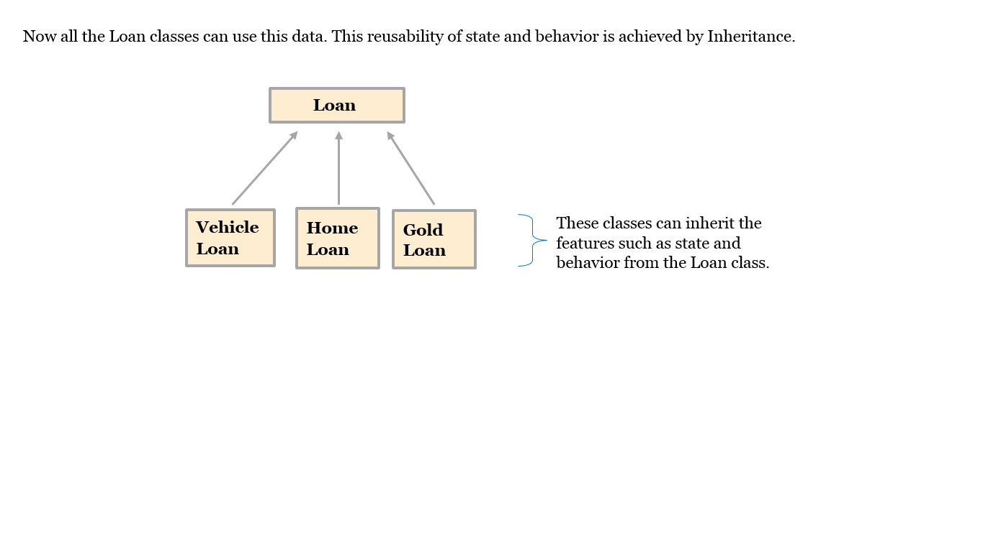

**Polymorphism**

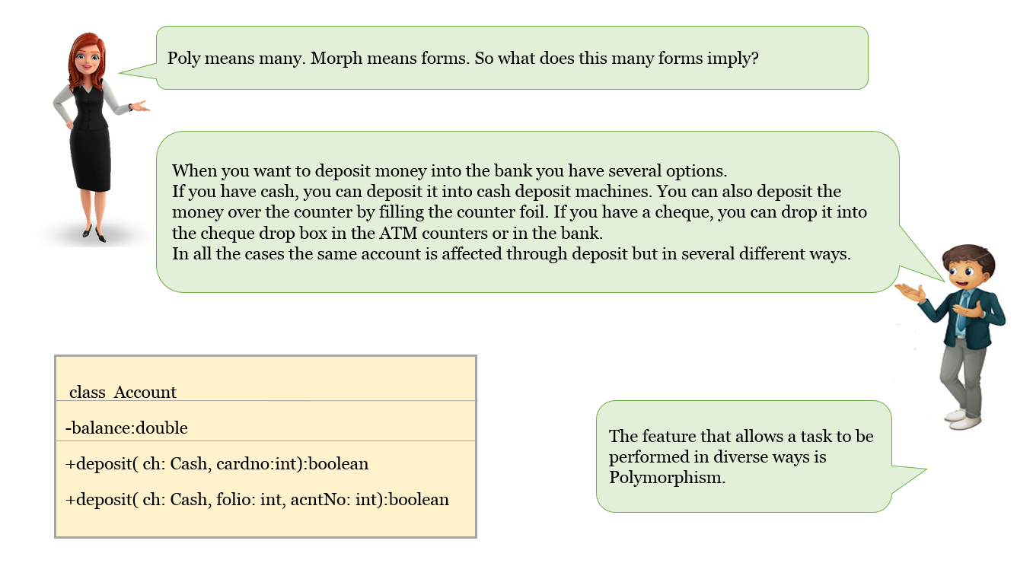

**Introduction to Constructors**

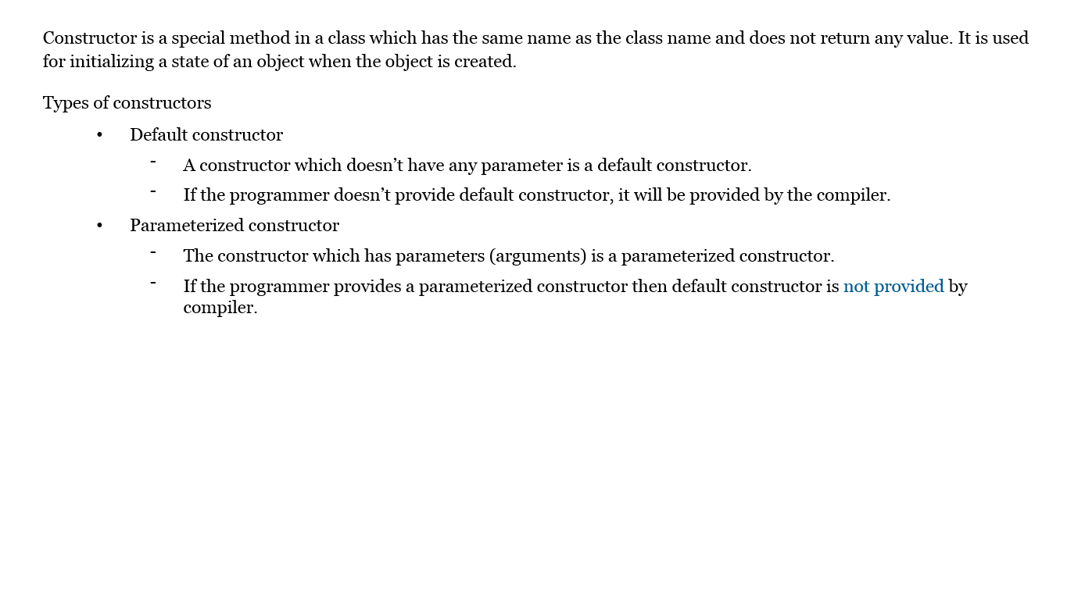

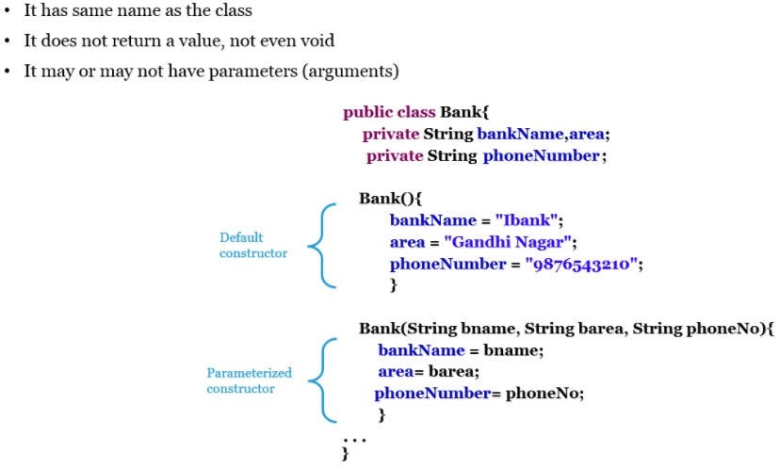

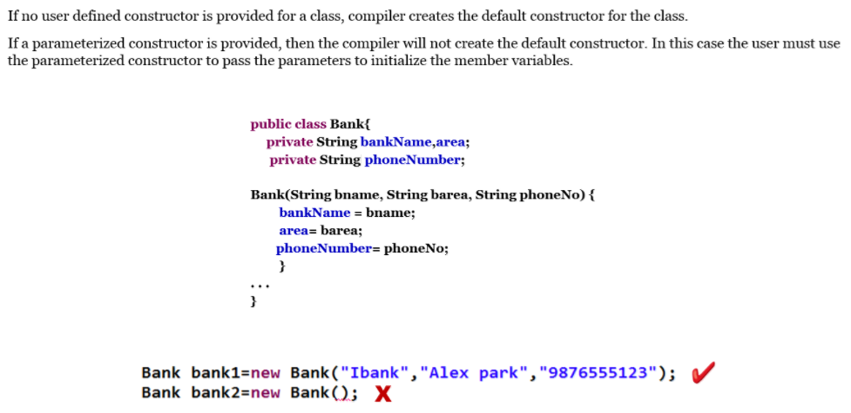

**Best Practices:**

Data object variables which are mandatory should be initialized through constructor, so we can avoid any setters for those variables

That ensures variables cannot be changed after new instance of object is created.

Eg:

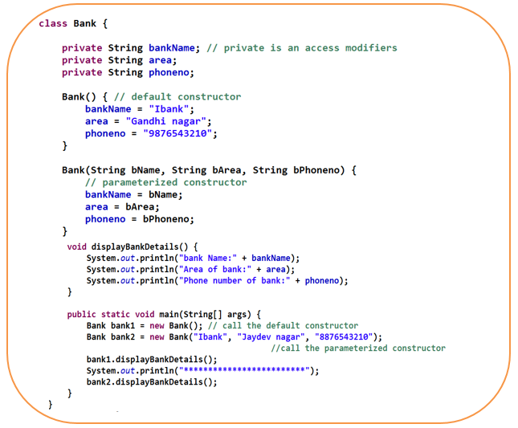

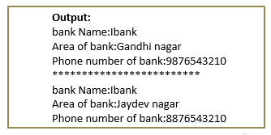

**this Keyword**

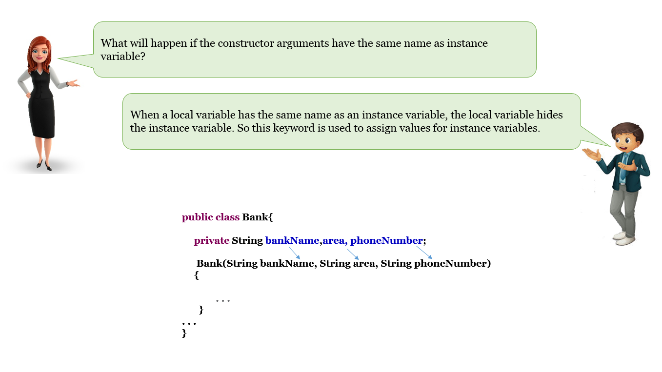

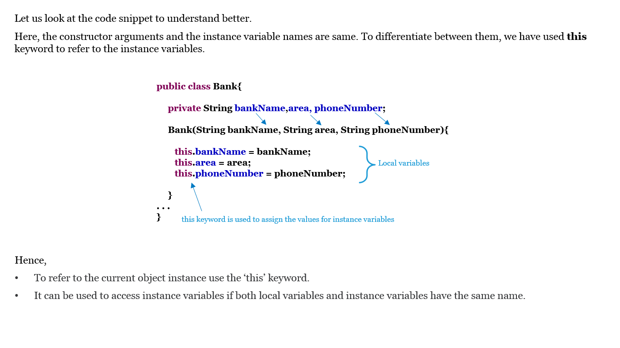

**Eg;**

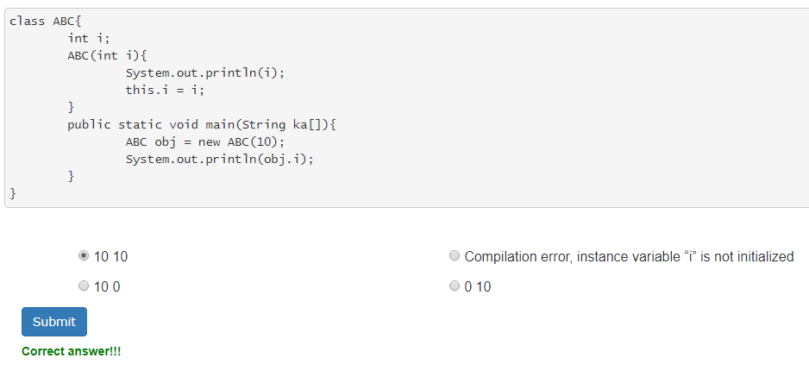

**Introduction to Inheritance**

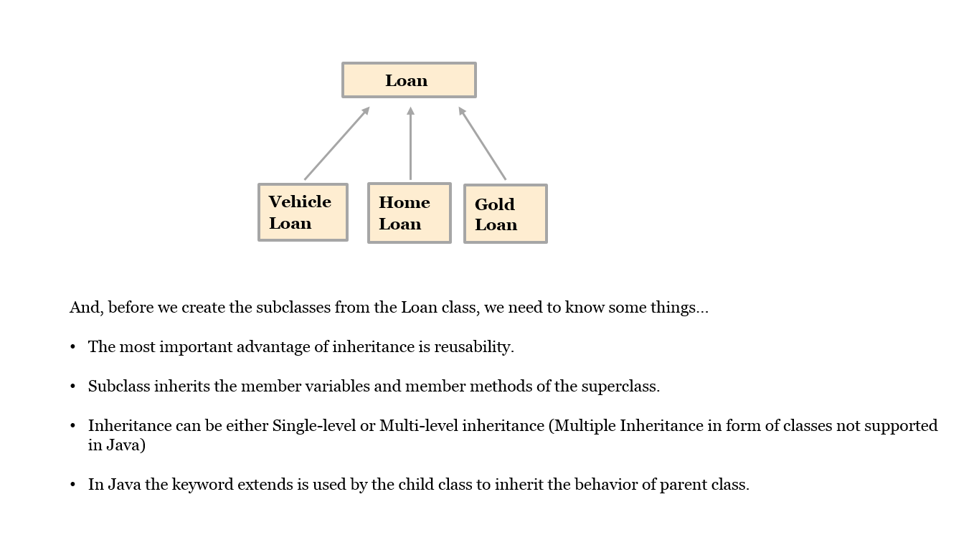



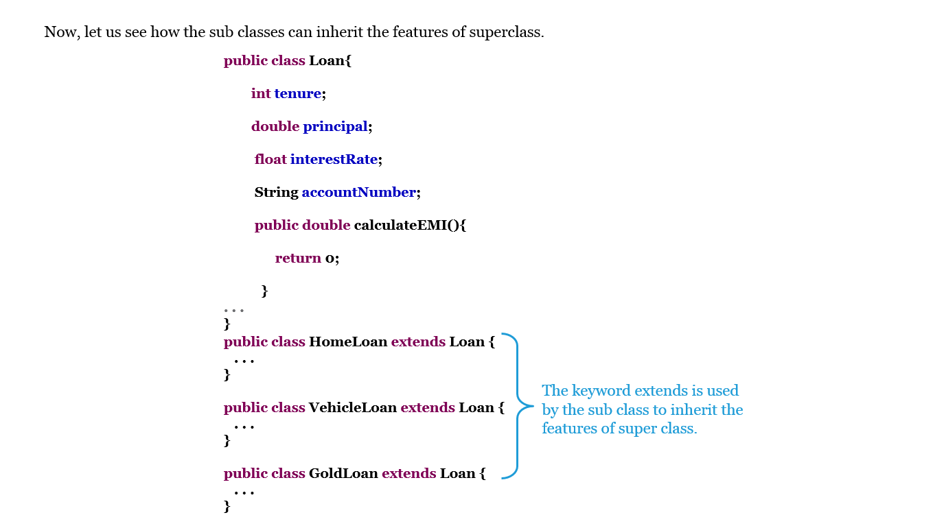

**Multi-level Inheritance**

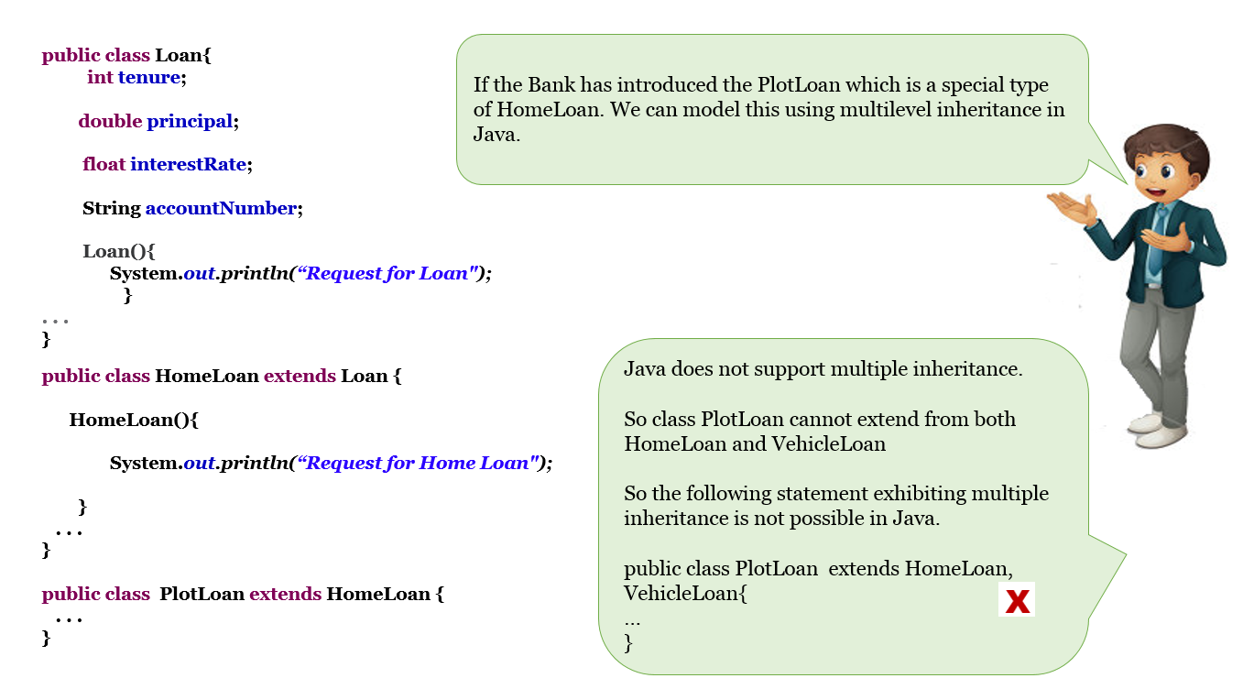

**Constructor Chaining**

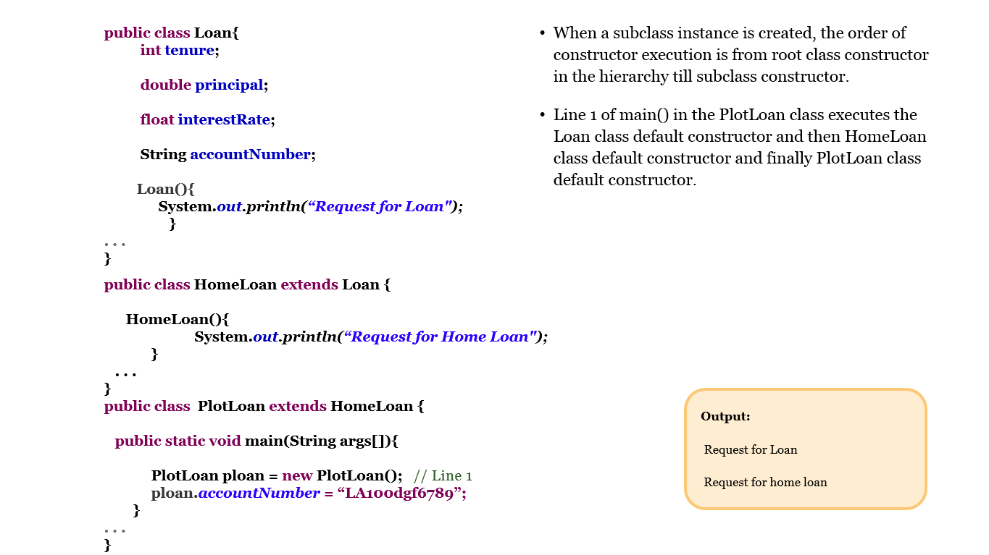

**Types of Polymorphism**

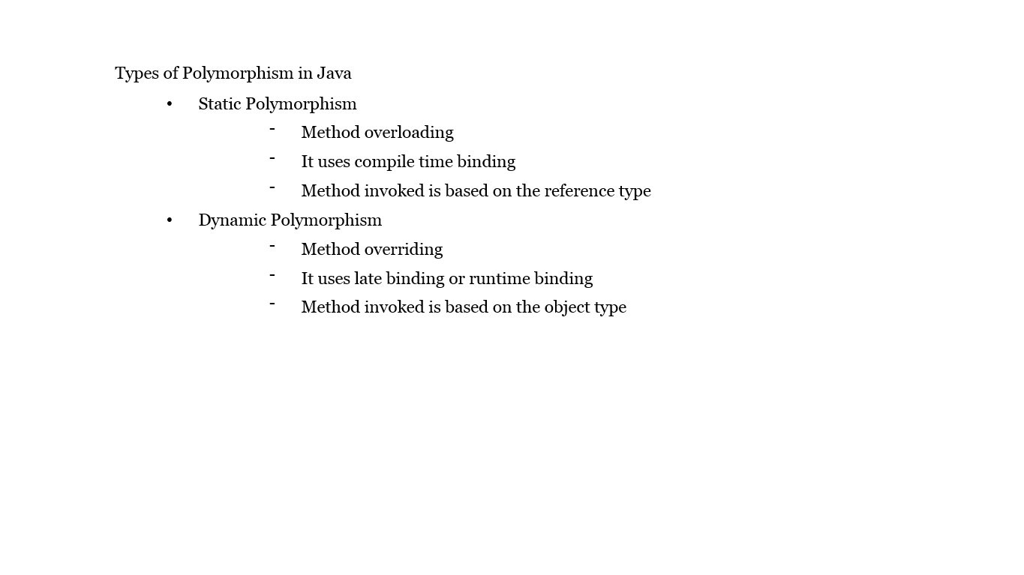

**Method Overloading**

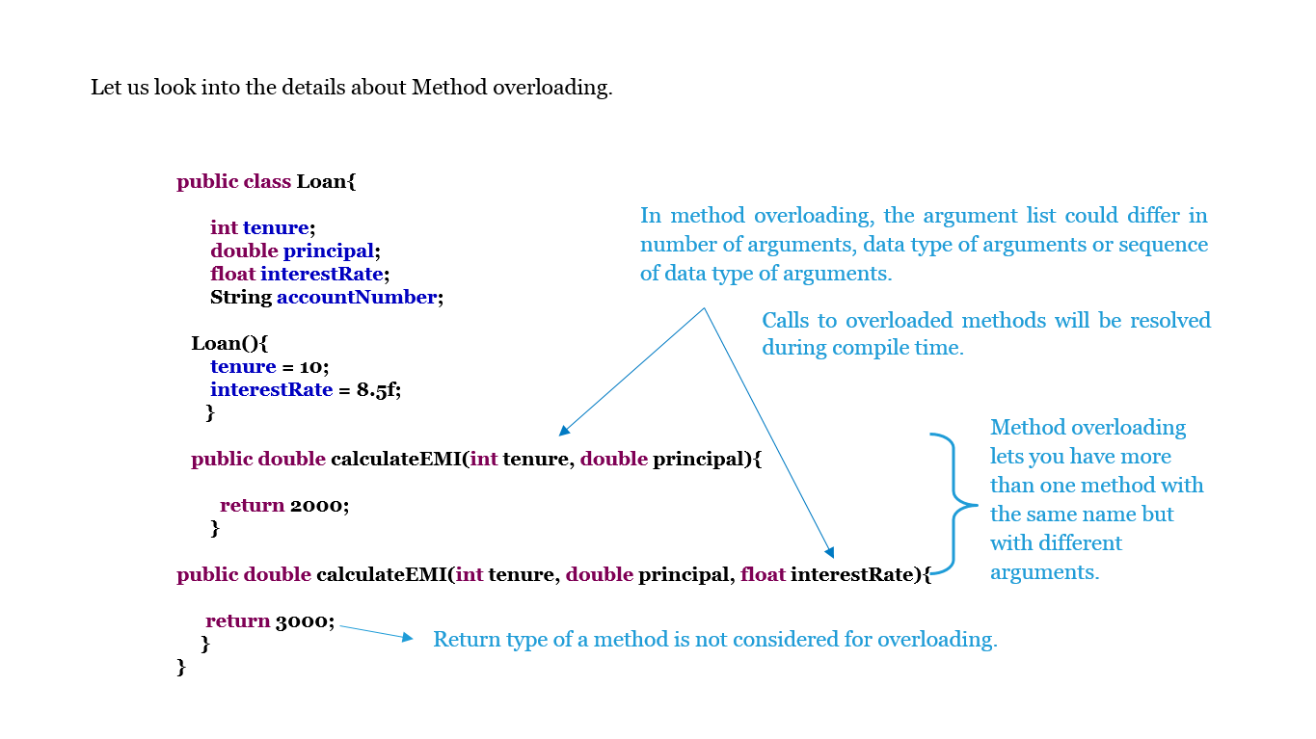

**Constructor Overloading**

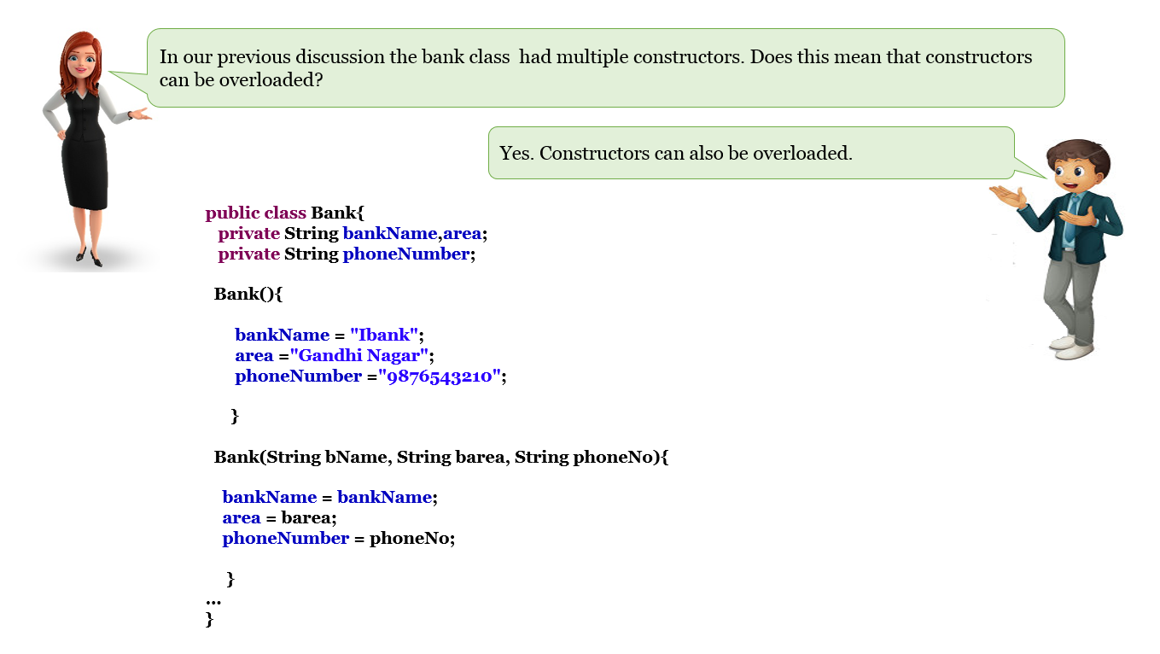

**Eg:**

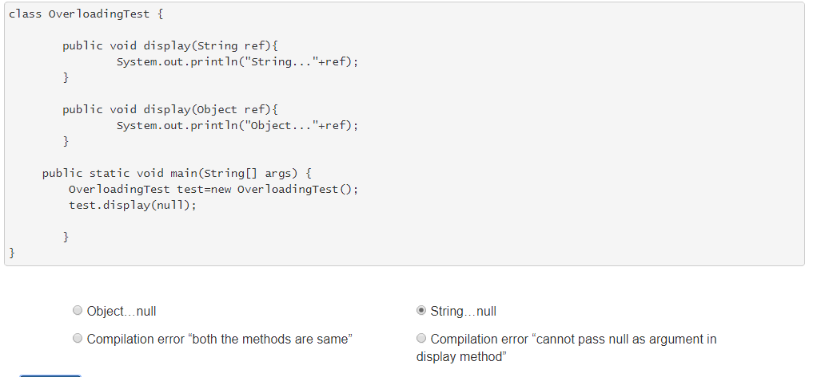

**Method Overriding**

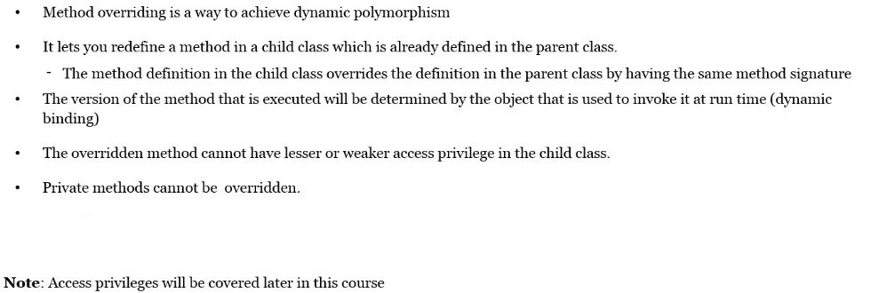

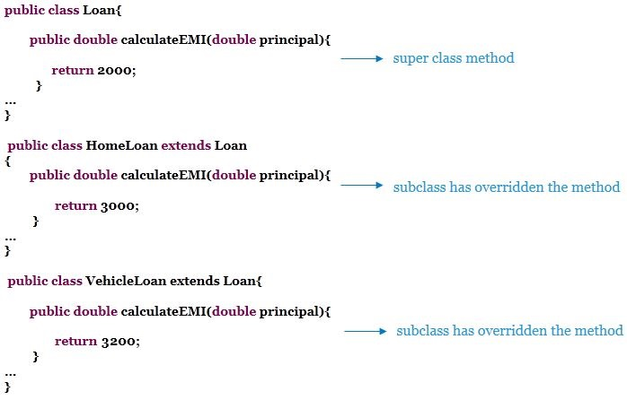

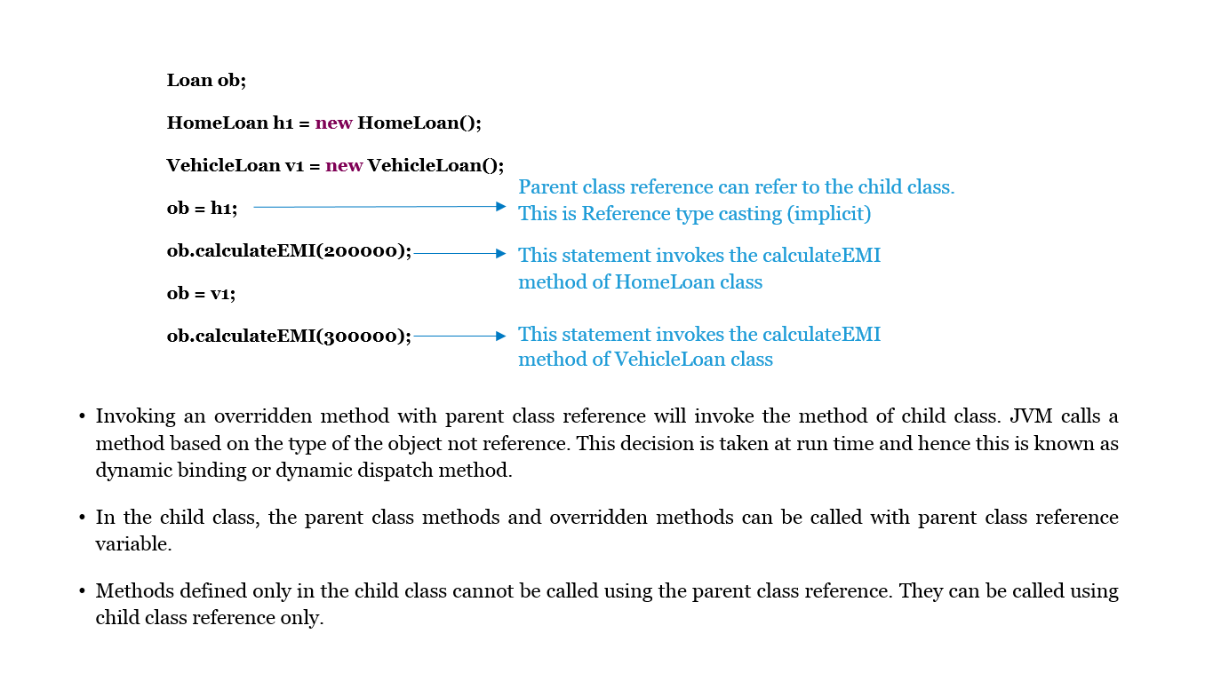

**Introduction to super Keyword**

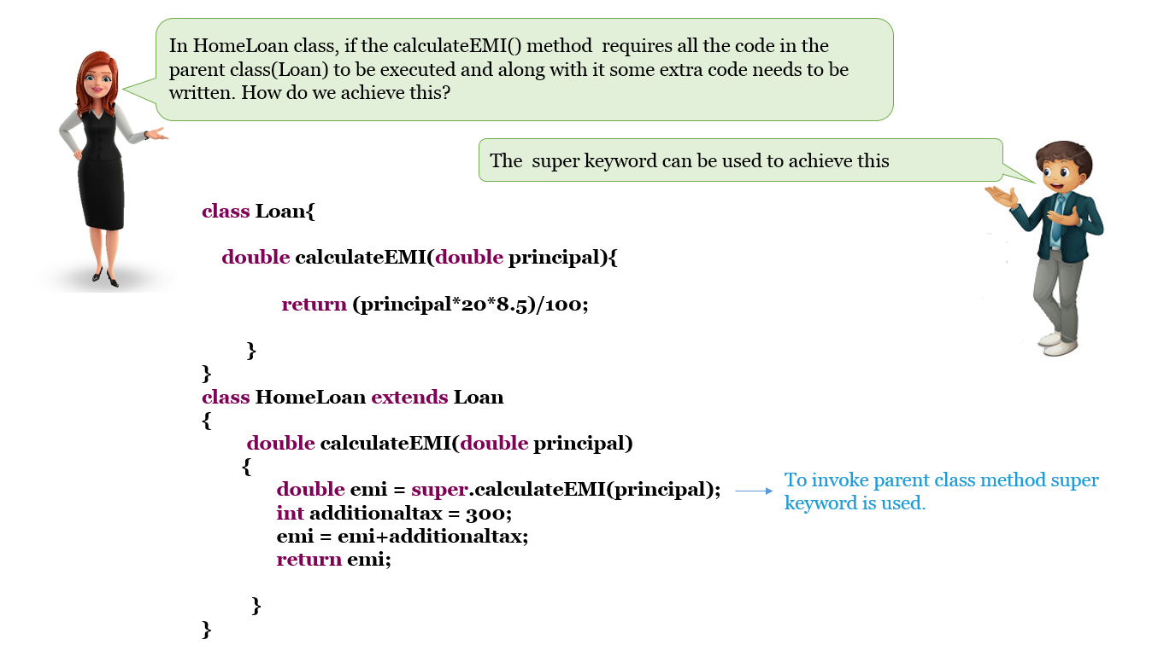

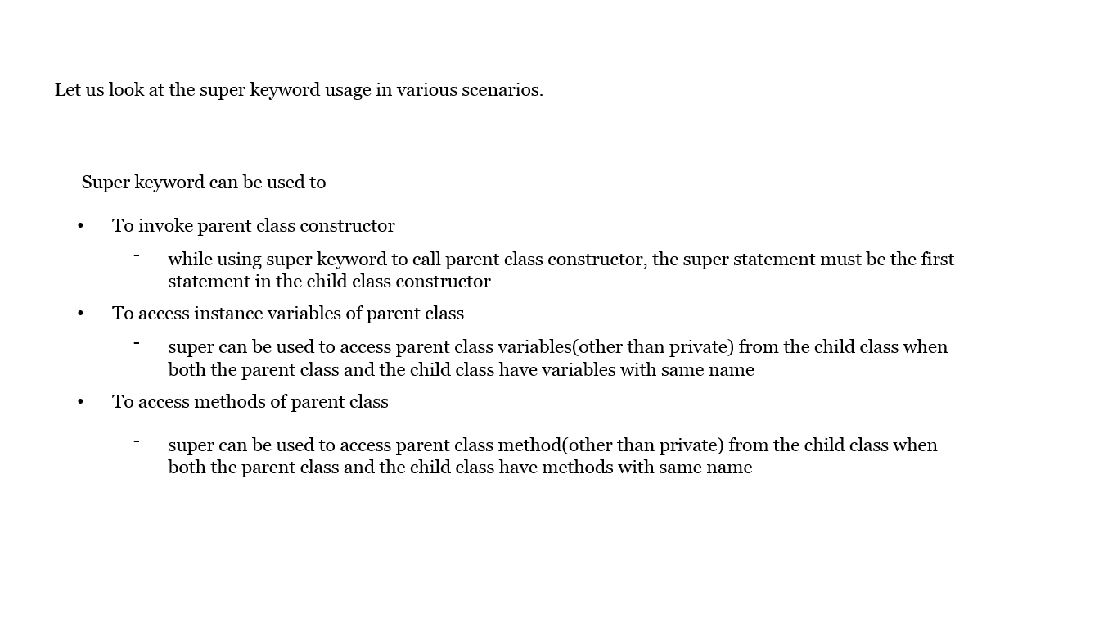

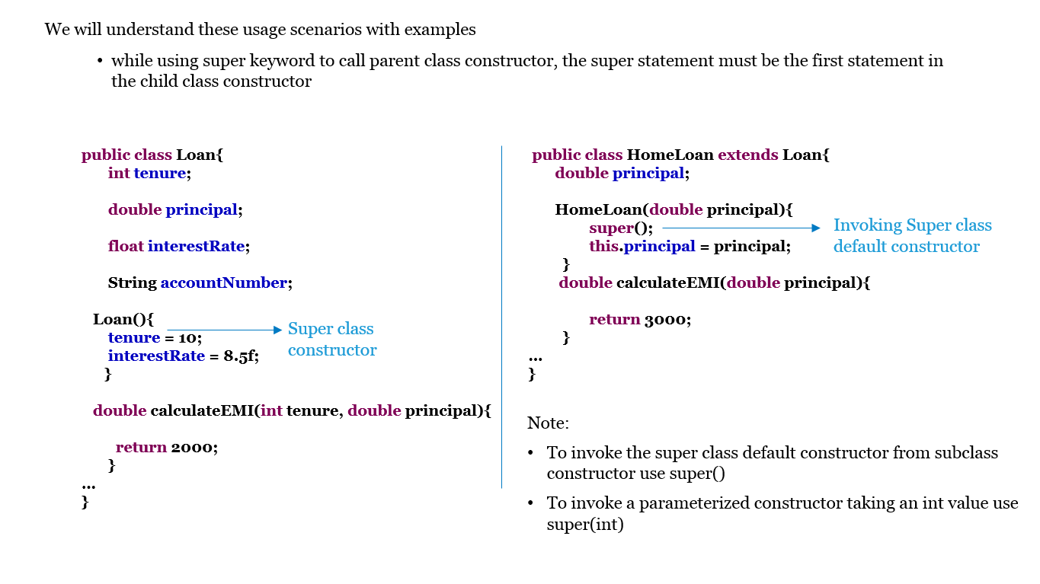

**Eg:**

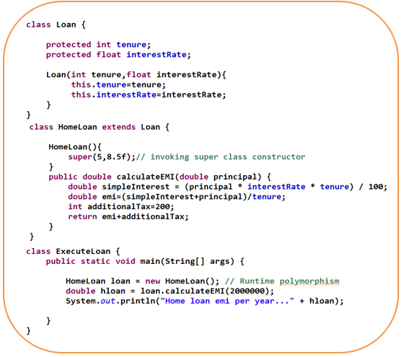

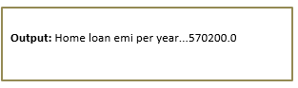

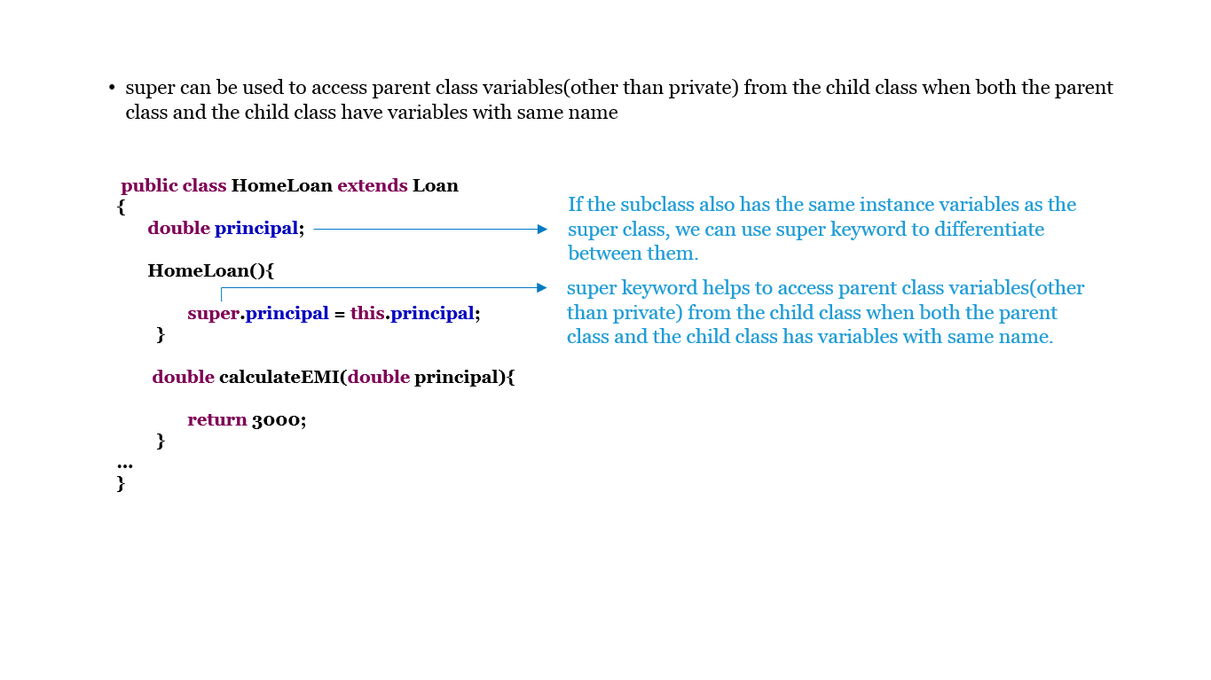

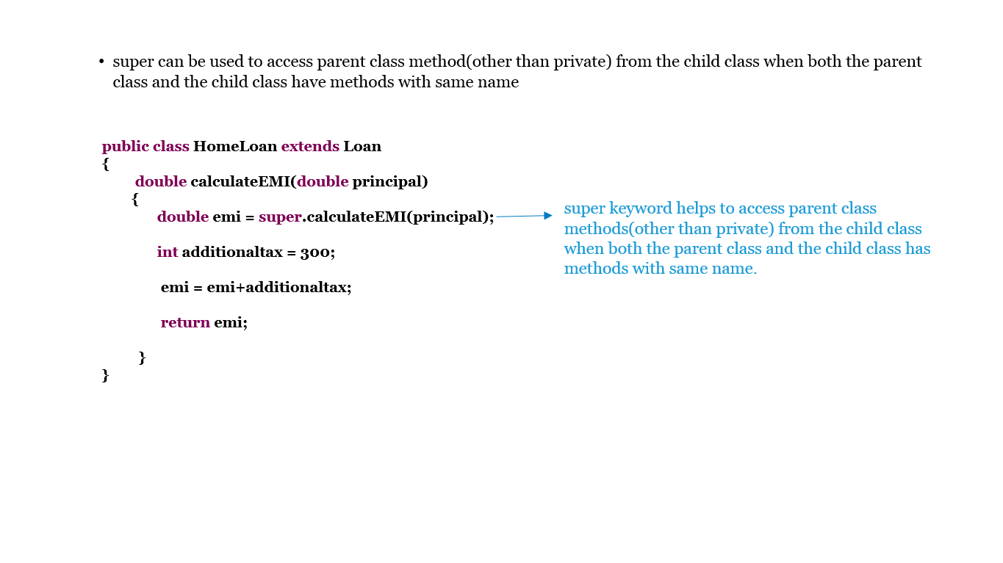

**Eg:**

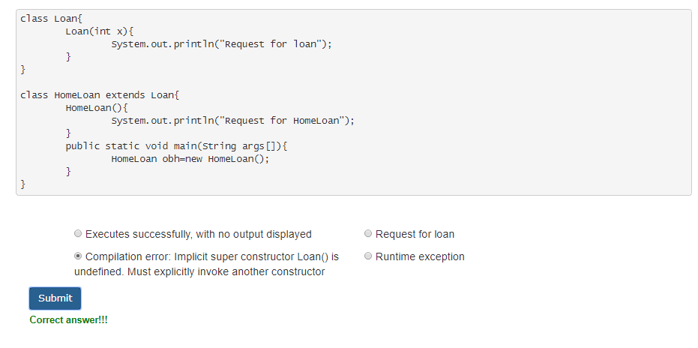

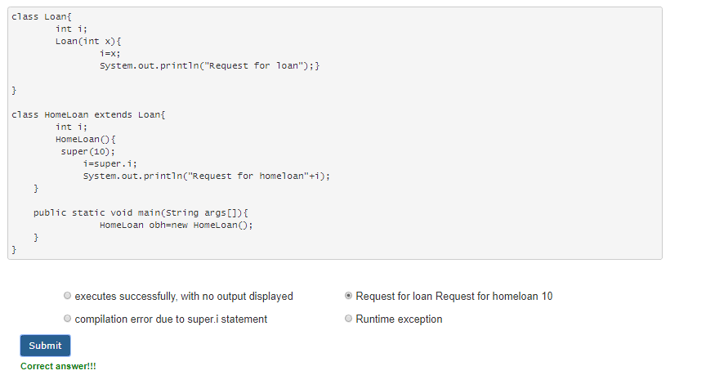

**final Keyword**

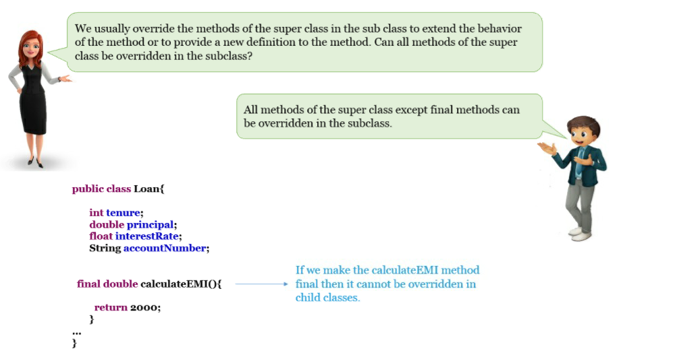

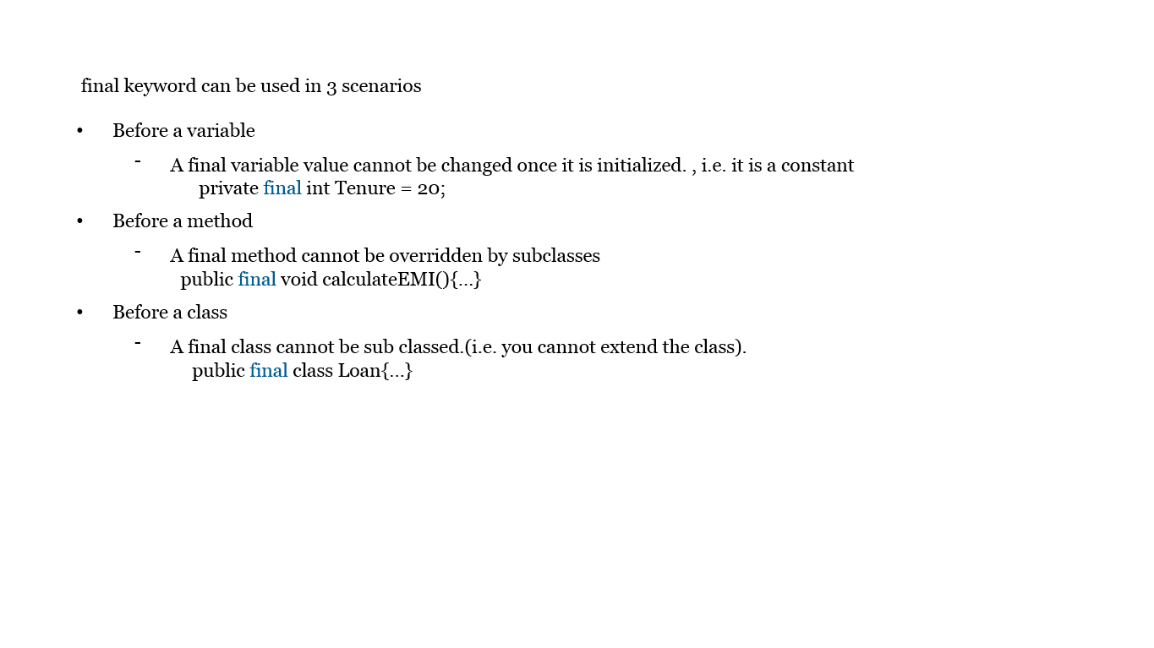

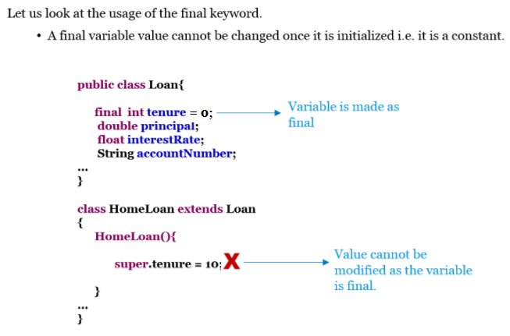

**Eg:**

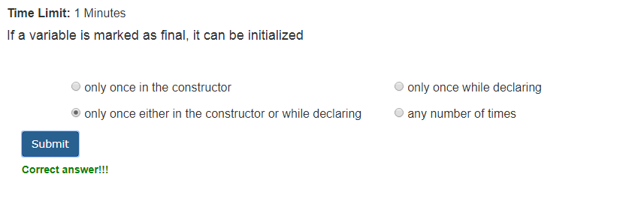

**static Variables**

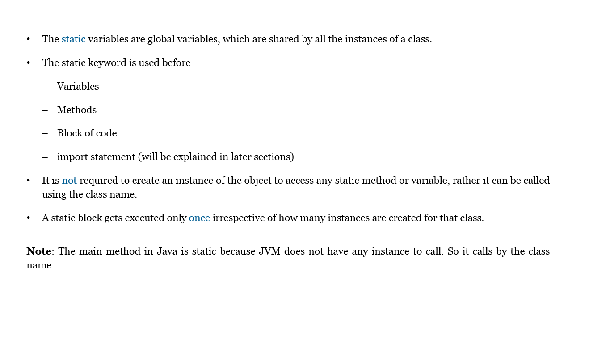

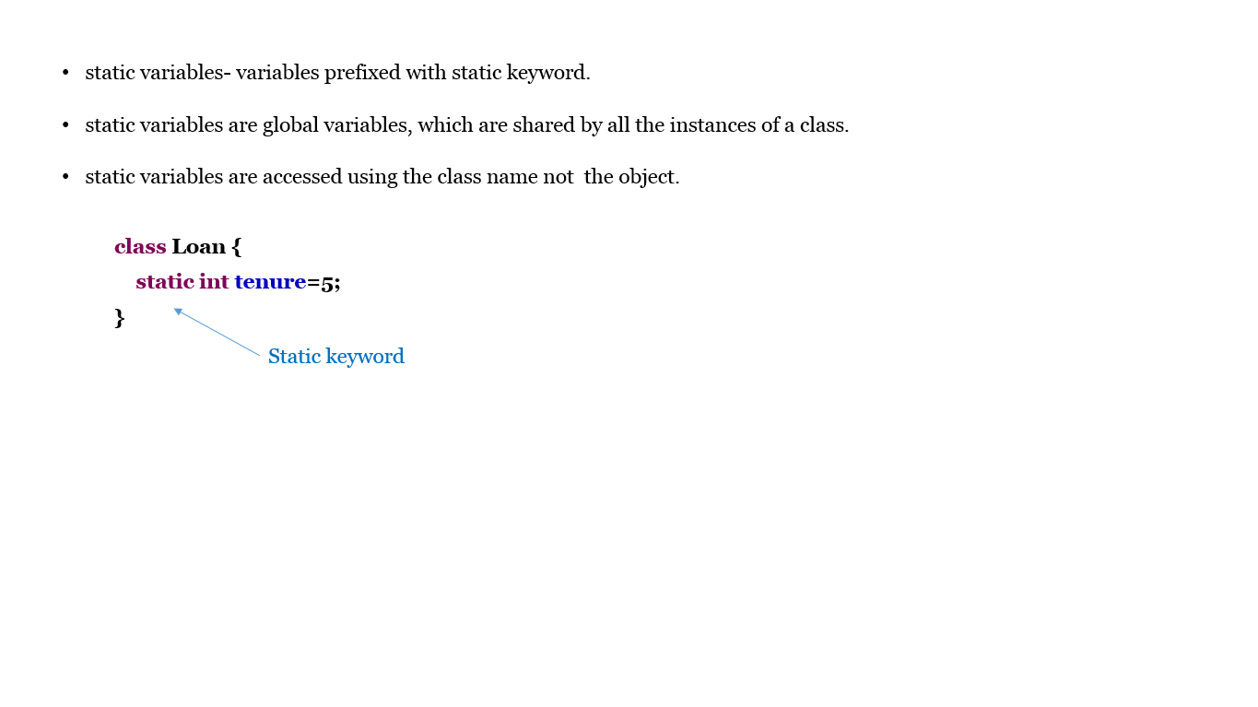

**static Methods**

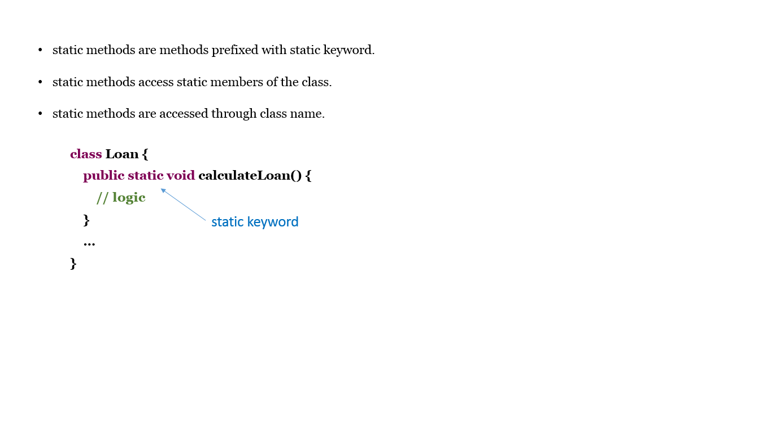

**static Blocks**

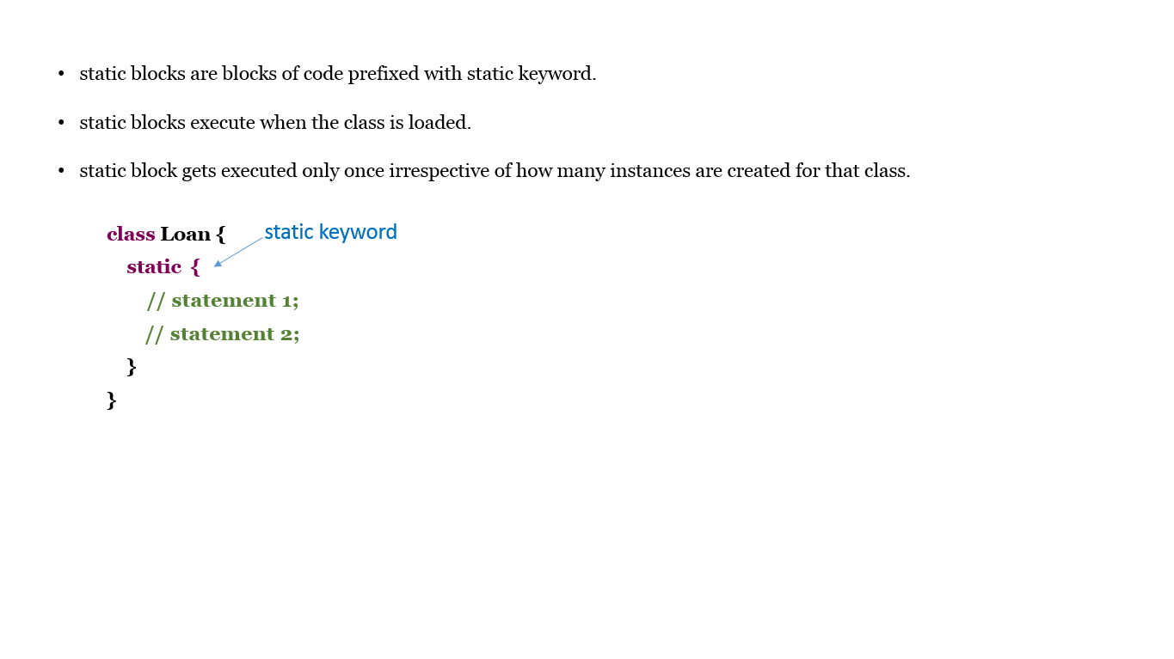

**static Modifier-Example**

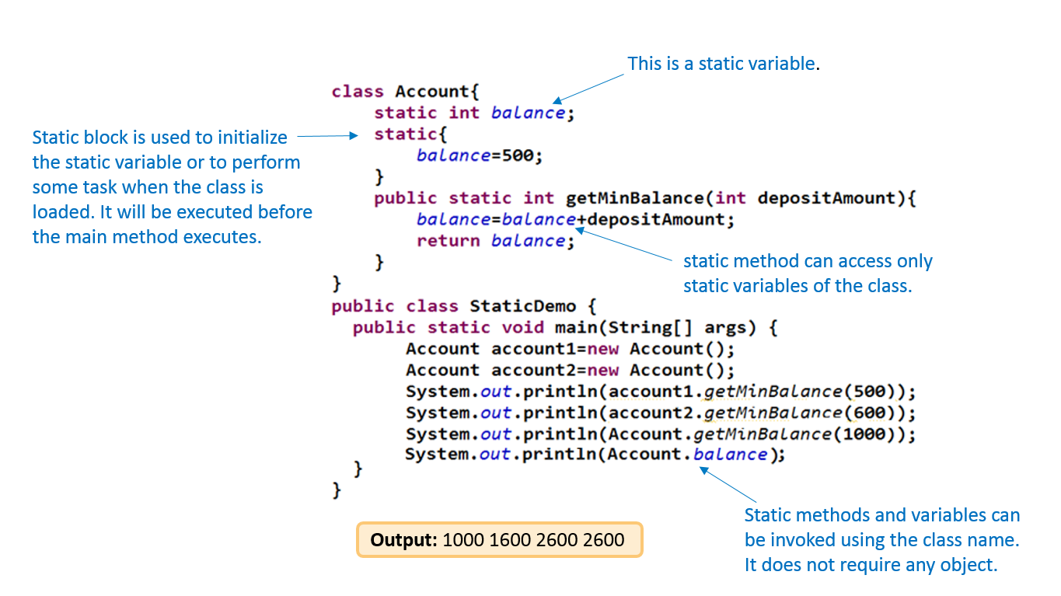

**Variable Arguments**

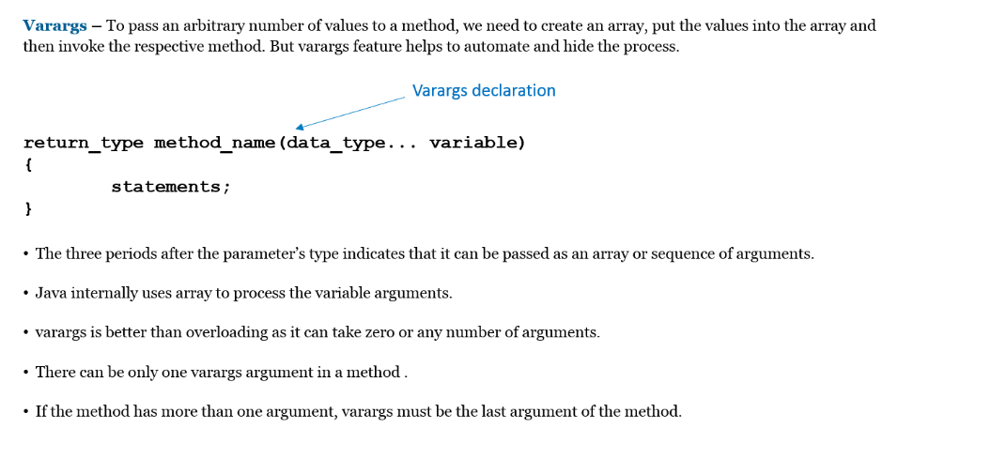

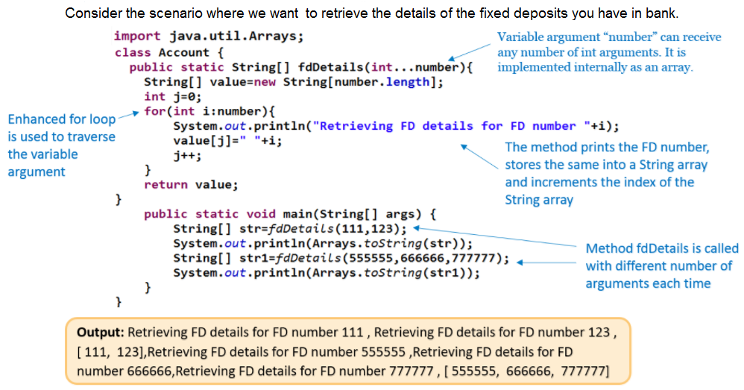

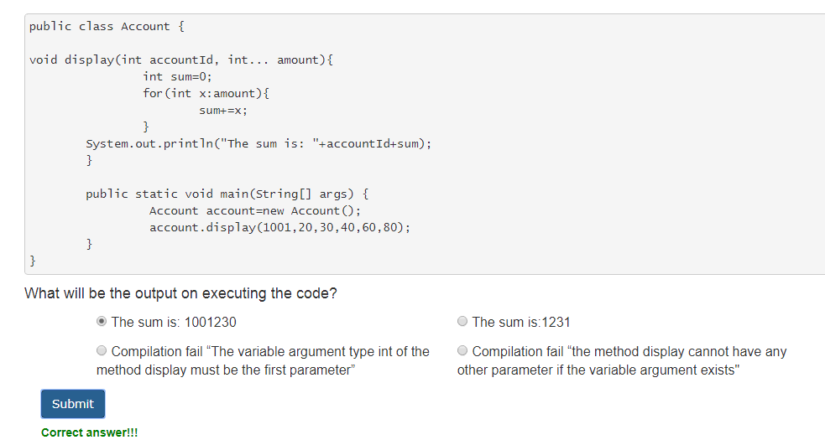

**Enumerated Data Types**

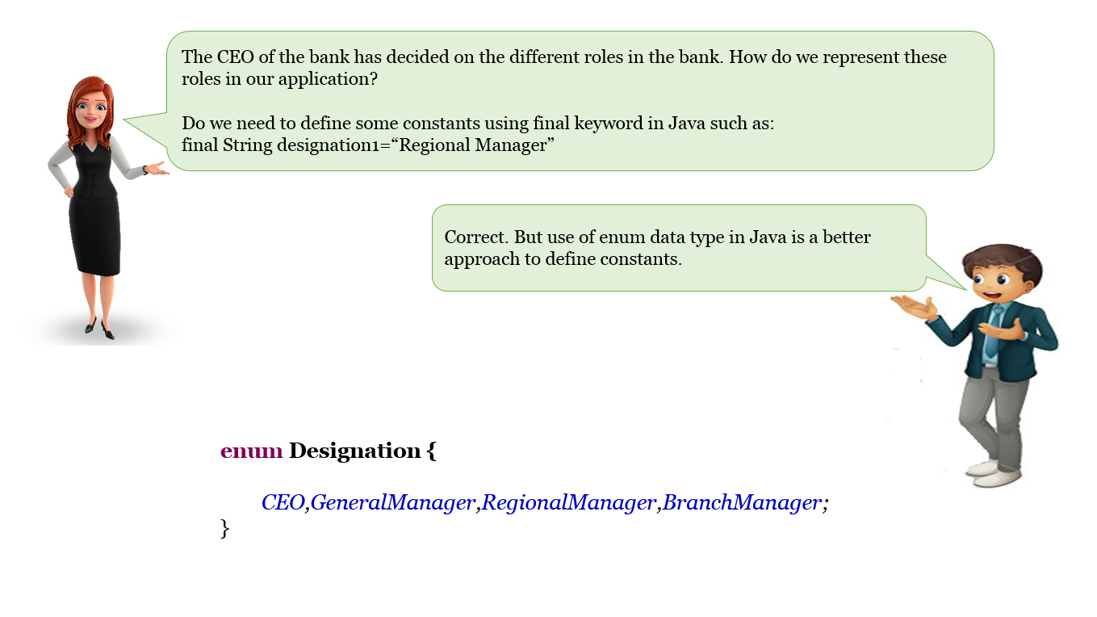

* An enum is a data type which contains fixed set of constants.
* The enum constants are static and final implicitly.
* All enums implicitly extend java.lang.Enum class
* enums in Java are considered to be reference types, like class or interface and thus, a programmer can define constructor, methods and variables in an enum

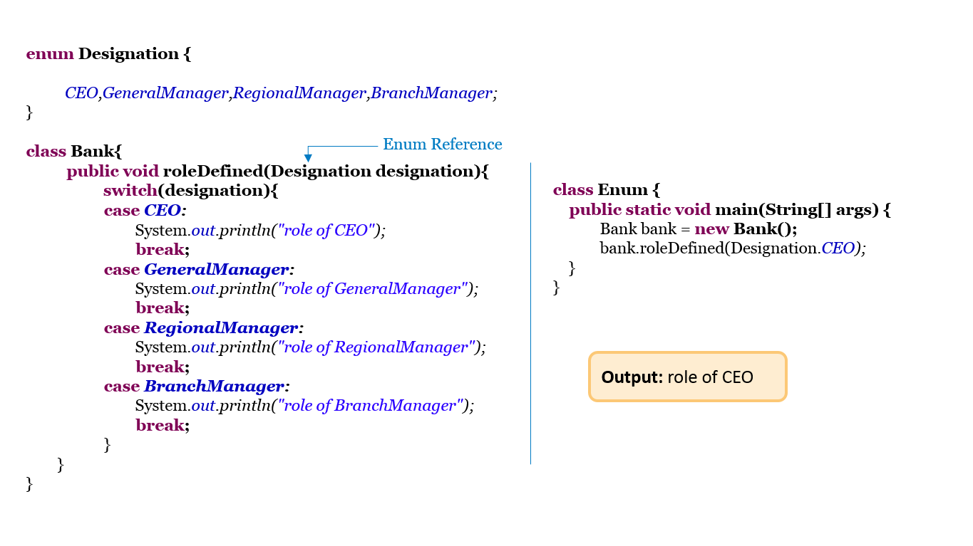

**Abstract Class**

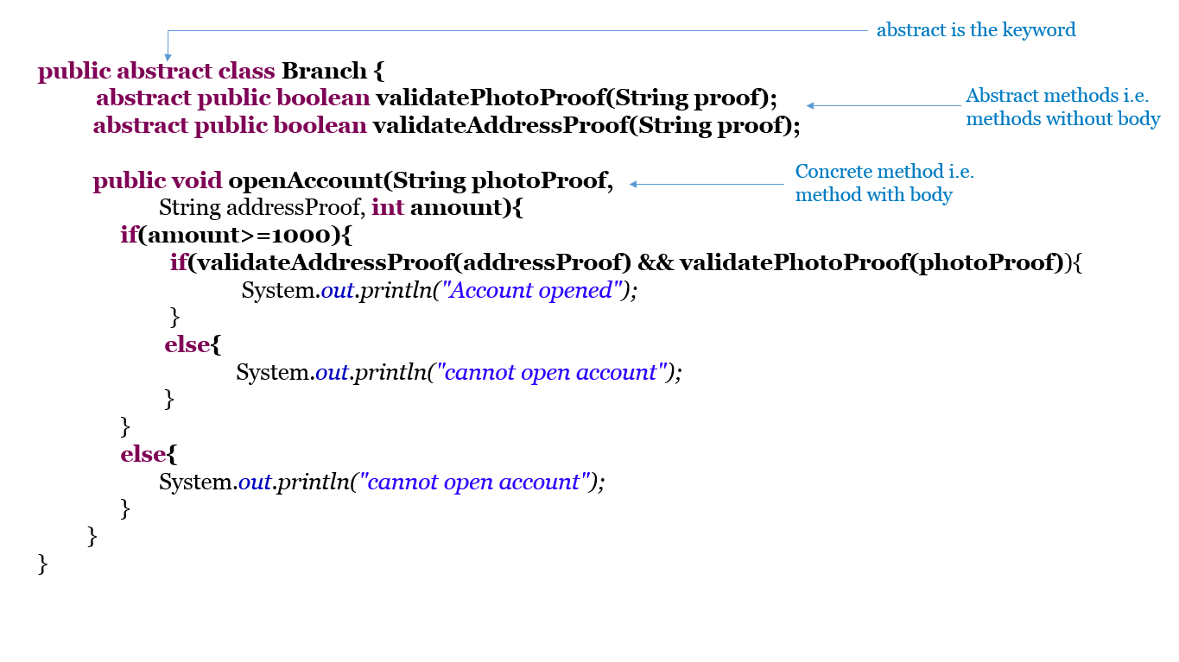

* An abstract class cannot be instantiated i.e. new keyword is not allowed.
* The subclass of an abstract class should override and provide implementation for all the abstract methods if it needs to be instantiated.
* If a class has abstract methods, the class must be an abstract class.
* If the subclass does not implement all the abstract methods then the subclass must also be declared as abstract.
* An abstract class may also have concrete methods i.e. methods with implementation.
* An abstract class reference can be assigned an object of its subclass, thereby achieving run-time polymorphism.

**Best Practices:**

Use abstract classes whenever you want to share code among several closely related classes

Use abstract classes when you want to declare non-static or non-final fields. This enables you to define methods that can access and modify the state of the object to which they belong

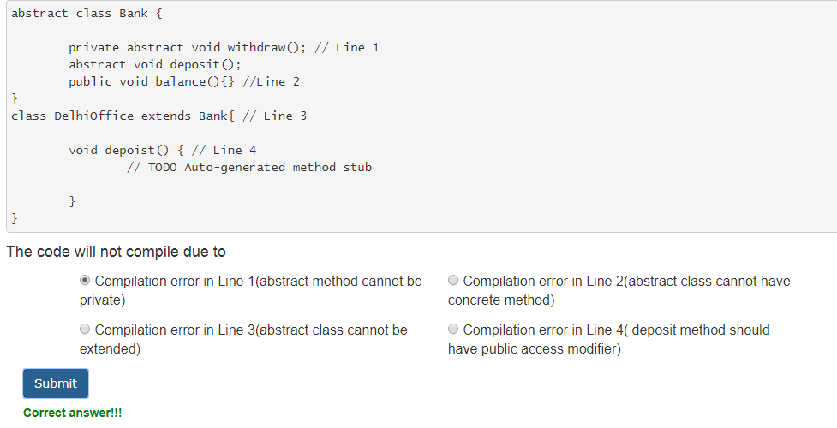

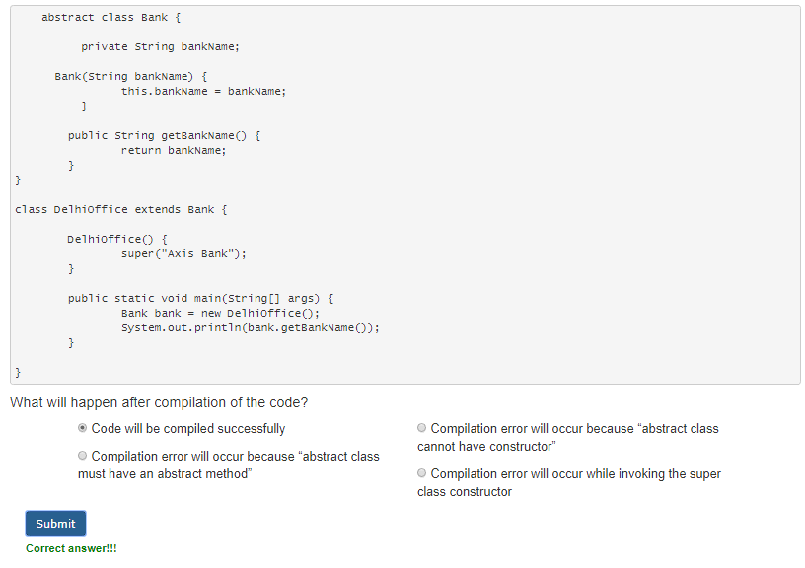

**Interface**

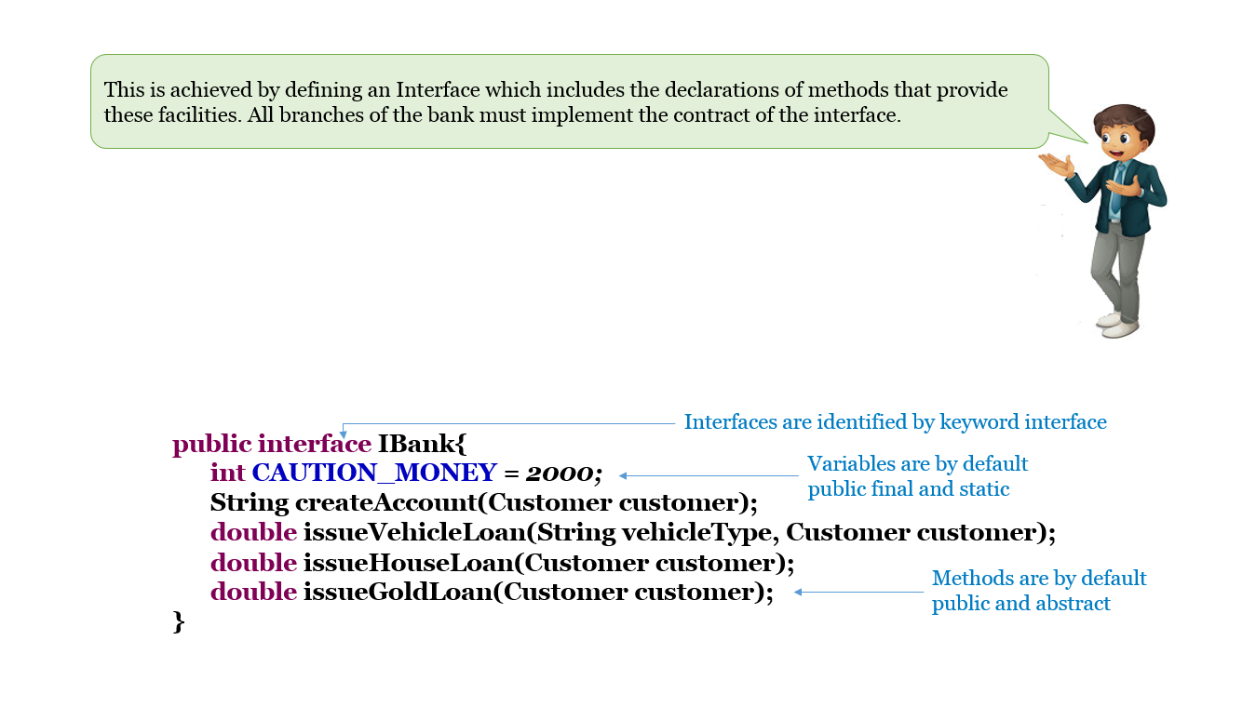

* An interface defines a contract for a class.
* An interface cannot be instantiated i.e. new keyword cannot be used. It cannot have private or protected members.
* All methods in an interface are implicitly public and abstract and variables are implicitly public, static and final
* The class which implements the interface needs to override all the abstract methods and provide implementations for them.
* If any of the abstract methods in interface is not overridden by the class that implements the interface then the class needs to be declared as abstract.
* Inheritance is possible in interface and it supports multiple inheritance.

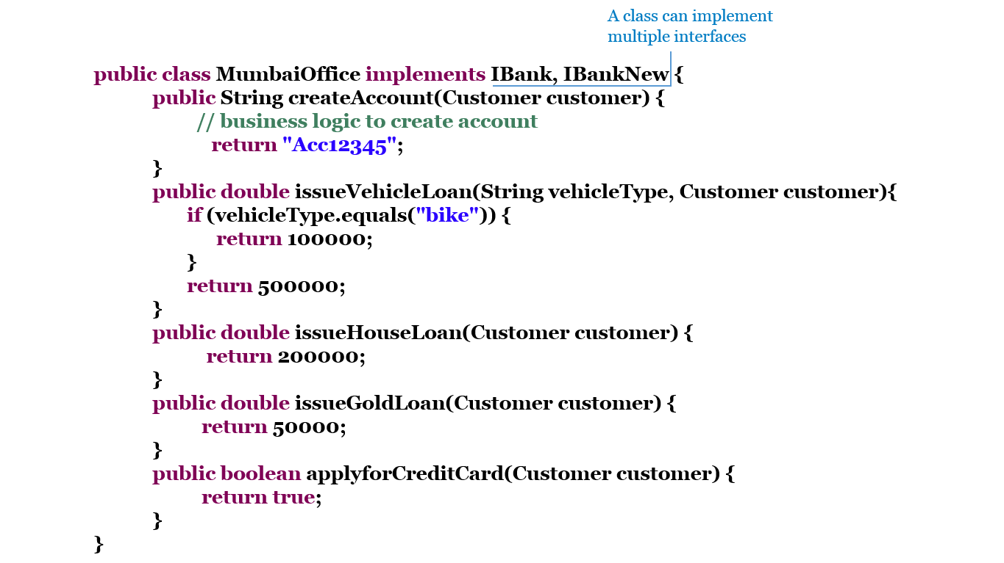

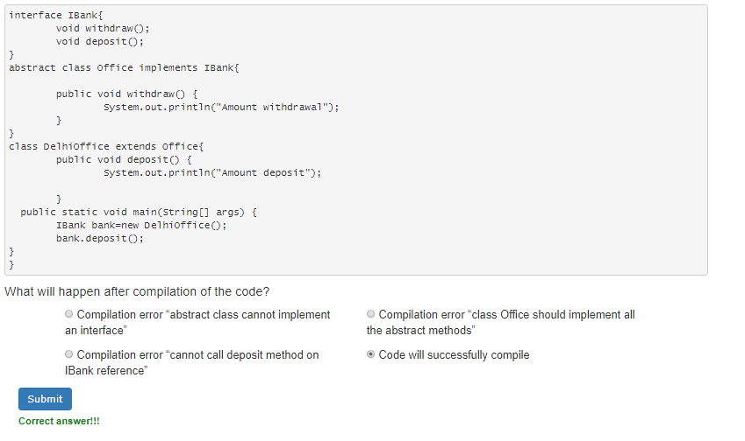

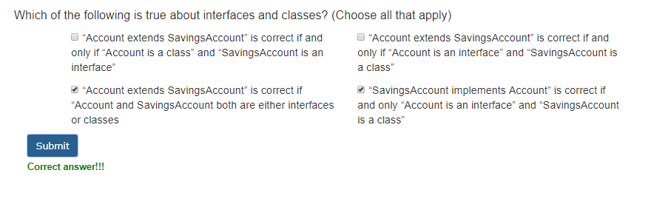

**Package**

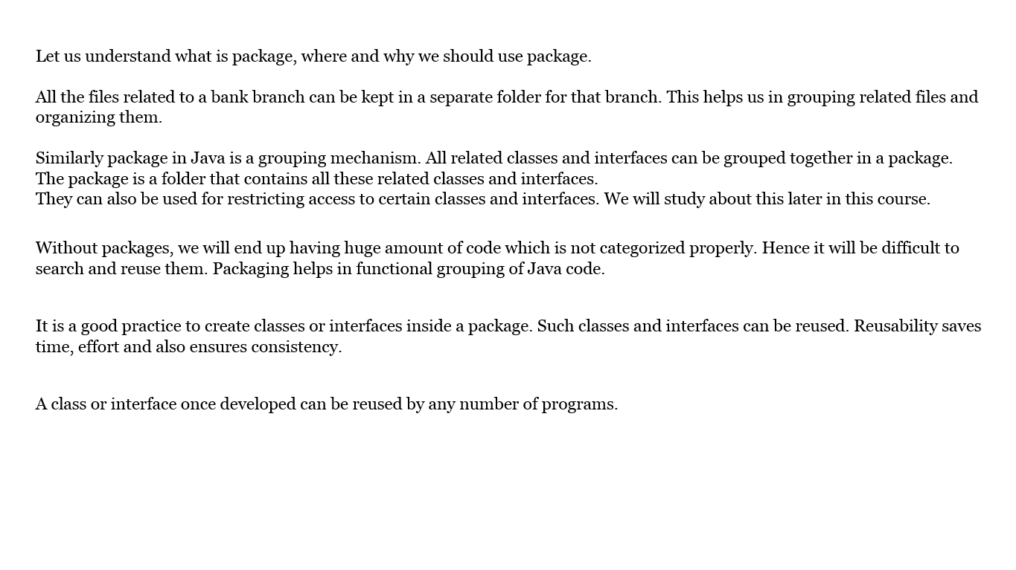

Best Practices:

* The name of package should start with a lowercase letter without spaces in between the name
* Break down your packages according to their functionality or modules. e.g. com.company.product.modules
* Create classes and interfaces inside a package so that it can be reused by saving our time effort and also ensures consistency
* Do not use the import statement with the asterisk (*) to import all classes in a package, but import specifically like for example import java.util.Scanner

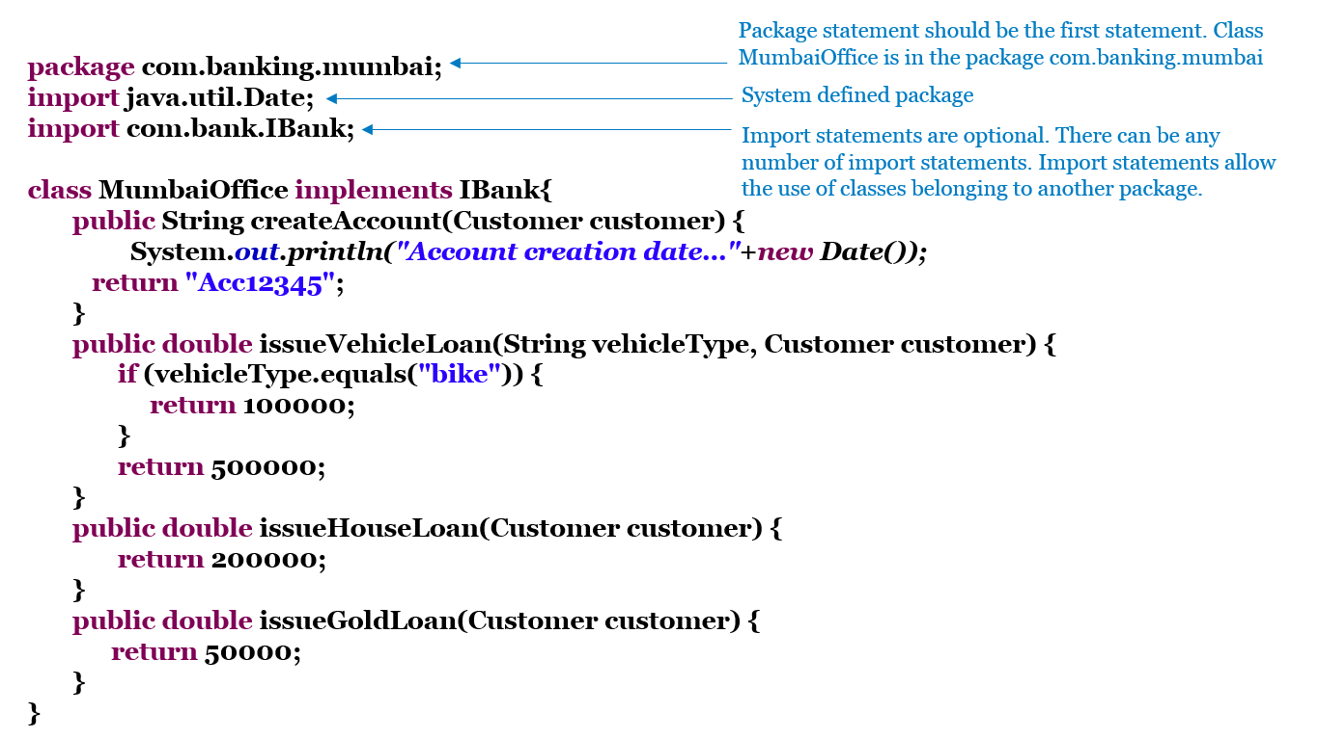

**Standard Java Packages**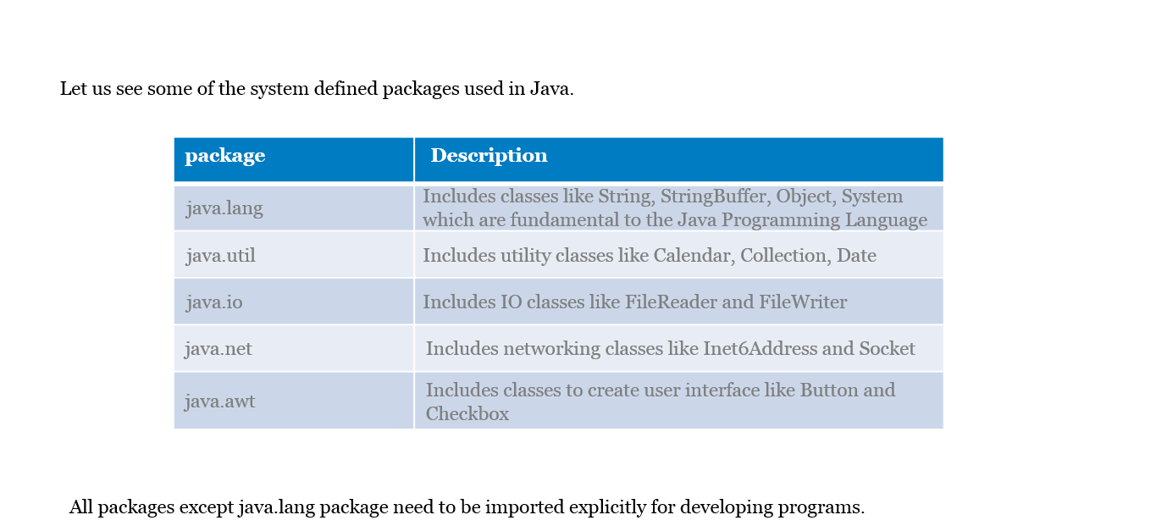

**Introduction: Access Modifiers**

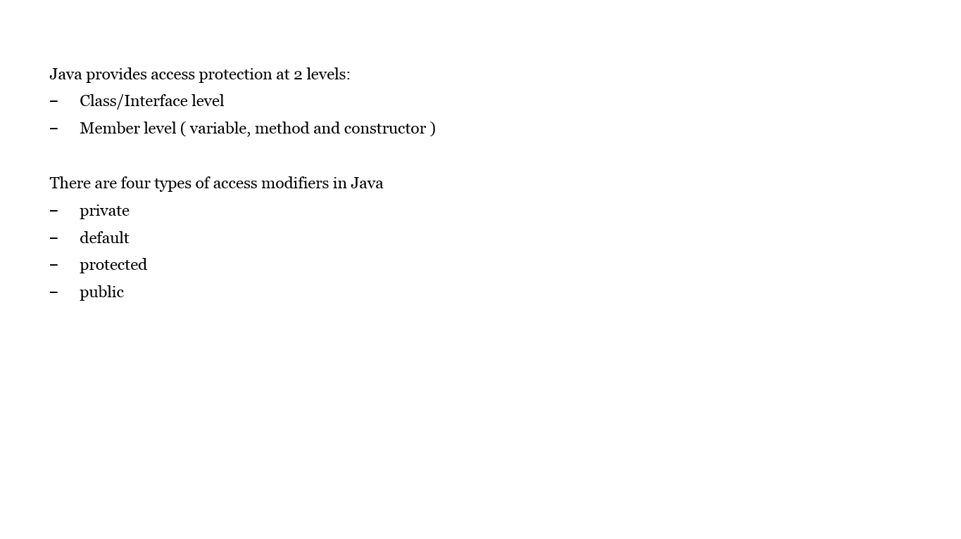

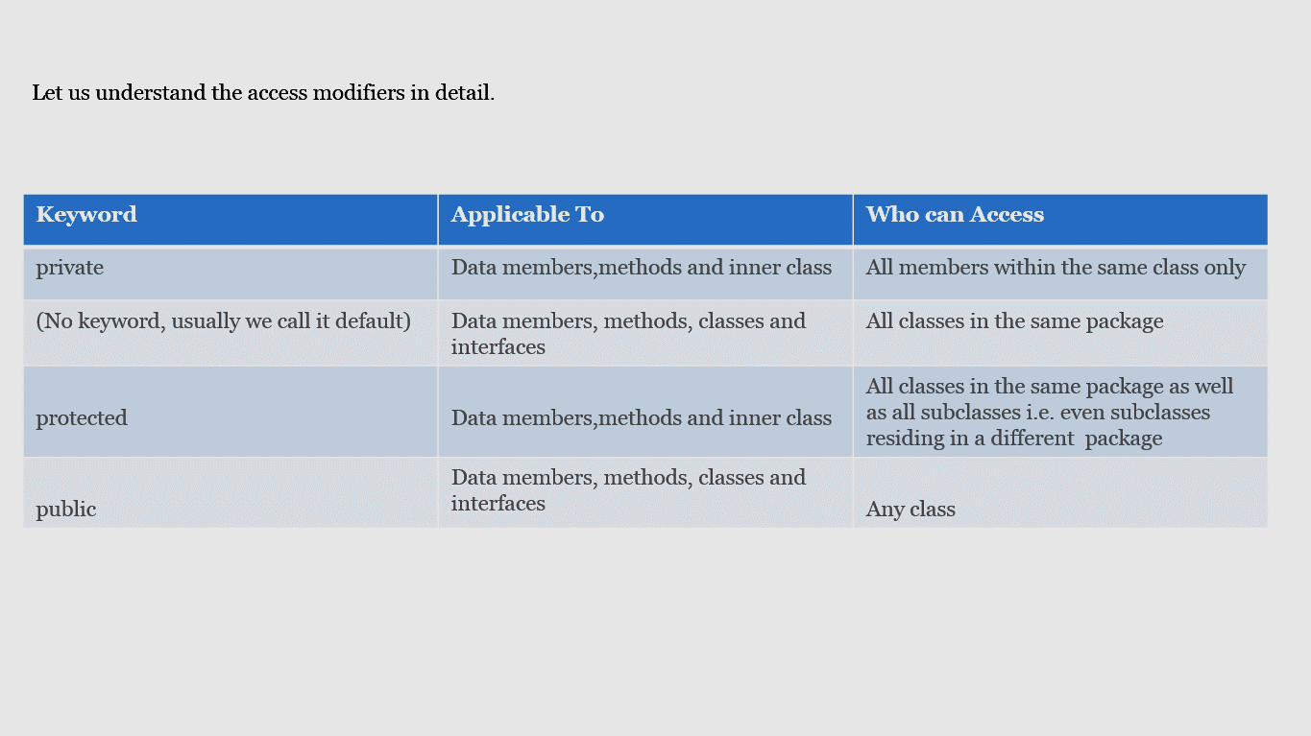

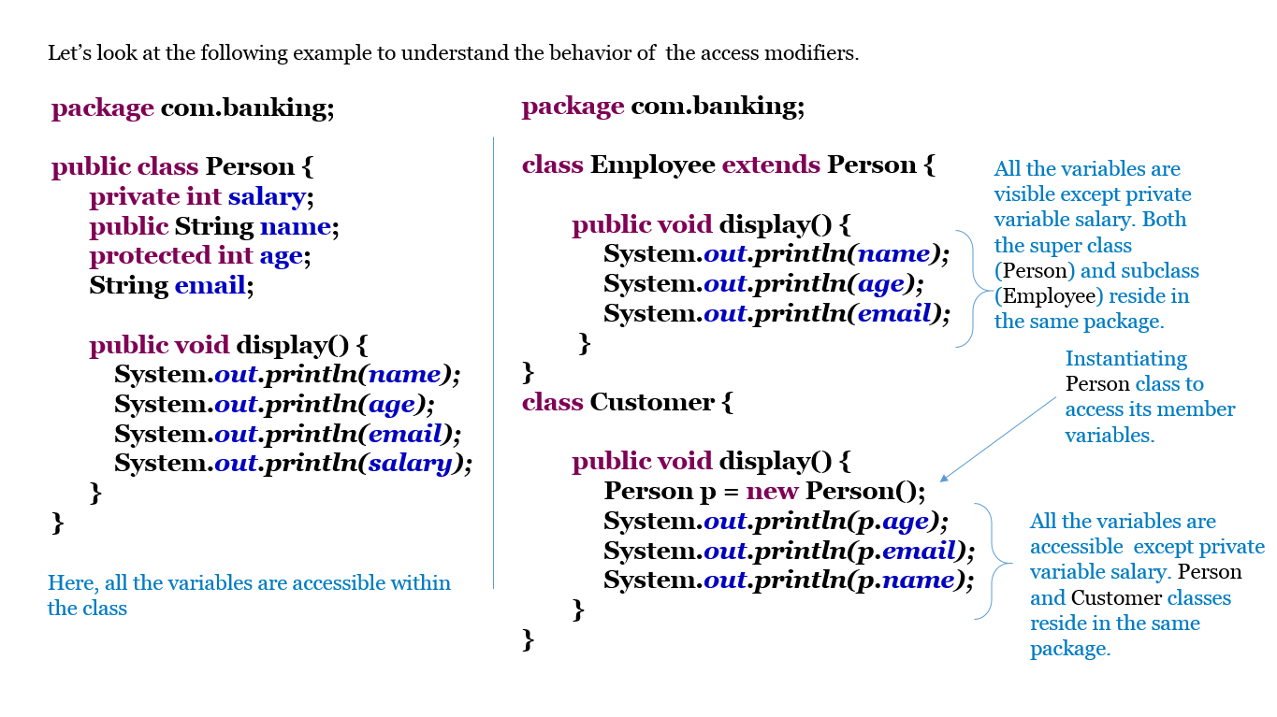

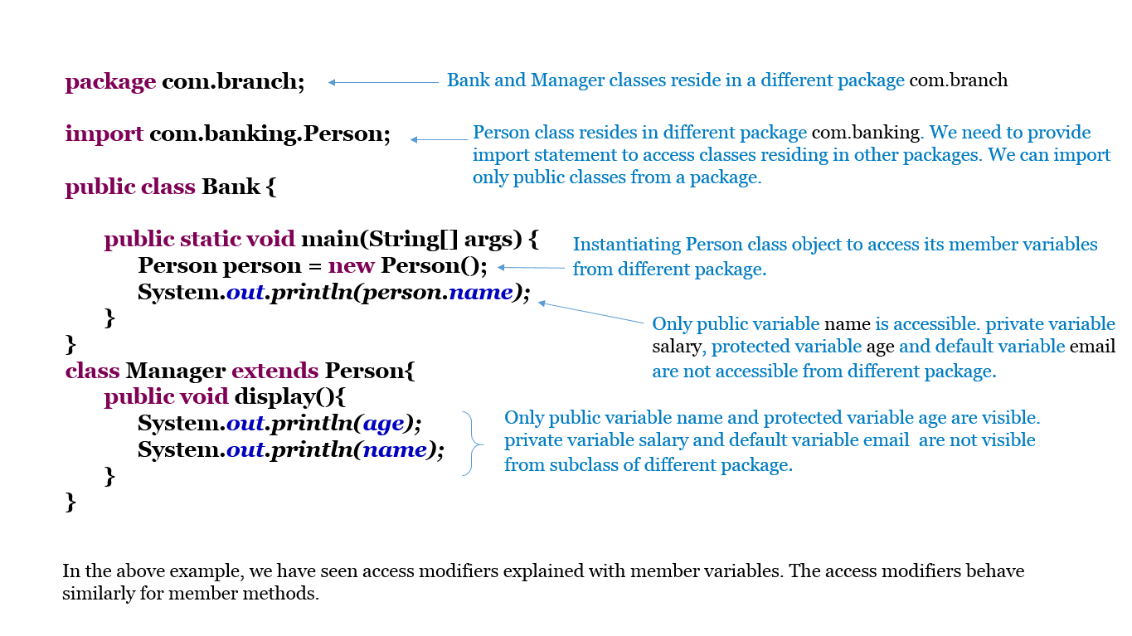

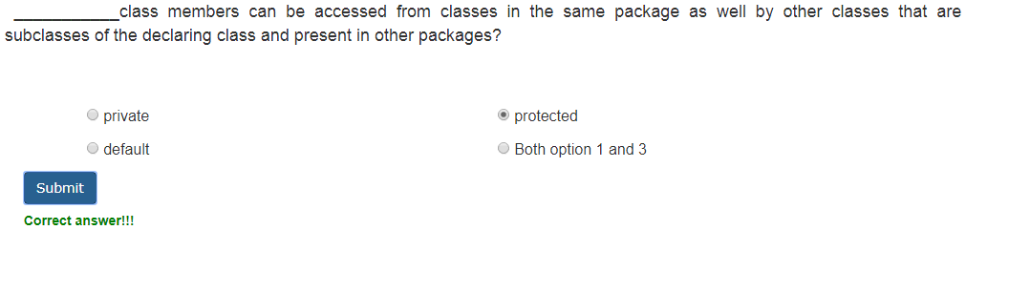

**Inner Class**

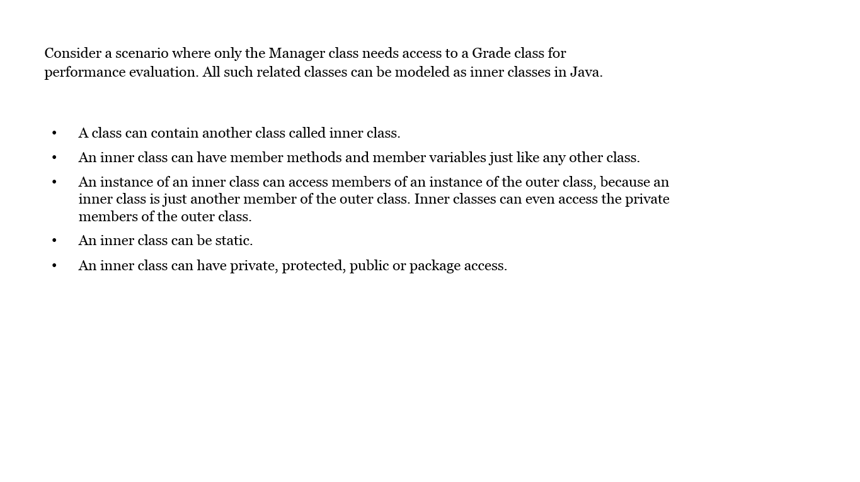

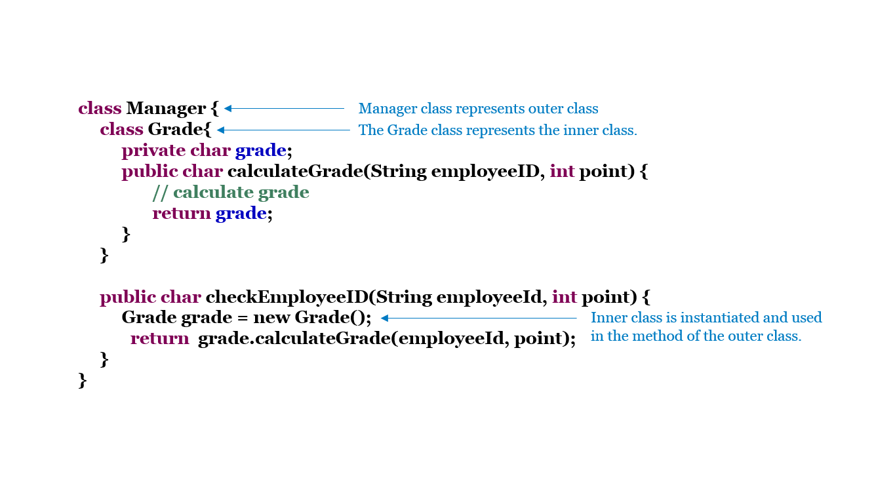 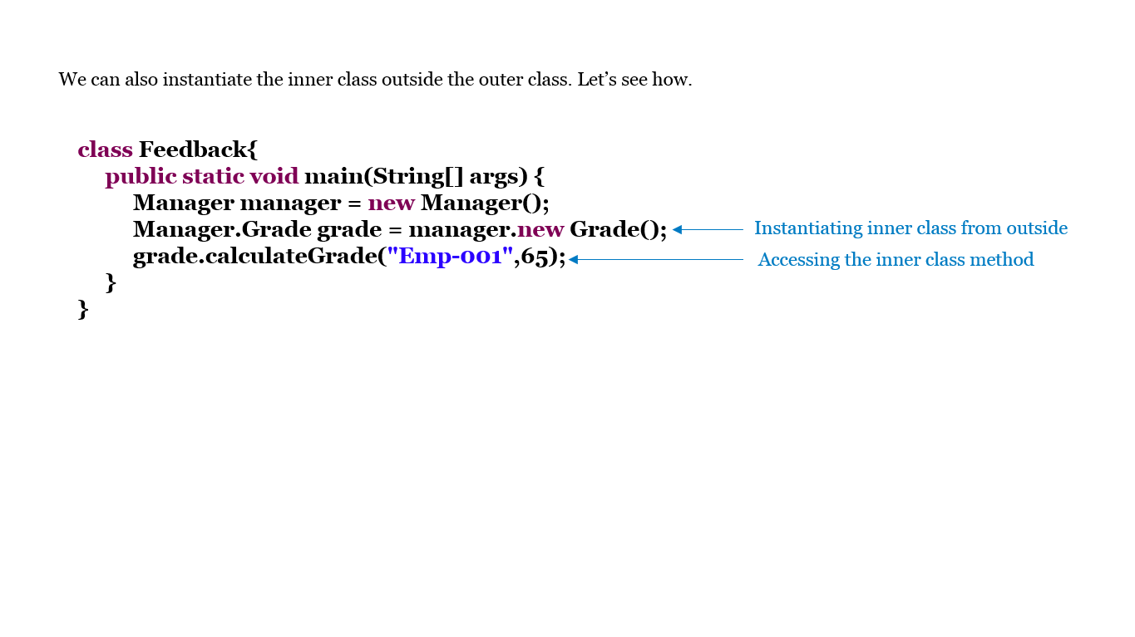

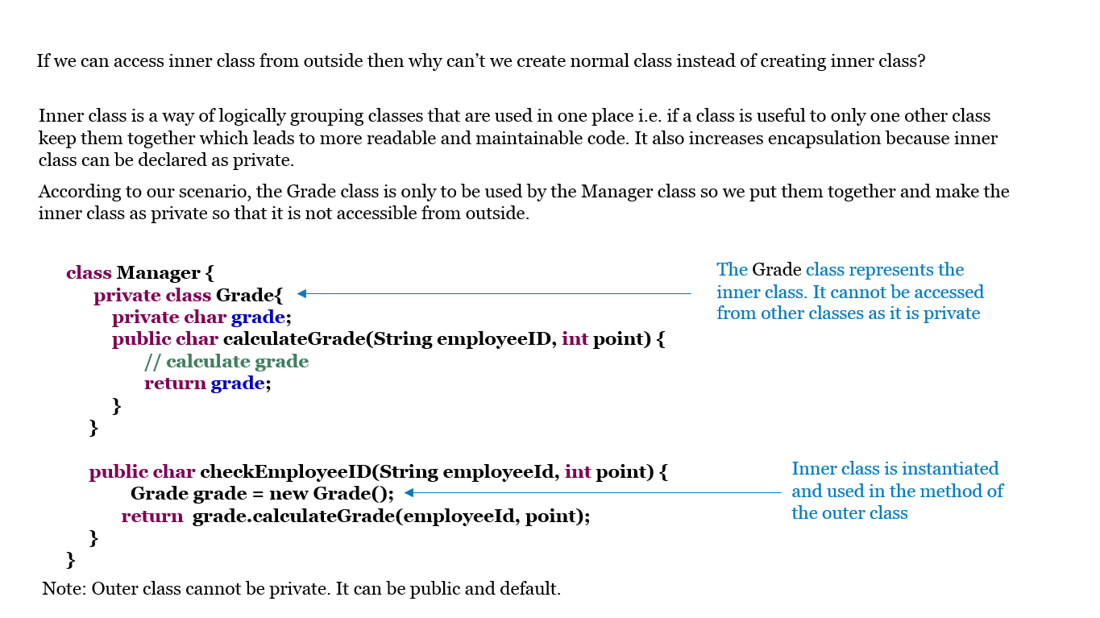

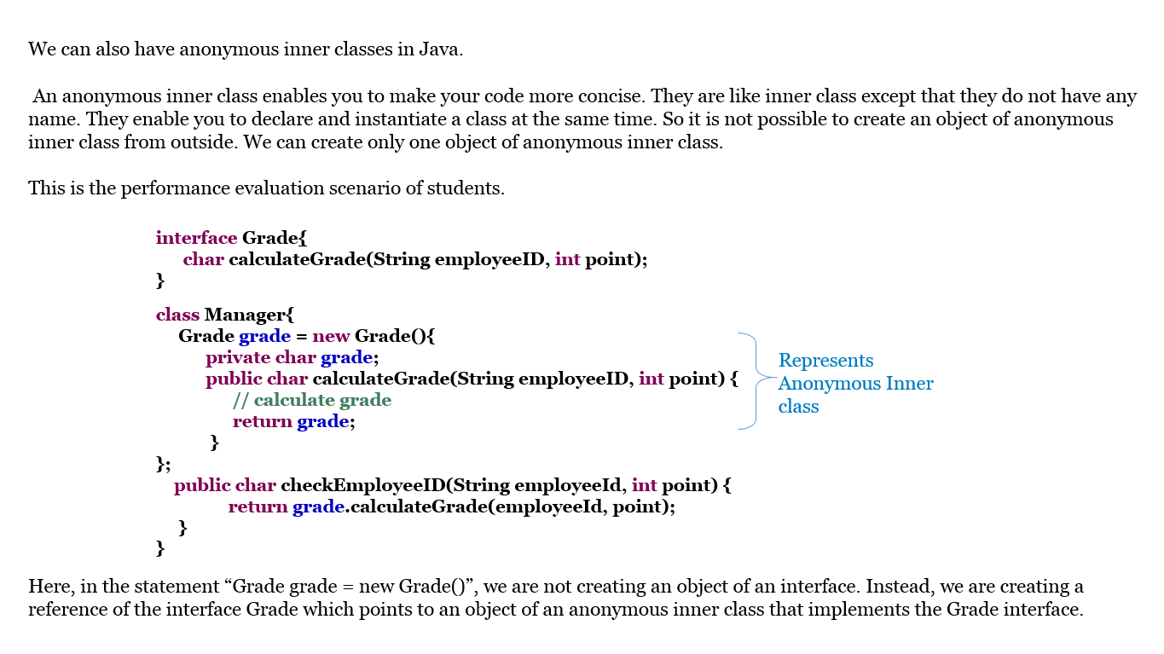

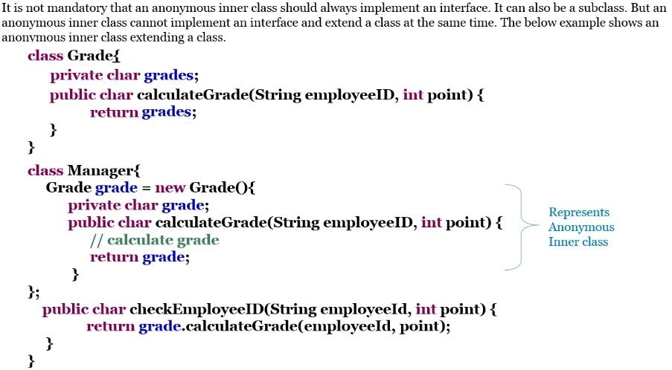

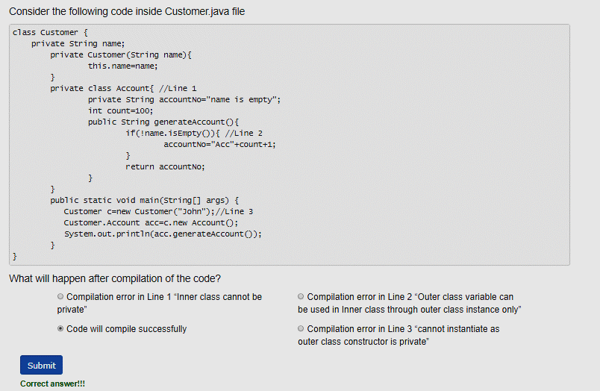

**Java Libraries**

* You may have come across many challenges while developing an application. For each and every functionality you need to create code from scratch like comparing two character arrays, finding the length of an array, working with dates and many more.
* But Java comes with a rich set of API ( Application programming interface). API is a set of all classes that are part of the JDK. It includes all Java packages, classes and interfaces. These prewritten classes provide tremendous support to a programmer while developing an application.

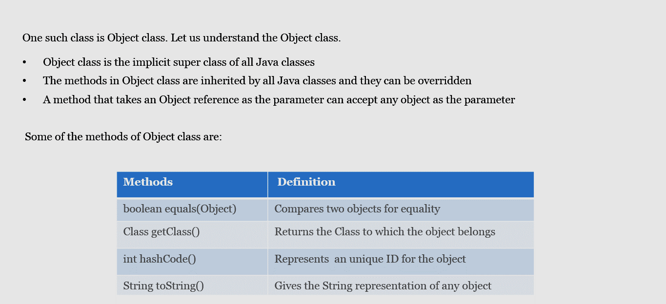

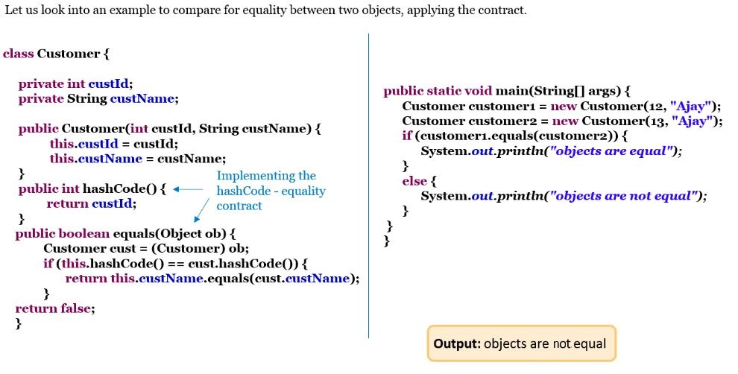

**Wrapper class**

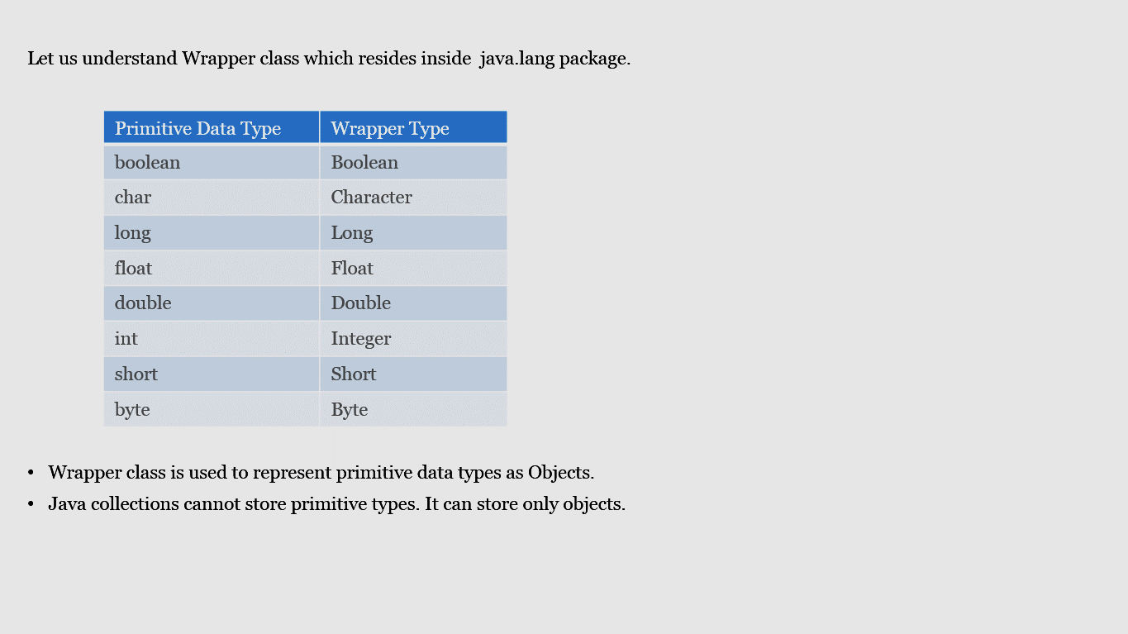

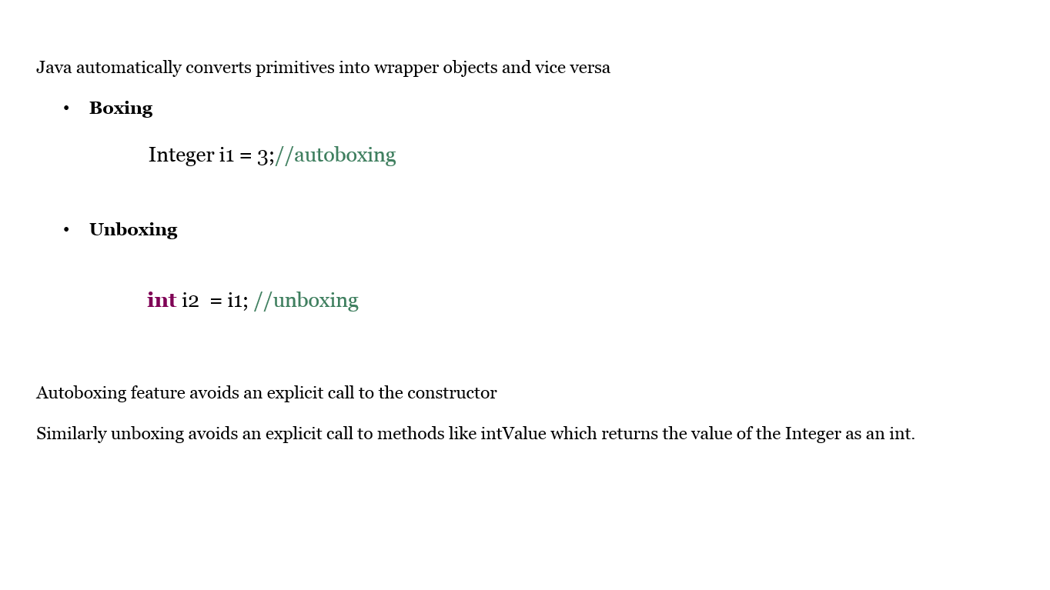

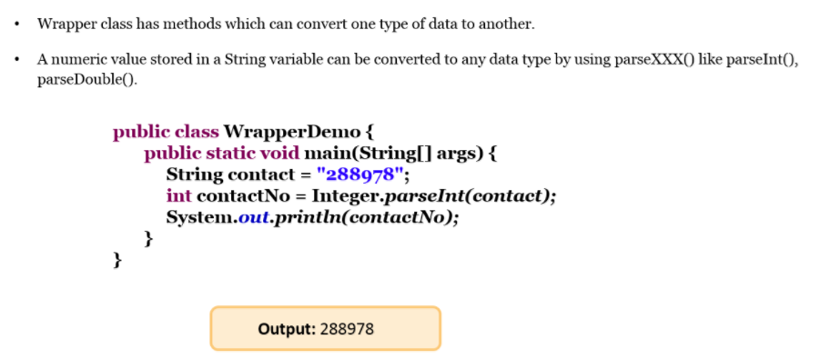

Best Practices:

* Primitive types are faster than wrapper classes and they can be used to prevent runtime exceptions since they are not nullable
* As Wrappers are classes, they are less efficient than a primitive that stores only a single value
* Whenever possible use primitive types since they are much efficient than Wrapper classes
* Comparing Wrappers using == is wrong because it compares the reference value and not the value represented by the Wrappers

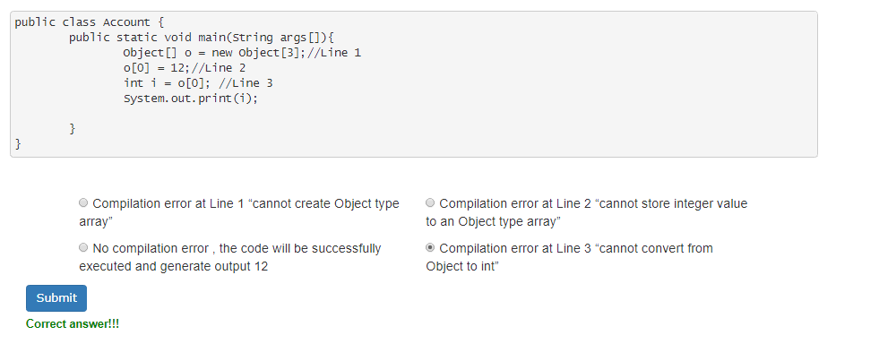

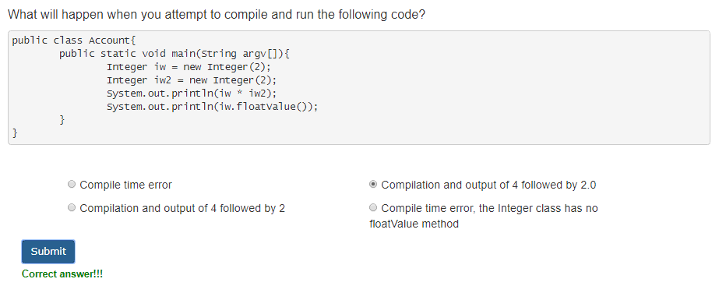

**String**

Strings can be created using one of the following methods:

* String username = “Jeena”
* String username = new String(“Jeena”)

String username = “Jeena”

Here username is represented as a String literal. String literals are created in a pool section of the heap memory. For example if we create another String literal: String name = “Jeena”; , then both name and username point to the same literal in the pool.

String username = new String(“Jeena”)

Here username is represented as a String object. If we create another String: String name = new String(“Jeena”); then both name and username point to two different objects in the memory.

Keep in mind that string literals are never garbage collected throughout the application. On the other hand, String objects are eligible for garbage collection.

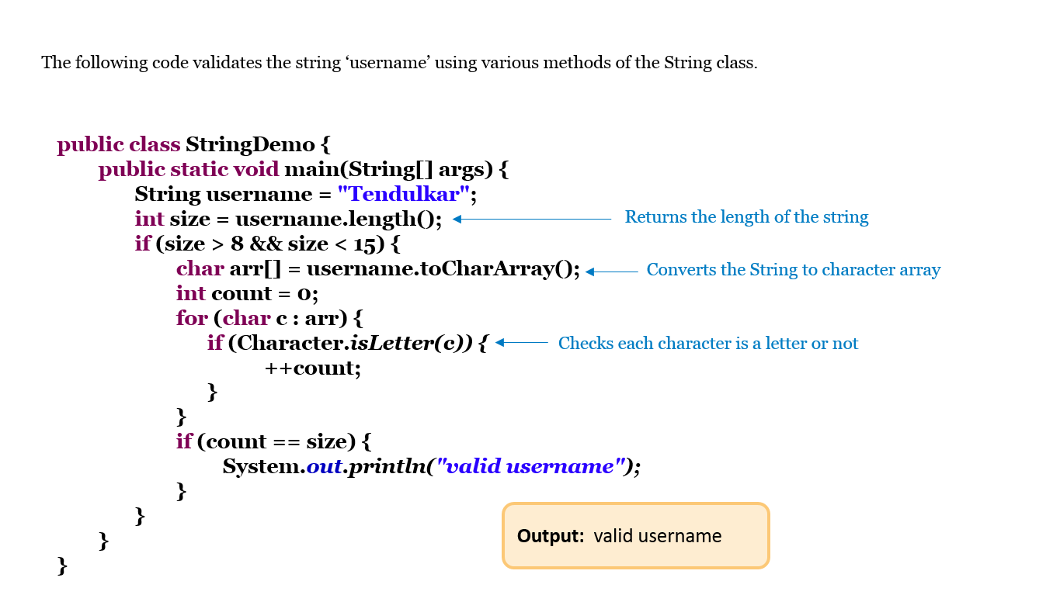

Best Practices:

* NullPointerException should be checked before checking the length of the String by doing null value check
* In conditional statements, prefer writing "123".equals(stringValue) over stringValue.equals("123") as the latter one can lead to a NullPointerException when stringValue is null.

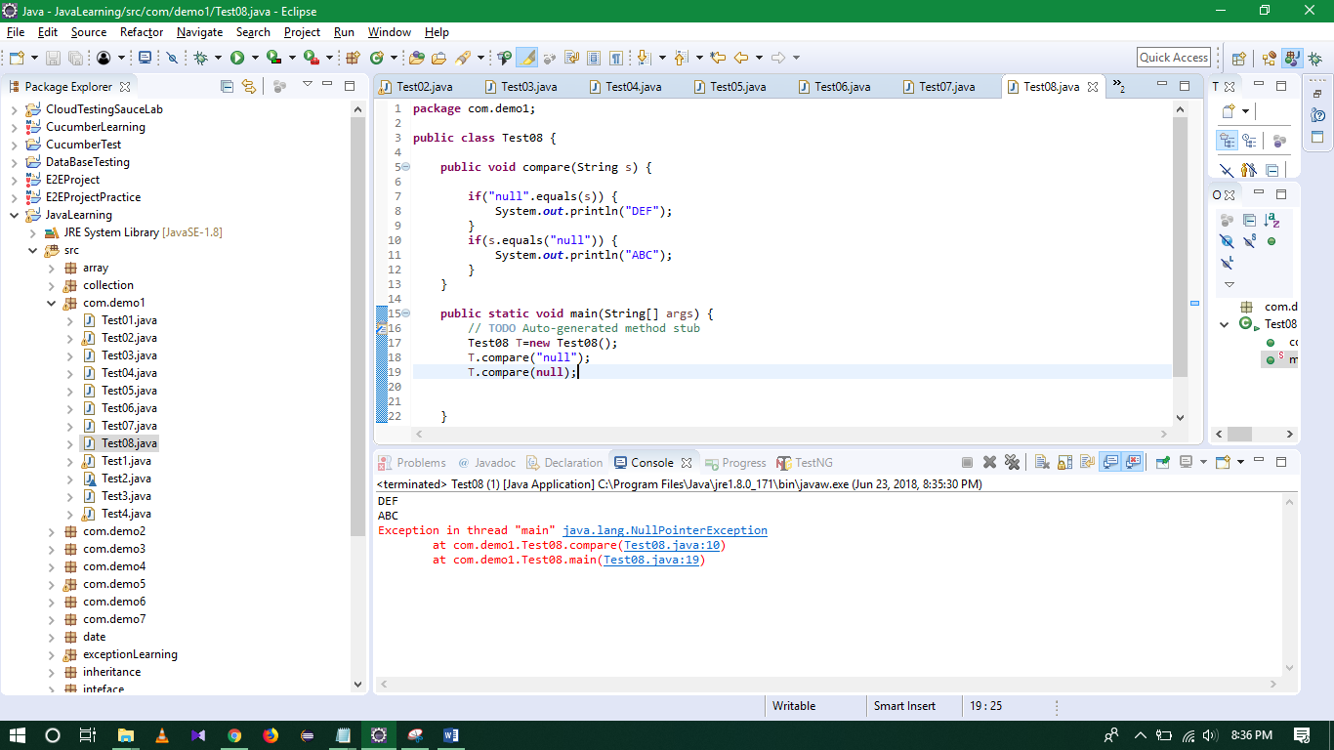

**StringBuffer**

* StringBuffer object is mutable i.e. it represents a String that can be changed without creating a new object.
* StringBuffer's capacity can be dynamically increased even though its initial capacity is specified.
* The API’s of StringBuffer are synchronized (understanding synchronized is outside the scope of this course)
* StringBuffer is a final class and it is available in java.lang package

 Some of the methods of StringBuffer class are append(), insert(), delete(), reverse().

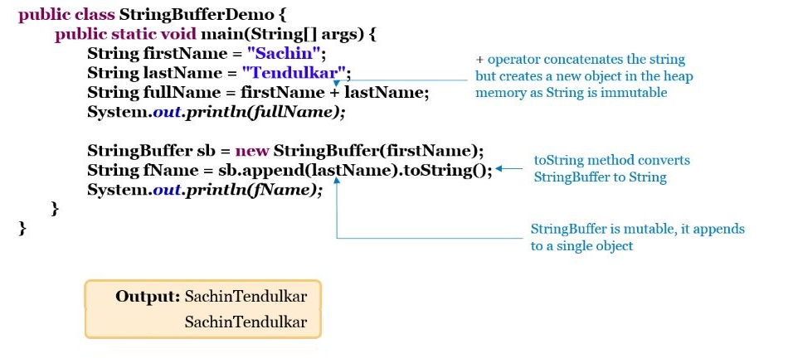

**StringBuilder** is the non-Synchronized version of the StringBuffer class.

* It is used when thread safety is not needed (thread safety is out of scope for this course)
* It is faster than String and StringBuffer class.
* It contains all the methods of the StringBuffer class

Example: StringBuilder sb = new StringBuilder()

Differences:

<http://www.techtamasha.com/difference-between-string-and-stringbufferstringbuilder-in-java/28>

Best Practices:

* String concatenation using the + operator
  + + operator is convenient for simple operation, fixed strings and for generating a single line output
  + It is inefficient for concatenating large no of strings since Strings are immutable and every time + is invoked a new String object gets created
  + String concatenation using +operator is both time and memory intensive, need to use with care
  + For generating mutable Strings use the StringBuilder class

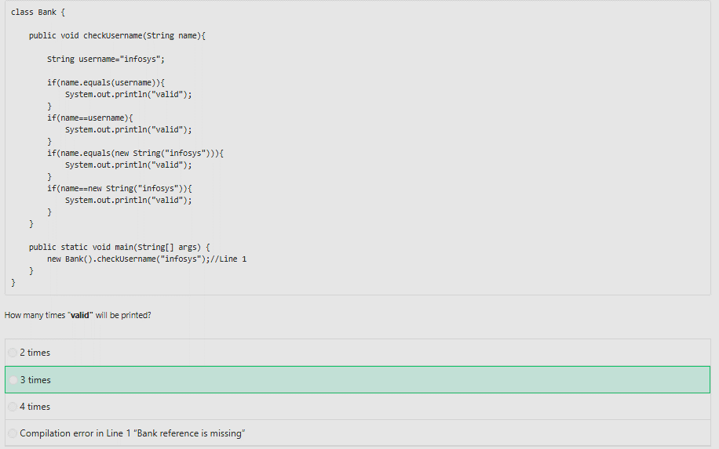

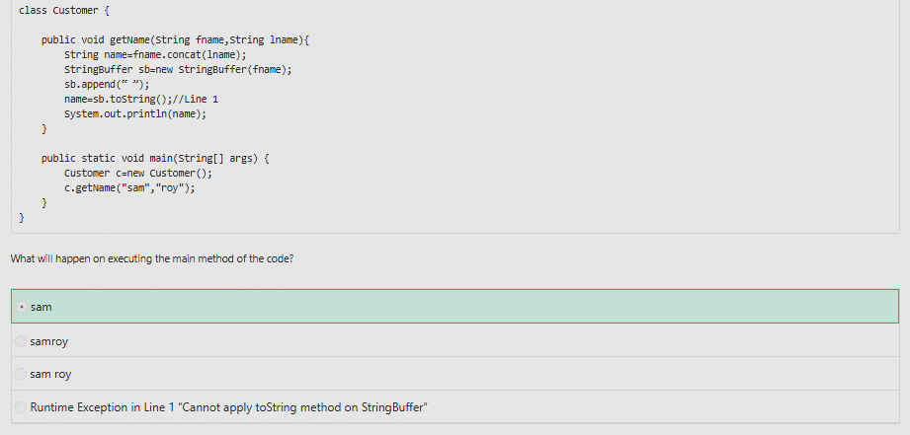

**Scanner**

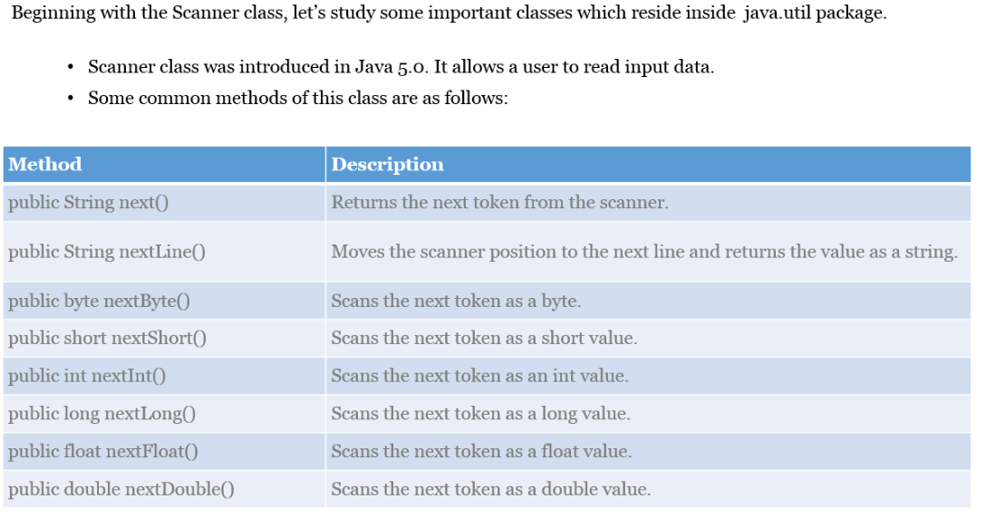

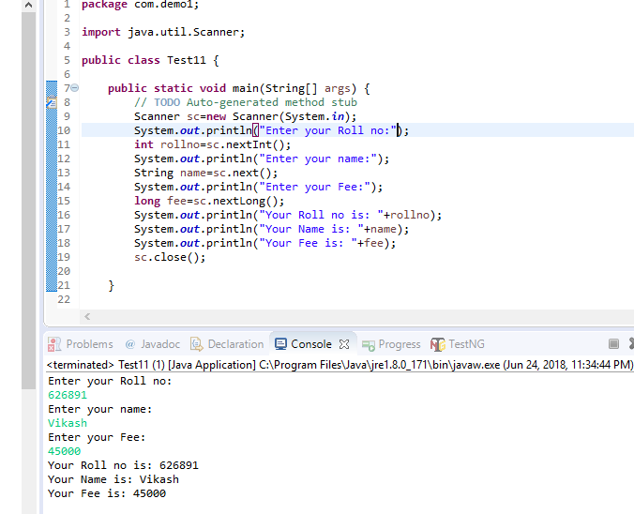

**Calendar**

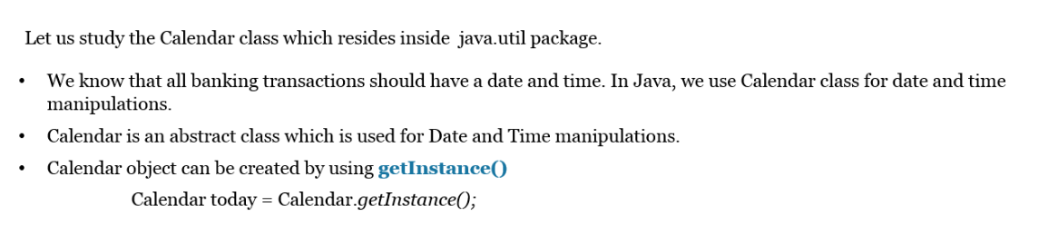

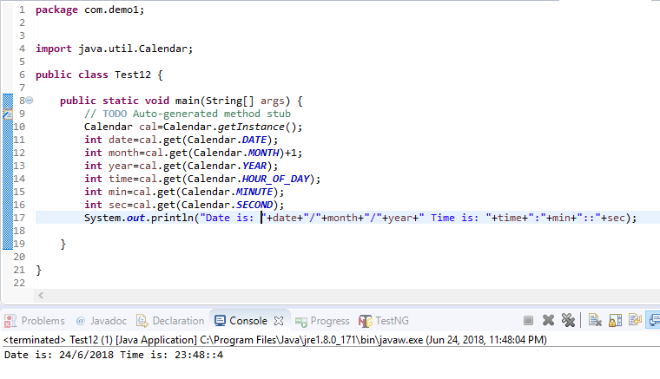

**Memory Management**

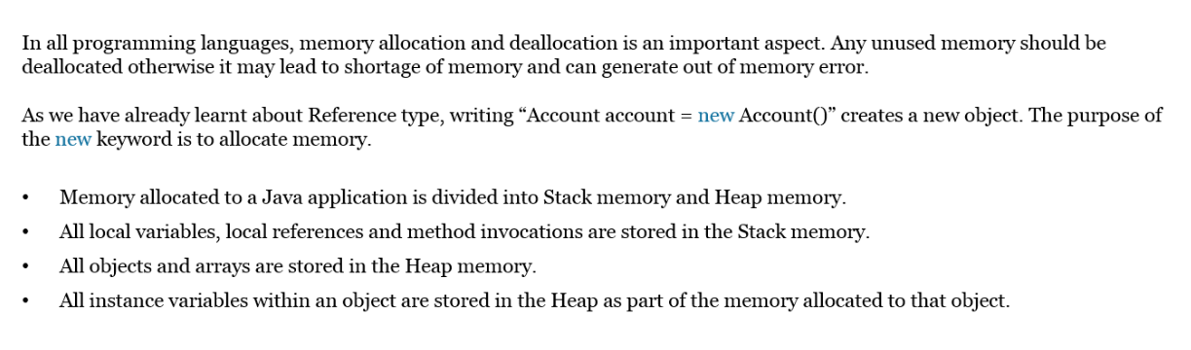

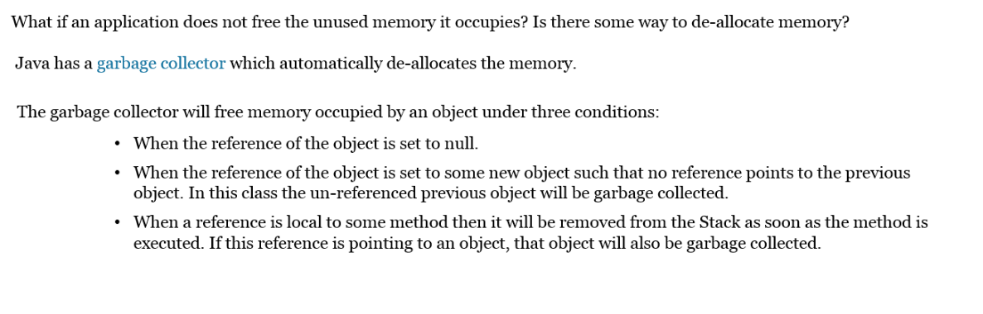

* finalize method is used when certain objects are required to perform some action before they are destroyed.
* By overriding this method, we can define specific actions that will occur when an object is just about to be reclaimed by the garbage collector.

                syntax : protected void finalize(){  }

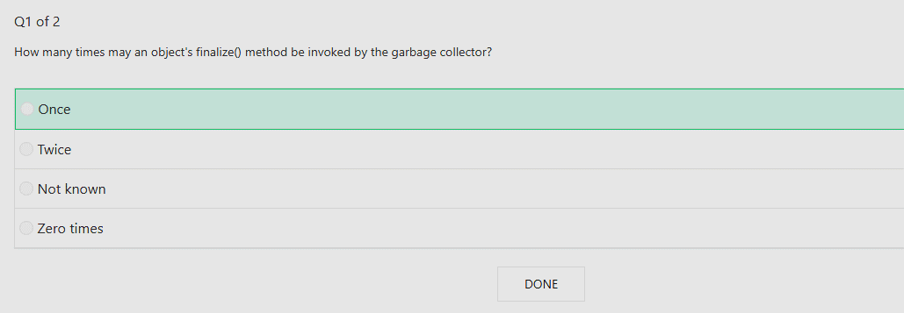

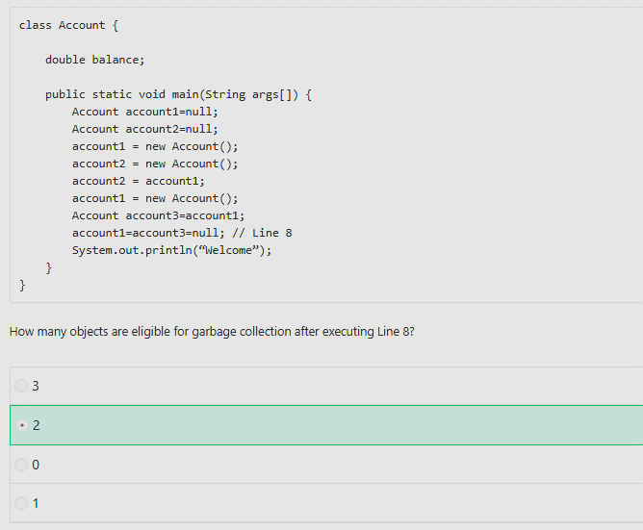

**Exceptions**

**Exception Propagation**

In Java, all exceptions are objects of the java.lang.Exception class. These objects carry the information related to the exception, including the stack trace.

Whenever an exceptional event occurs, the runtime environment (JRE) generates the exception object and throws it. The moment an exception object is thrown, further execution stops. And if it is not taken care of, the exception is propagated to the calling environment. The calling environment can be either a calling method, or the runtime system.

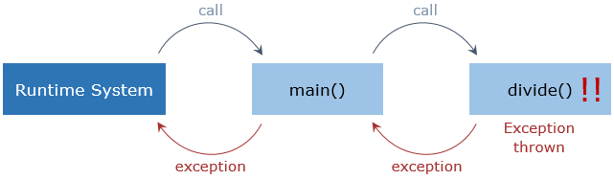

In the case above, an exception is generated inside divide(). Since divide() doesn't take care of it, the exception propagates to its calling environment, which is the main() method. The main() method also doesn't take care of it, and the exception propagates to its calling environment, which is the runtime.

When the runtime receives the exception, it shows the stack trace and terminates the program.

**Throwable Hierarchy**

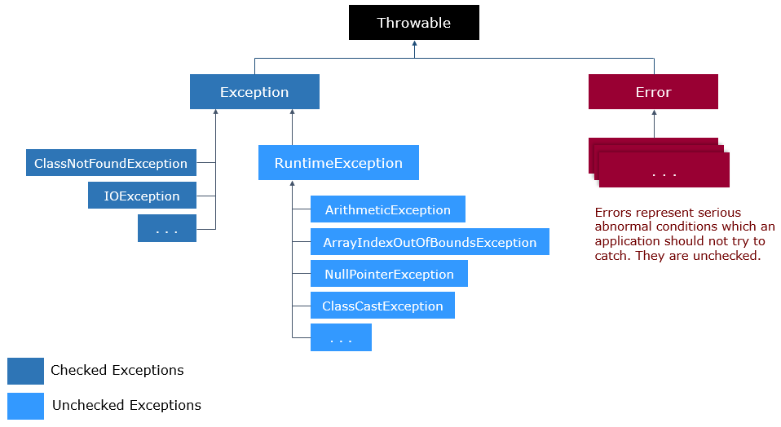

**Checked exceptions** occur at compile time, and should be handled or declared for propagation.

**Unchecked exceptions** occur at runtime, and need not be handled or declared for propagation.

**Throwable Class**

An exception object can make use of the below methods of Throwable class:

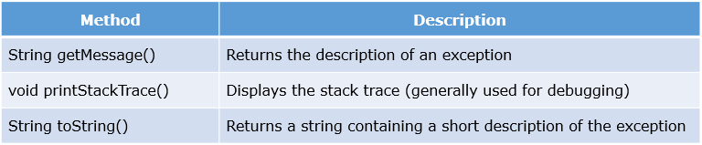

Have a look at how to use the methods:

*System.out.println("Exception message: " + throwable.getMessage());*

*System.out.println("Exception stack trace: " + throwable.printStackTrace());*

*System.out.println("Description of the exception: " + throwable.toString());*

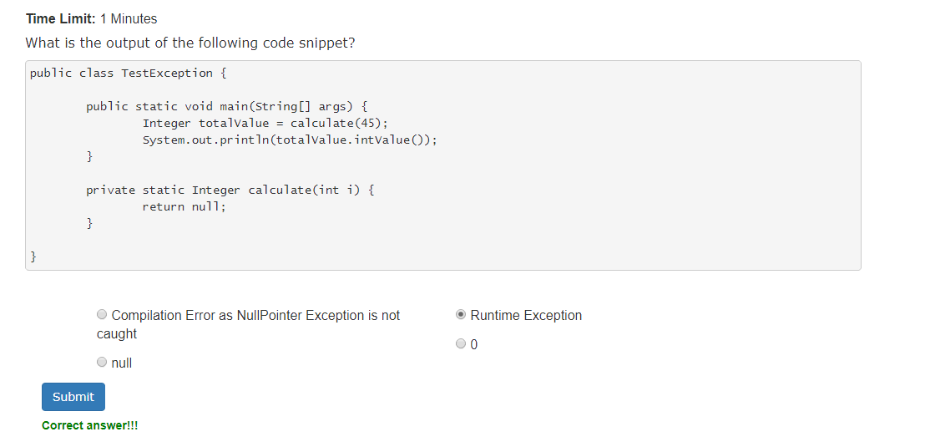

**Exception Handling**

Having seen what exception are and how they affect a program, let's see how we can handle them.

To make things easier and convenient, Java provides excellent exception handling mechanisms.

Whenever there is a chance of an exception to occur in a method, we have two choices:

***Handle the exception there itself***

***or***

***allow it to propagate to be handled somewhere else***

We'll start with handling exceptions and later see how to allow propagation.

**The try-catch Block**

Handling exceptions involves using the try-catch block for constructing an exception handler.

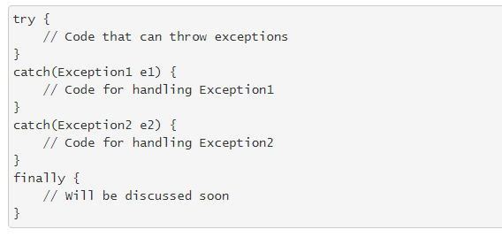

The code that can throw an exception is enclosed inside the try block. A try block is immediately followed by one or more catch blocks or a finally block.

A catch block is an exception handler which can handle the exception specified as its argument. A catch block can accept objects of type Throwable or its subclasses only.

Now let's create an exception handler block for our ArithmeticException example 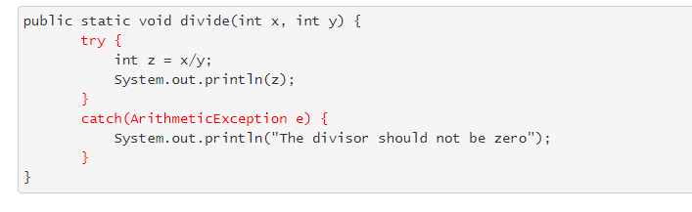

**Best practice:** In a catch block, prefer specific exceptions rather than general exceptions or unspecific exceptions.

**Catch Block**

Whenever an exception is thrown inside a try block, it is immediately caught by the first matching catch block which can handle it. The code inside the try block following the line causing the exception is ignored.

When an exception is caught and handled by a catch block, the execution continues from immediately after the try-catch block.

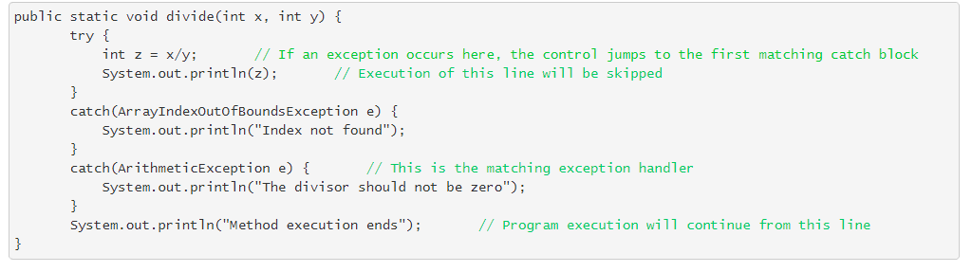

* If no matching catch block is found, the exception will remain unhandled and will be propagated.
* If no exception is thrown inside a try block, the catch blocks following it are ignored.

A catch block which can handle objects of Exception class can catch all the exceptions.

This should always be the last catch block in the catch sequence.

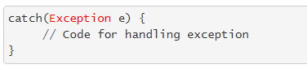

**Note:** try-catch blocks can be nested.

If we need a similar exception handling logic for multiple exceptions, a multi-catch block can be used. The catch blocks in Java 7 and higher can handle more than one type of exception:



**finally Block**

An exception inside a try block causes the rest of the code to be skipped. This might lead to the important parts of the code not being executed.

Code which closes connections, releases resources, etc. need to be executed in all the conditions. Keeping them inside the try block cannot guarantee their execution.

In such situations, the finally block plays an important role.

It always executes, irrespective of whether an exception occurs or not.

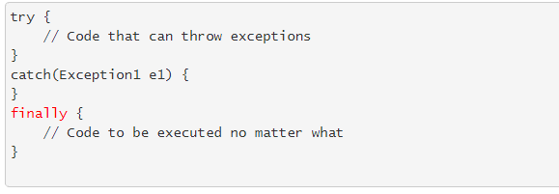

The finally block will be disrupted if an exception occurs inside it, or if System.exit() is invoked before it.

Note: A try block should be always followed by either at least one catch or a finally block.

Best practice: The finally clause should normally have code that does not throw exceptions. If the finally clause does throw an exception, log it or handle it, never allow it to bubble out.

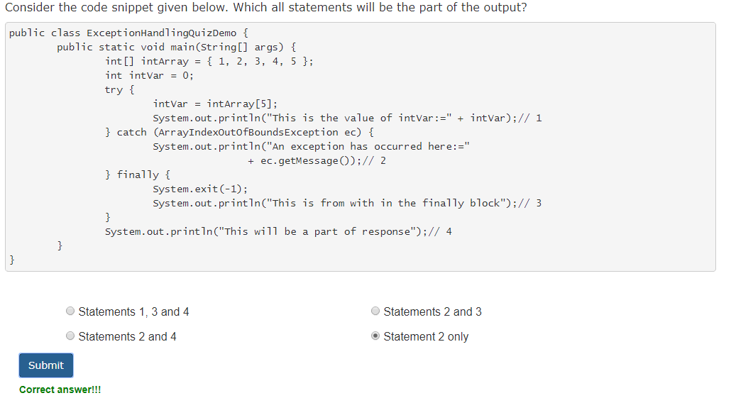

**throw Keyword**

Exceptions are generated when some predefined exceptional events like division by zero occurs in a program. Sometimes it is reasonable and convenient to define our own exceptional events.

Java allows us to explicitly generate or throw exceptions using the throw keyword:

*Exception e = new Exception();*

*throw e;*

Any object of type Throwable can be thrown.

Exceptions also accept a message for themselves:

throw new Exception("The divisor should not be zero");

Having exceptions with custom messages increases the readability of our applications.

Now let's see how we can use this in our example…

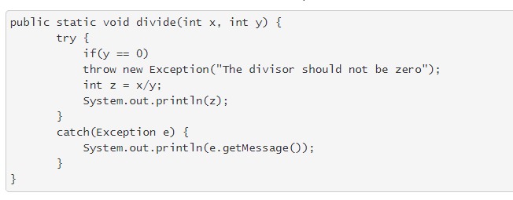The above code will generate an exception with the given message if the condition is satisfied.

Until now, we have been handling exceptions in the method in which they are thrown. What if we need to propagate and handle the exceptions elsewhere!

If there is a checked exception which the method doesn't handle, it has to be declared using the throws clause:

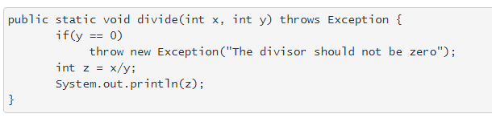

If the exception happens to be thrown from this method, it will be propagated to the calling method (main() method in our example). Because of the declaration, main() will be aware and be prepared to handle the exception.

Or, main() could also just declare it to be thrown.

Have a look at the implementation of main() method, to handle the exception thrown from the divide() method:

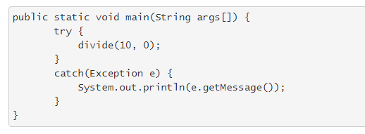

Note: Exceptions are either handled or declared to be thrown.

**Checked Exceptions** should be either declared in the throws clause of method or handled inside the catch block. Exception and it subclasses are Checked Exceptions.

Few checked exceptions are:

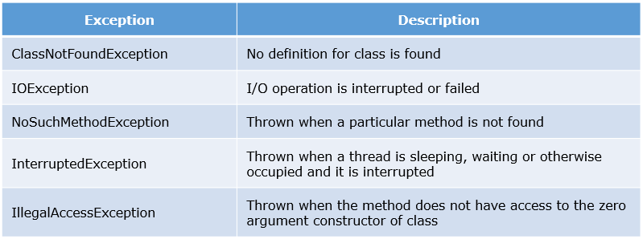

**Unchecked exceptions** are not mandatory to either declare or handle and are ignored at compile time. Error, RuntimeException and their subclasses are Unchecked exceptions.

Error and its subclasses are used for serious errors from which programs are not expected to recover. For example, out of memory error.

Runtime exceptions are used to indicate programming errors such as logic errors or improper use of an API. For example,

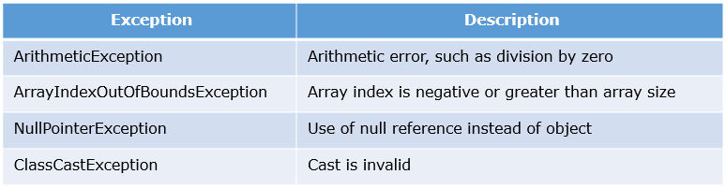

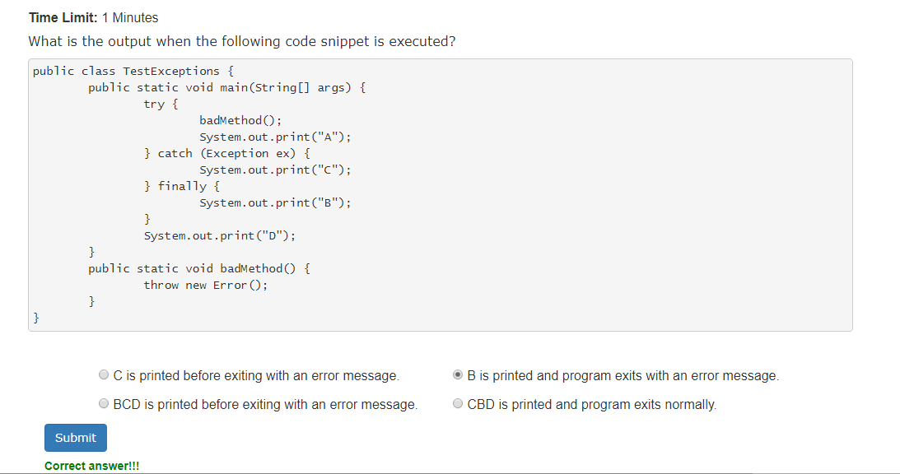

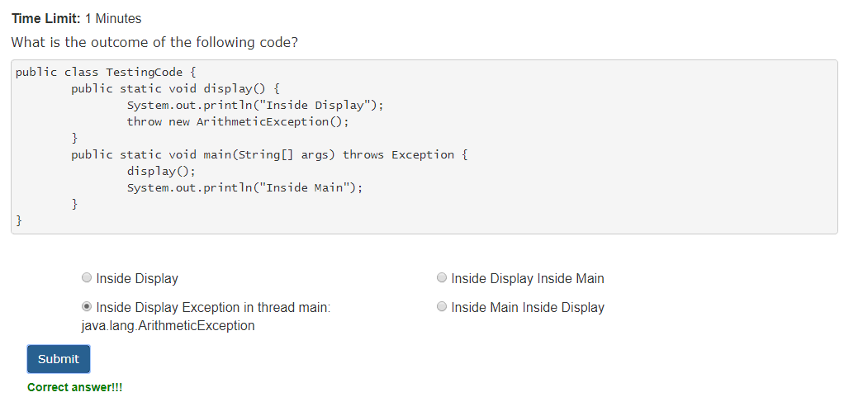

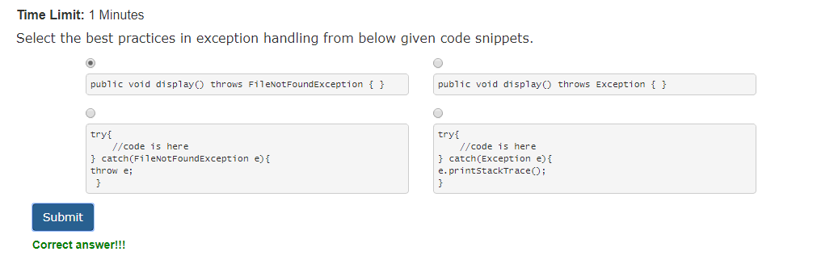

**User-Defined Exceptions**

Besides working with exceptions provided by Java, we can have our own custom exceptions.

Having user-defined exceptions not only increases the flexibility of our applications, but also makes the code more manageable.

We can create a user-defined exception class by extending the Exception class:

public class DivisionException extends Exception { }

We can also set messages by using the parameterized constructor:

public DivisionException(String message) {

super(message);

}

Now we can use our user-defined exception in our example:

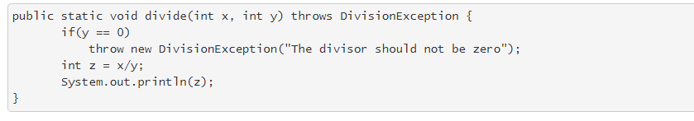

# [Difference Between throw, throws and Throwable In Java](https://javaconceptoftheday.com/difference-between-throw-throws-and-throwable-in-java/)

<https://javaconceptoftheday.com/difference-between-throw-throws-and-throwable-in-java/>

**Collection Framework**

The collections framework provides a set of interfaces and classes for representing and manipulating collections. Introduced as part of J2SE 1.2, it standardizes the way we store and access data from collections. It is a part of the java.util package.

The framework has the following advantages:

* Ready to use classes and algorithms
* Better program speed and quality
* Reduced programming effort

**Autoboxing and Unboxing**

https://www.geeksforgeeks.org/autoboxing-unboxing-java/

